Globalization and Human Aspect of Development
in Developing Countries: Evidence from Panel Data
Jeet Bahadur Sapkota
This paper evaluates the effects of globalization on human development, gender development and human poverty in the developing countries and compares the effects across world regions as well as the income groups of countries. Applying the GLS random effect model to the annual panel data of 124 developing countries covering 9 years from 1997, the study shows that globalization, measured by the KOF Index of globalization, not only promotes human and gender development but also reduces human poverty significantly. Not surprisingly, all three aspects of globalization (economic, social and political) contribute to the overall effect of globalization. To complement these findings, the paper calls for a study of some country cases. The conclusion is made that such studies will facilitate the development of policy recommendations tailored towards countries in their cultural context, with a positive (or at least neutral) impact on the reduction of human development gaps within them.
Keywords: globalization, human development, gender development, poverty, KOF Index.
- Introduction
The modern world economy and society are globalizing more rapidly than ever seen in the past (Urata 2002: 20; Dreher et al. 2008: 1–4). Globalization is one of the most closely observed processes among scholars, policy makers, politicians and even the general public (Collier and Gunning 2008: 1–2). Conventionally, the impact of globalization on economic efficiency and growth outcomes has drawn the most research attention (Garrett 2000; Nyahoho 2001; Dreher 2006). It is clear that income is an important part of living standards, but so are health and education (Stiglitz 2006); hence these aspects should also receive similar research efforts. In this regard, recent articles framing the theoretical linkage between globalization and human quality of life (QOL) by Sirgy et al. (2004: 292–295) and empirical testing some of the linkages by Tsai (2007: 121–122) conclude that globalization has both positive and adverse effects on human QOL. For the purpose of this study, globalization is defined as the diffusion of goods, services, capital, technology, and people (workers) across national borders, and the definition and measurement will be discussed further in Section II.
In the debate on possible consequences of globalization, non-economists generally tend to oppose globalization as they expect the costs associated with globalization to exceed its benefits, particularly in developing countries. On the contrary, supported by
a number of empirical studies, most economists strongly believe the net effect of globalization is positive (Dreher 2006: 1091). Although, Sirgy et al. (2004) and Tsai (2007) have investigated this question by assessing globalization's effects on human and social aspects of development, their efforts are still exploratory and further empirical examinations are necessary. The present study attempts to contribute to the study of globalization by an empirical analysis to test the theories proposed by earlier research, with
a focus on the human aspects of development.
The paper proceeds as follows. Section II provides the recent trends and linkage between globalization and human aspects of development and poverty, as well as the working definitions of key terms. Section III discusses the methodology employed,
the data used and the variables explored. Section IV discusses the results of the analysis and Section V concludes the paper.
- Globalization, human and gender development and human poverty
Most of the empirical studies in relation to the so-called third wave of globalization¹ employ proxies such as trade, capital flows and openness as the measure of globalization using cross-section data (Dreher 2006: 1092). For example, Heinemann (2000: 298) shows that more globalized countries have lower increments in government outlays and taxes and lower government consumption. Rodrik (1998) also used cross-sectional data and found no effects of capital account openness on economic growth. Recently, however, some scholars have used panel data to find the effects of globalization and showed the positive impacts of openness to growth and poverty reduction but mixed impacts on income inequality (Dollar and Kraay 2004; Greenaway et al. 1999; Edison et al. 2002).
These detailed studies, however, failed to consider the overall effect of globalization, as they focused on individual sub-dimensions. As all the dimensions of globalization are strongly related to each other and are important in explaining the consequences of globalization, omitting such important variables from the regression equation can generate severely biased coefficients (Dreher 2006: 1092). In addition, as mentioned earlier, most of these studies motivated by the conventional wisdom focus solely on economic growth, income poverty and income inequality (Garrett 2000; Nyahoho 2001; Dreher 2006).
To avoid these shortcomings, this study uses the KOF Index of Globalization developed by Dreher (2006) and updated in Dreher et al. (2008), which is considered the most comprehensive indicator of globalization. Although there is another measure of overall globalization developed by A. T. Kearney/Foreign Policy Magazine (2002), it just ranks the countries in terms of globalization and the rank is only available for recent years. Thus, A. T. Kearney Index of globalization cannot be used for the purpose of empirical study.
To define globalization by formulating the KOF Index of Globalization, Dreher referred to the definition given by Keohane and Nye (2000: 4) among others, and summarized the definition of globalization in the following three dimensions:
- ‘economic globalization, characterized as long-distance flow of goods, capital and services as well as information and perceptions that accompany market exchanges;
- political globalization, characterized by a diffusion of government policies; and
- social globalization, expressed as the spread of ideas, information, images and people’ (Dreher 2006: 1092).
Dreher then considered all possible elements for each dimension of globalization and developed the indexes of economic, social and political globalization by employing appropriate weights systematically for each component following the methodology of Gwartney and Lawson (2001). The components of a certain aspect of globalization were transformed on a zero-to-ten scale before the principle components technique was used to construct a weighted summary index for individual dimensions of globalization. Then the indexes of economic, social and political globalization were combined into
a single index of overall globalization giving the respective weights for each dimension and named the KOF Index of Globalization, which is the working definition and measure of globalization of this study. Refraining from further explaining the details of this comprehensive indicator of globalization, the paper presents the elements considered and weight placed to calculate the KOF Index of Globalization in Appendix-I, which provides its broad concept and comprehensive methodology used to obtain the index.
Diagram 1 presents the comparison among the trends of the three types of globalization on the basis of KOF Indexes. Representing the high turmoil in international security as well as an increasing role of global governance, political globalization fluctuates more with higher values. However, economic globalization has a rather steady upward trend. Although social globalization has the lowest index value, the progress goes along with the pace of other forms of globalization. Overall, globalization has moved faster since the beginning of the 1990s.
Diagram 2 presents the regional comparison of overall globalization. It clearly shows that Sub Saharan Africa and Asia are below the world average of globalization trend and Europe is the most globalized region. However, the trend of globalization of the remaining three regions, South America, North America, and Oceania, found to be very close to each other but the three regions are always above the world average. Notably, globalization trends for all the regions have moved upward since 1970 to 2006, and became steeper since the early 1990s.

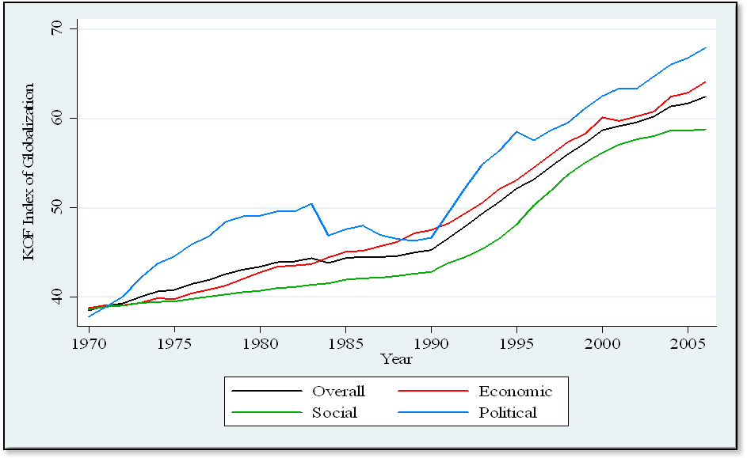
Diagram 1. Major factors' comparison of globalization trend (1970–2006)
Source: Calculations by the author based on the data from Dreher (2006). Updated data can be found online at http://globalization.kof.ethz.ch/ (accessed on May 2, 2009).
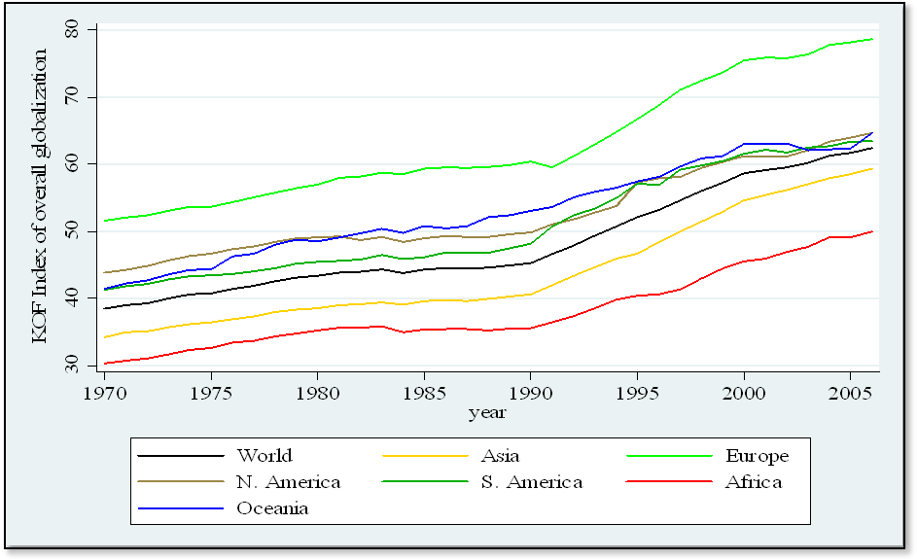
Diagram 2. Regional comparison of overall globalization trends (1970–2006)
Source: Calculations by the author based on the data from Dreher (2006). Updated data can be found online at http://globalization.kof.ethz.ch/ (accessed on May 2, 2009).

As explained earlier, the dependent variable of this study is the human aspect of development. The paper uses the human development indicators developed by the United Nations Development Program (UNDP) because of their popularity and availability. Out of the five indexes; the Human Development Index (HDI), the Gender Development Index (GDI), the Gender Empowerment Index (GEM), and the Human Poverty Indexes (HPI-1 for developing countries and HPI-2 for developed countries), this study takes the HDI, GDI and HPI-1 as the dependent variables. The HDI involves three key sub-constructs with corresponding measures: longevity (e.g., life expectancy at birth indicators), knowledge (e.g., adult literacy rates and combined enrollment ratios), and an adequate standard of living (e.g., adjusted per capita income in dollar purchase power parity). Similarly, GDI is a composite index measuring average achievement in three basic dimensions captured in the human development index – a long and healthy life, knowledge, and a decent standard of living – adjusted to account for inequalities between men and women. The HPI-1, which is the measure of human poverty for developing countries, measures poverty in terms of percent of people expected to die before the age of 40, the percent of adults who are illiterate, and deprivation in economic provisioning (UNDP 2008). See detailed explanation of the indexes in Appendix-II.
Diagram 3 presents the trends of HDI across regions from 1975 to 2005. One general observation is that Sub Saharan Africa has the lowest HDI followed by South Asia; this fact is consistent with globalization trends, although the regional classifications are different to some extent between Dreher's and UNDP's reporting. Notably, the HDI is growing at a more rapid pace from the mid-1990s, which can be attributed to rapid globalization starting from the beginning of the 1990s. In addition, the EAP region has been taking an even more rapid pace of human development from the same period and exceeded the global average in 2000. This is because of its high and shared economic growth (World Bank 1993).

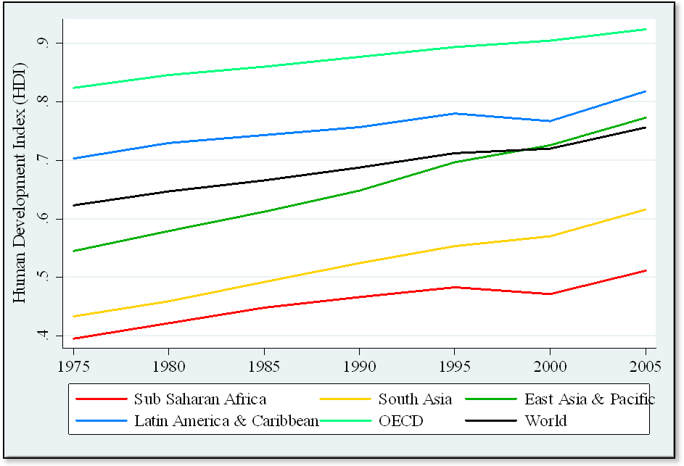

Diagram 3. Regional comparison of human development trend (1975–2005)

Source: Calculations by the author based on the UNDP (2009) data. Updated data available online at http://hdr.undp.org/en/statistics/data/ (accessed on May 3, 2009).

As we observed from the general trends of globalization and human development, it is easy to predict their positive relationships. Although most literature agrees that globalization is the reality of the current world society (Guillén 2001), the human consequences of globalization remain controversial. Two contradicting theories prevail in how globalization affects human welfare. First, neoliberalists believe that globalization enhances productive efficiency and generates extraordinary prosperity. Although the wages for unskilled workers fall, especially in developed nations, globalization manages these potential threats by acquiring additional skills, and the benefits can spread over the masses (Grennes 2003). Additionally, globalization has operated to spread industrialization into developing countries and thus has reduced global income inequality (Firebaugh and Goesling 2004). Economic globalization in terms of trade liberalization was found to be effective in increasing productivity and institutional building of a society, which leads to faster economic growth (Urata and Yokota 1994; Rodrik et al. 2004). However, many argue that some policy measures are essential to make globalization work for all. Mayer (2007) pointed out that globalization alone is not a sufficient condition for convergence to development. For example, trade liberalization without roads and ports would not lead to more trade or help the poor (Stiglitz 2004). Even though scholars point out the defects of the current form of globalization and suggest better options, they ultimately tend to favor globalization.
On the contrary, many others see globalization as a new hegemonic project that transnational capitals operate in a way that promises little betterment for most countries. This second approach claims that the current form of globalization is a creation of
a new world order that facilitates capitalist accumulation in the so-called free market environment (Petras and Veltmeyer 2001). Promoting private interests in a limitless setting of a free market ignores personal as well as social interests (Smart 2003). As a result, benefits from globalization go mainly to the already advantaged (Scholte 2000).
Within the context of these controversies, this paper attempts to answer how and which types of globalization generate the most favorable and unfavorable human consequences. Using the theoretical base provided by the Sirgy et al. (2004) and improving the empirical model offered by Tsai (2007), the paper evaluates the impacts of globalization on human welfare.
- Data and Methodology
Sample and time coverage
Most of the previous empirical analysis usually uses cross-country data of a certain period (Rodrik 1998; Garret 2000). Although this is useful to find the differences in comparing countries, such cross-country studies fail to observe changes of certain structural features and their correlates over time. Thus, this study builds a panel of 124 developing countries covering 9 years of annual data of globalization and human development from 1997 to 2005. The selected countries are listed in the Appendix-III. The data from 1997 onward is used because there is no HPI data available before 1997. Although Tsai (2007) also uses the panel data of 112 developing countries, the results are too weak to capture the time effects as the data is in the intervals of 10 years from 1980 to 2000.
Panel data has the merit of having a larger number of observations that give precise estimates and test statistics with more power. More importantly, panel data allows the assessment of dynamic causality in a time-series situation close to natural experiment that a change in the level of human welfare of a country can be attributed to changes of certain hypothesized factors (Wooldridge 2003).
The data and its sources
HDI, GDI and HPI-1 (Human Poverty Index (HPI-1) for developing countries) are dependent variables. This data is taken from the yearly Human Development Reports from 1998 to 2007/08. The detail definitions of the dependent variables and the summary statistics are given in Appendix-III and Appendix-V, respectively.
The KOF Index of Globalization, as defined in the previous section (detailed in Appendix-I), is the explanatory variable for this study. The index is the most comprehensive indicator of globalization that is currently available. Contrary to the conventional approach of using proxies of globalization by specific factors such as trade and investment, this paper adopts a more multidimensional, pluralistic approach. A multidimensional approach is far more useful to prevent an over-simplification of the complexities involved in understanding globalization because of the problem of omitting important variable(s) and the problem of measurement and interpretation (Dreher et al. 2008). In fact, assessing the extent to which any country is more (or less) globalized at any particular point of time requires much more than employing data on flows of trade, migration or foreign direct investment. In addition, in spite of the due importance of both political integration and social integration, most of the economic literature neglects these types of globalization.
In choosing the set of control variables, this paper follows standard practice as much as possible. Firstly, the development level of a country is considered as a critical element in improving human development (Ranis et al. 2000; Tsai 2007). Thus, it includes per capita GDP to differentiate development levels across countries. Secondly, as the study focuses on developing countries, population growth is also included, because the literature has long documented the harmful impacts of unchecked fertility against limited resources, such as attenuated health and educational expenditures, insufficient housing, sanitary and water, etc. (Goldthorpe 1996). Finally, this study also introduces two kinds of dummy variables. At first, all the regional dummies excluding East Asia and the Pacific (EAP) are created to compare the regional effect in comparison with EAP regions. Then, dummies of lower middle-income countries (LMCs) and upper middle-income countries (UMCs) are created to compare with the low income countries (LMCs). The regional divisions and the other classifications are based on the World Bank classification of countries and regions (World Bank 2008). The natural logarithms of all the variables (except dummies) are taken to reduce the skewedness of the data.

The model
Throughout this study, the GLS random effect estimation model is used to analyze
the data because this method has the capacity to recognize the unobservable cross-sectional heterogeneity (such as geographical proximities, and climate or cultural differences) in panel data and treat them as uncorrelated with other observable factors (Wooldridge 2003). Thus, along with the overall impact on whole the cross-section,
it allows us to compare the effects across different sets of individuals having common characteristics. The random effect estimation model is one of the well known models in panel data analysis, which is described as follows:
$$y_{\text{it}}=β_{0}+β_{1}C_{\text{it}}+β_{2}G_{\text{it}}+(u_{i}+∈_{\text{it}})$$
Where, y is the vector of dependent variables (i.e. HDI, HPI-1 and GDI). C is the vector of control variables (i.e. GDP per capita and population growth in this study).
G is the vector of explanatory variables (i.e. the indexes of globalization). β is the coefficient of each globalization index that explain the strength and direction of impact on human welfare indicators. In addition, i represents the group identifier (i.e. 124 countries), and t represents the time identifier (i.e. 9 years from 1997 to 2005). Similarly, $(u_{i}+∈_{\text{it}})$is the composite error term, where u_{i} is the unobservable country effect fixed over time. A crucial assumption of this model is that the u_{i} is uncorrelated with the regressors C_{it} and G_{i}. However, if u_{i} is correlated with the regressors, fixed effect model fits best for the analysis. This assumption is tested with the Hausman specification test in Stata and found good fit for the random effect model over fixed effect model. Finally, $∈_{\text{it}}$is the error term.
Previously, this model was applied by Tsai (2007) in the similar study. However, Tsai put each index of globalization in the equation separately and compared the impact of each type of globalization on human well-being. Instead, this study starts the analysis with the index of economic globalization in the model then runs the regression by adding the index of social and political globalization. This avoids the biases that comes from the missing important variable(s) and generates robust results.
- Results
Table 1 provides the first evidence of the relationship between human development and globalization. Column 1 includes the index of economic globalization with control variables – GDP per capita and population growth, and the dummies for geographical regions and for LMC and UMC. The regions and the classification of countries in terms of the levels of development are based on the World Bank classification of world regions and countries.² As we can see, the coefficient of economic globalization is 0.11, which reveals that one percentage increase in economic globalization would increase HDI by 0.11 percentage points. The level of significance of this effect is 1 percent.
As expected, the control variable GDP per capita has a positive impact and population growth has negative impact on HDI. The impacts are significant at a 1 percent and
5 percent level, respectively.
As GDP per capita is one of the main components of HDI itself, there is a high chance of autocorrelation between this control variable and the dependent variable, which might lose the estimation power of the model significantly. Therefore, the Wooldridge test for autocorrelation in panel data in Stata ran and found no first order autocorrelation. These results support the proposition made by Sirgy et al. (2004) that economic globalization enhances human quality of life. Dummies for the world geographical regions and income groups of countries are included in the regressions, however excluded from the results.
Column 2 adds the index of social globalization on the previous equation. The result is highly consistent with Column 1. Similarly, the social globalization has increasing human development effects with a 1 percent level of significance. The differences of the effect of globalization across regions and the level of development of countries are highly consistent with the results of Column 1.
More interestingly, the results do not change significantly when political globalization includes in the equation as Column 3. As expected, the political globalization is also found significant in increasing human development. The regional and development level effects are also consistent with previous results.

Table 1

Human development and globalization (1997–2005)

Dependent variable: log of human development index (HDI)
 | (1) | (2) | (3) | (4)
GDP per capita | 0.06***(0.01) | 0.04*** (0.01) | 0.03*** (01) | 0.04*** (01)
Population growth | –0.01** (0.01) | –0.01** (0) | –0.01* (0) | –0.01** (0)
Economic globalization | 0.11*** (0.02) | 0.07***(0.02) | 0.07***(0.02)
Social globalization |  | 0.08*** (0.02) | 0.06*** (0.02)
Political globalization |  |  | 0.08*** (0.02)
Overall globalization |  |  |  | 0.16*** (0.02)
Constant | –1.22*** (0.11) | –0.95*** (0.01) | –1.45*** (0.11) | –1.3*** (0.11)
Overall–R² (N) | 0.43 (774) | 0.5 (738) | 0.5 (738) | 0.41 (871)
Notes: GLS random effect estimations are reported. Standard errors are in parentheses. * means the coefficient is significant at 10 percent, ** at 5 percent, and *** at 1 percent. Globalization data are from Dreher (2006), GDP per capita (current US$) and population growth rate are from World Development Indicator (WDI) online database of the World Bank, and human development indicators (HDI), human poverty indicators for developing countries (HPI-1) and gender related development indicators (GDI) are from the Human Development Reports (HDR 1997 to GDR 2007/08) of United Nations Development Program (UNDP). All the variables, dependent as well as explanatory, are logged in the regression to neutralize the skewedness of data. The Data covers the 1997 to 2005 annually. Regions and the level of development are classified on the basis of the World Bank classification of countries. Column (1), (2) and (3) have fewer observations because some particular type of globalization has no data reported for some countries and for some years.

Finally, Column 4, the most important step of the analysis, employs a single but combined index of overall globalization. The results are quite consistent with Column 1, 2 and 3. Each case evidences that globalization increases the human development of developing countries significantly. The findings are similar with the outcomes of empirical analysis by Tsai (2007), but the relationship that he found was rather poor, because Tsai showed the significance level of the overall impact of globalization on human development at 10 percent and also reported no significant impact of economic and social globalization.
Similarly, Table 2 demonstrates the effects of globalization on gender-related development. Here, GDI is a dependent variable and the rest are same as previous table. The effect of overall globalization was found significant at 5 percent and the magnitude of the effect is as high as for HDI, i.e. 0.16 (Column 4). The result is very much consistent with the recent finding by Munshi and Rosenzweig (2006), as they found that lower-caste girls in the Indian city Bombay are taking full advantage of the opportunities from globalized economy by switching rapidly to English schools. Whereas working class boys in the lower caste, who have already a dominating role within their ethnic group tend to continue to go local language schools that lead them to a traditional occupation with low income. Furthermore, the result also supports the cross-country evidence by Oostendorp (2004) that evident the significant impact of trade and FDI net inflows on narrowing occupational gender wage gap for low-skill occupations worldwide.
The results of Column 2 and Column 3 are not consistent with Column 4, though. The significance of the effect disappears when the three indexes of globalization (Column 3) include in the regression equation. The effect was not even significant when the economic and social globalization included in the equation together (Column 2). However, when social and political globalizations are excluded from the equation, economic globalization alone is significant to increase GDI (Column 1). Why? The result simply demonstrates the problem of multicollinearity among the variables³ (see correlation matrix in Appendix-IV). However, the vif test⁴ shows that there are no serious problems of multicollinearity. Indeed, the problem disappeared when we regress with the single index of overall globalization, as it eliminates the problem that comes when we use multiple interdependent. Thus, the paper argues that globalization helps to increase gender-related development as well. This finding complements the earlier empirical evidence of enhancing the gender development effects of globalization by Seguino and Grown (2006) and also by Munshi and Rosenzweig (2006) and Oostendorp (2004) as explained earlier.

Table 2

Gender-related development and globalization (1997−2005)

Dependent variable: log of gender-related development index (GDI)
 | (1) | (2) | (3) | (4)
GDP per capita | 0.12*** (0.03) | 0.11*** (0.03) | 0.1***(0.03) | 0.09***(0.03)
Population growth | –0.03 (0.02) | –0.02 (0.02) | –0.02 (0.02) | –0.02** (0.02)
Economic globalization | 0.15** (0.02) | 0.11 (0.07) | 0.11 (0.07)
Social globalization |  | 0.07 (0.06) | 0.07 (0.06)
Political globalization |  |  | 0.03 (0.05)
Overall globalization |  |  |  | 0.16** (0.08)
Constant | –1.89*** (0.27) | –1.92*** (0.28) | –2.02*** (0.32) | –1.73*** (0.26)
Overall–R² (N) | 0.52 (733) | 0.51 (712) | 0.52 (712) | 0.52 (800)
Notes: GLS random effect estimations are reported. Standard errors are in parentheses. * means the coefficient is significant at 10 percent, ** at 5 percent, and *** at 1 percent. Globalization data are from Dreher (2006), GDP per capita (current US$) and population growth rate are from World Development Indicator (WDI) online database of the World Bank, and human development indicators (HDI), human poverty indicators for developing countries (HPI-1) and gender related development indicators (GDI) are from the Human Development Reports (HDR 1997 to GDR 2007/08) of United Nations Development Program (UNDP). All the variables, dependent as well as explanatory, are logged in the regression to neutralize the skewedness of data. The Data covers the 1997 to 2005 annually. Regions and the level of development are classified on the basis of the World Bank classification of countries. Column (1), (2) and (3) have fewer observations because some particular type of globalization has no data reported for some countries and for some years.

Table 3 shows the relationships between human poverty and globalization. It follows the same procedures as Tables 1 and 2, but using the HPI-1 as dependent variable. As expected, the economic, social and overall indexes of globalization have found significant in reducing poverty, as the coefficient of each indicator has a negative sign. The level of significance for political globalization, however, is reduced to 5 percent. The results for each column are consistent with each other, although the magnitude of economic globalization becomes smaller to some extent while adding other types of globalization. More interestingly, the poverty-reducing effect of all types of globalization is quite higher than the human development effect. For instance, if globalization increases by 1 percent, HPI-1 is expected to decrease by 0.52 percent, which is only 0.16 percent in case of HDI and GDI as well.

Table 3

Human poverty and globalization (1997−2005)

Dependent variable: log of human poverty index for developing countries (HPI-1)
 | (1) | (2) | (3) | (4)
GDP per capita | –0.06***(0.03) | –0.03 (0.03) | –0.02 (0.03) | –0.03 (0.03)
Population growth | 0.05*** (0.02) | 0.04** (0.02) | 0.04** (0.02) | 0.04** (0.02)
Economic globalization | –0.33*** (0.05) | –0.2*** (0.07) | –0.19*** (0.07)
Social globalization |  | –0.25*** (0.05) | –0.22*** (0.06)
Political globalization |  |  | –0.12** (0.05)
Overall globalization |  |  |  | –0.52*** (0.07)
Constant | 4.94*** (0.32) | 4.49*** (0.28) | 5.43*** (0.35) | 5.38*** (0.34)
Overall–R² (N) | 0.39 (725) | 0.46 (689) | 0.46 (689) | 0.41 (782)
Notes: GLS random effect estimations are reported. Standard errors are in parentheses. * means the coefficient is significant at 10 percent, ** at 5 percent, and *** at 1 percent. Globalization data are from Dreher (2006), GDP per capita (current US $) and population growth rate are from World Development Indicator (WDI) online database of the World Bank, and human development indicators (HDI), human poverty indicators for developing countries (HPI-1) and gender related development indicators (GDI) are from the Human Development Reports (HDR 1997 to GDR 2007/08) of United Nations Development Program (UNDP). All the variables, dependent as well as explanatory, are logged in the regression to neutralize the skewedness of data. The Data covers the 1997 to 2005 annually. Regions and the level of development are classified on the basis of the World Bank classification of countries. Column (1), (2) and (3) have fewer observations because some particular type of globalization has no data reported for some countries and for some years.

Notably, the globalization effect on HPI-1 is the highest in its magnitude. This is encouraging, because the literature does not conflict with the positive impact of globalization on growth but on poverty and the inequality-reducing effect. Consequently, benefits primarily go to the wealthy (Scholte 2000). Similarly, as political globalization is found to be less significant in reducing human poverty compared to economic and social globalization, further research is essential to find out the reason behind this phenomenon. In fact, as a main aspect of political globalization, global governance should be more responsible in taking care of poorer group of world society.
Overall, the KOF Index of Overall Globalization is found statistically significant to increase HDI, GDI and decrease HPI-1. Even for the segregated index of globalization, the results are robust. Therefore, these results support the claims of mainstream literature.
V. Conclusion
In the context of disputing arguments among scholars, the empirical results of this study reveal that globalization enhances human and gender-related development and reduces human poverty significantly, which supports a number of propositions made by Sirgy
et al. (2004), and the empirical evidences by Tsai (2007) and Oostendorp (2004), among others. The KOF Indexes of Globalization are highly significant regarding all three dependent variables of human development and have been shown to be quite robust in the GLS random effect regression model. Not surprisingly, all of the aspects of globalization – economic, social and political – contribute to the overall effect. Indeed, these three factors of globalization are a tripod of global integration, which go along together rather than contradict each other.
Finally, some country-specific cases are proposed to complement the finding of this study and to make more specific policy recommendations. China and India are particularly recommended for such country cases, as they are drawing global attention that produces significant internal and external impacts following rapid globalization. Furthermore, the impact of globalization on the inequality of human development is another urgent area of further research to demonstrate a more complete picture of the interactions between globalization and the human aspects of development.
Acknowledgements
This paper was presented at the 43rd annual meeting of Asian Studies on the Pacific Coast (ASPAC) in June 2009, and awarded by the ‘ASPAC-Esterline Graduate Student Best Paper Award’. The author sincerely thanks Prof. Tsuneo Akaha and Prof. Glynn Wood of the Monterey Institute of International Studies and the meeting participants for their perceptive critiques. Sincere thank also goes to Prof. Shujiro Urata, Prof. Shunji Matsuoka, and Prof. Kyosuke Kurita from the Graduate School of Asia Pacific Studies, Waseda University for their constructive comments on the preliminary draft of the paper. The author also thank to Prof. Cathryn Stam from the State University of New York for correcting the language errors. The author is also grateful to the Global Institute for Asian Regional Integration (GIARI), and the Program Leader Prof. Satoshi Amako for the generous funding to conduct this research.
Notes
¹ According to Martell (2007), some recent contributions in globalization literature have identified three waves or perspectives in globalization theory − the globalists, skeptics, and transformationalists or postskeptics (for example, Held et al. 1999; Holton 2005). For details, see Martell (2007).
² For details: http://go.worldbank.org/K2CKM78CC0 (accessed: February 5, 2010).
³ Multicollinearity refers to a situation in which two or more explanatory variables in a multiple regression model are highly correlated. A multiple regression model with correlated predictors can indicate how well the entire bundle of predictors predicts the outcome variable, but it may not give valid results about any individual predictor, or about which predictors are redundant with others.
⁴ As a common test for collinearity, the study computed the variance inflation factor (vif) for
the parameter estimates and found vif is 3.34, which is below 10, the Benchmark for vif test.

References
A. T. Kearney
2002. Globalization Index. Foreign Policy Magazine. URL: http://www.foreign
policy.com.
Collier, P., and Gunning, J. W. (eds.)
2008. Globalization and Poverty. Vol. I. Cheltenham: Edward Elgar Publishing Inc.
Dollar, D., and Kraay, A.
2004. Trade, Growth, and Poverty. The Economic Journal 114(493): 22–49.
Dreher, A.
2006. Does Globalization Affect Growth? Empirical Evidence from a new Index. Applied Economics 38(10): 1091–1110.
Dreher, A., Gaston, N., and Martens, P.
2008. Measuring Globalization – Gauging its Consequence. New York: Springer.
Edison, H. J., Levine R., Ricci, L., and Slok, T.
2002. International financial integration and economic growth. Journal of International Money and Finance 21(6): 749–776.
Firebaugh, G., and Goesling, B.
2004. Accounting for the recent decline in global income inequality. American Journal of Sociology 110: 283–312.
Garrett, G.
2000. The causes of globalization. Comparative Political Studies 33(6–7): 941–991.
Goldthorpe, J. E.
1996. The Sociology of Post-colonial Societies. Cambridge: Cambridge University Press.
Greenaway, D., Morgan, W., and Wright, P.
1999. Exports, export composition and growth. Journal of International Trade & Economic Development 8(1): 41–51.
Grennes, T.
2003. Creative destruction and globalization. Cato Journal 22: 543–558.
Guillén, M. F.
2001. Is Globalization civilizing, destructive or feeble? A critique of five key debates in the social science literature. Annual Review of Sociology 27: 235–260.
Gwartney, J. D., and Lawson, R. R.
2002, 2001. Economic Freedom of the World: Annual Reports. URL: http://www.
freetheworld.com/efw_previous.html. Accessed on April 11, 2009.
Heinemann, F.
2000. Does globalization restrict budgetary autonomy? A multidimensional approach. Intereconomics 35: 288–298.
Held, D., McGrew, A., Goldblatt, D., and Perraton, J.
1999. Global Transformations. Cambridge: Polity Press.
Holton, R.
2005. Making Globalization. Basingstoke: Palgrave.
Keohane, R. O., and Nye, J. S.
2000. Introduction. In Nye, J. S., and Donahue, J. D. (eds.), Governance in a Globalizing World (pp. 1–44). Washington, DC:Brookings Institution Press.
Martell, L.
2007. The Third Wave in Globalization Theory. International Studies Review 9: 173–196.
Mayer, D.
2007. Globalization and the Human Development Trap. UNU-WIDER Research Paper 64.
Munshi, K., and Rosenzweig, M.
2006. Traditional Institutions Meet the Modern World: Caste, Gender and Schooling Choice in a Globalizing Economy. American Economic Review 96(4): 1225–1252.
Nyahoho, E.
2001. Globalization and economic goals. The Journal of Social, Political, and Economic Studies 26: 543–568.
Oostendorp, R. H.
2004. Globalization and the Gender Wage Gap. Policy Research Working Paper 3256. Washington DC: The World Bank.

Petras, J., and Veltmeyer, H.

2001. Globalization Unmasked Imperialism in the 21st Century. London: Zed.
Ranis, G., Stewart, F., and Ramirez, A.

2000. Economic growth and human development. World Development 28: 197–219.
Reimer, J. J.
1998. Who needs capital account convertibility? In Fischer, S., Cooper, R. N., Dornbusch, R., Garber, P. M., Massad, C., Polak, J. J., Rodrick, D., and Tarapore, S. S. (eds.), Should the IMF Pursue Capital Account Convertibility? (pp. 55–65). Princeton, NJ: Department of Economics, Princeton University.
Rodrik, D., Subramanian, A. T., and Trebbi, F.
2004. Institution Rule: the primacy of institutions over geography and integration in economic development. Journal of Economic Growth 9: 131–165.
Sachs, J. D., and Andrew, W.
1995. Economic Reform and the Process of Global Integration. Brookings Papers on Economic Activity 1: 1–118.
Scholte, J. A.
2000. Globalization: A Critical Introduction. New York: St. Martin's Press.
Seguino, S., and Grown, C.
2006. Gender Equity and Globalization: Macroeconomic Policy for Developing Countries. Journal of International Development 18: 1–24.
Sirgy, M. J., Lee, D., Miller, C., and Littlefield, J. E.
2004. The impact of globalization on a country's quality of life: toward an integrated model. Social Indicators Research 68: 251–298.
Smart, B.
2003. Economy, Culture and Society: A Sociological Critique of Neo-liberalism. Buckingham: Open University Press.
Stiglitz, J. E.
2006. Making Globalization Work. New York: W. W. Norton.
2004. Globalization and Growth in Emerging Markets and the New Economy.
The Journal of Policy Modeling 25: 505–525.
Tsai, C.
2007. Does Globalization Affect Human Well-being? Social Indicators Research 81: 103–126.
UNDP (United Nations Development Program).
1998. Human Development Report 1998. New York: Oxford University Press.
2008. Human Development Report 2007/08. New York: Oxford University Press.
2009. Human Development Report 2007/08, updated database. URL: http://hdr.undp.
org/en/statistics/data/ Accessed on May 3, 2009.
Urata, S.
2002. Globalization and the Growth in Free Trade Agreements. Asia-Pacific Review 9(1): 20–32.
Urata, S., and Yokota, K.
1994. Trade Liberalization and Productivity Growth in Thailand. The Developing Economies 32(4): 444–459.
Wooldridge, J. M.
2003. Introductory Econometrics: A Modern Approach. Mason, OH: Thomson South-Western.
World Bank
1993. The East Asian Miracle: Economic Growth and Public Policy. Washington, DC: The World Bank.
2002. Globalization, Growth and Poverty: A Review of International Evidence. Washington, DC: The World Bank.
2006. World Development Indicators 2006. Washington, DC: The World Bank.
2008. World Development Indicators 2008. Washington, DC: The World Bank.
WTO (World Trade Organization).
2008. World Trade Report 2008: Trade in Globalizing World. Geneva: WTO.

Appendices

Appendix-I

Components of the KOF Index of globalization
A. Economic Globalization [38 %]
i) Actual Flows (50 %)
  - Trade (percent of GDP) (19 %)
  - Foreign Direct Investment, flows (percent of GDP) (20 %)
  - Foreign Direct Investment, stocks (percent of GDP) (23 %)
  - Portfolio Investment (percent of GDP) (17 %)
  - Income Payments to Foreign Nationals (% of GDP) (21 %)
ii) Restrictions (50 %)
  - Hidden Import Barriers (21 %)
  - Mean Tariff Rate (29 %)
  - Taxes on Int'l Trade (percent of current revenue) (25 %)
  - Capital Account Restrictions (25 %)
B. Social Globalization [39 %]
i) Data on Personal Contact (34 %)
  - Telephone Traffic (26 %)
  - Transfers (percent of GDP) (3 %)
  - International Tourism (26 %)
  - Foreign Population (percent of total population) (20 %)
  - International letters (per capita) (26 %)
ii) Data on Information Flows (34 %)
  - Internet Users (per 1000 people) (36 %)
  - Television (per 1000 people) (36 %)
  - Trade in Newspapers (percent of GDP) (28 %)
iii) Data on Cultural Proximity (32 %)
  - Number of McDonald's Restaurants (per capita) (37 %)
  - Number of Ikea (per capita) (39 %)
  - Trade in books (percent of GDP) (24 %)
C. Political Globalization [23 %]
  - Embassies in Country (25 %)
  - Membership in International Organizations (28 %)
  - Participation in U.N. Security Council Missions (22 %)
  - International Treaties (25 %)

Notes: The number in parentheses indicates the weight used to derive the indexes. Weights may not sum to 100 because of rounding. All indexes range between 0 (not globalized) and 10 (globalized). Source: Dreher, A. (2006); updated in Dreher, A., Gaston, N., and Martens, P. (2008).

Appendix-II
Definition of dependent variables
- Human development index (HDI) is a summary measure of human development. It measures the average achievements in a country in three basic dimensions of human development:
• A long and healthy life, as measured by life expectancy at birth.
• Knowledge, as measured by the adult literacy rate (with two-thirds weight) and the combined primary, secondary and tertiary gross enrolment ratio (with one-third weight).
• A decent standard of living, as measured by GDP per capita in purchasing power parity (PPP) terms in US dollars' (UNDP 2008).
For details on how the index is calculated, see Technical note 1 of Human Development Report 2007/08.
- Gender-related development index (GDI): GDI is a composite index measuring average achievement in the three basic dimensions captured in the human development index – long and healthy life, knowledge and a decent standard of living – adjusted to account for inequalities between men and women. For details on how the index is calculated, see Technical note 1 of Human Development Report 2007/08.
3. Human poverty index for developing countries (HPI-1): HPI-1 is a composite index measuring deprivations in the three basic dimensions captured in the human development index – a long and healthy life, knowledge and a decent standard of living. For details on how the index is calculated, see Technical note 1 of Human Development Report 2007/08.
(Source: UNDP 2009: 366–367).

Appendix-III
List of countries included in the study (in alphabetical order)

- Albania
- Algeria
- Angola
- Argentina
- Armenia
- Azerbaijan
- Bangladesh
- Belarus
- Belize
- Benin
- Bhutan
- Bolivia
- Botswana
- Brazil
- Bulgaria
- Burkina Faso
- Burundi
- Cambodia
- Cameroon
- Cape Verde
- Central African Republic
- Chad
- Chile
- China
- Colombia
- Comoros
- Congo
- Congo Rep.
- Costa Rica
- Cote d'Ivoire
- Croatia
- Djibouti
- Dominica
- Dominican Republic
- Ecuador
- Egypt
- El Salvador
- Eritrea
- Ethiopia
- Fiji
- Gabon
- Gambia
- Georgia
- Ghana
- Grenada
- Guatemala
- Guinea
- Guinea-Bissau
- Guyana
- Haiti
- Honduras
- India
- Indonesia
- Iran
- Jamaica
- Jordan
- Kazakhstan
- Kenya
- Kyrgyzstan
- Lao PDR
- Latvia
- Lebanon
- Lesotho
- Libya
- Lithuania
- Macedonia
- Madagascar
- Malawi
- Malaysia
- Maldives
- Mali
- Mauritania
- Mauritius
- Mexico
- Moldova
- Mongolia
- Morocco
- Mozambique
- Namibia
- Nepal
- Nicaragua
- Niger
- Nigeria
- Pakistan
- Panama
- Papua New Guinea
- Paraguay
- Peru
- Philippines
- Poland
- Romania
- Russia
- Rwanda
- Saint Kitts
- Saint Lucia
- Saint Vincent
- Senegal
- Seychelles
- Sierra Leone
- Solomon Islands
- South Africa
- Sri-Lanka
- Sudan
- Suriname
- Swaziland
- Syria
- Tajikistan
- Tanzania
- Thailand
- Togo
- Tonga
- Tunisia
- Turkey
- Uganda
- Ukraine
- Uruguay
- Uzbekistan
- Vanuatu
- Venezuela
- Vietnam
- West Samoa
- Yemen
- Zambia
- Zimbabwe

Appendix-IV
Summary statistics of the variables
Variables | Obs. | Mean | Std. Dev. | Min | Max
Human Development Index (HDI) | 1116 | 0.63 | 0.16 | 0.25 | 0.87
Gender-related Dev. Index (GDI) | 963 | 1.25 | 19.32 | 0.26 | 600.00
Human Poverty Index (HPI-1) | 863 | 29.06 | 15.40 | 3.30 | 65.50
GDP per capita | 1116 | 1810.89 | 1846.23 | 81.58 | 8931.87
Population Growth | 1116 | 1.63 | 1.24 | –2.76 | 9.76
KOF Index of Economic Globalization | 891 | 52.79 | 13.36 | 17.64 | 84.60
KOF Index of Economic Globalization | 954 | 47.65 | 17.20 | 8.56 | 89.69
KOF Index of Economic Globalization | 990 | 59.88 | 18.70 | 20.95 | 93.60
KOF Index of Economic Globalization | 990 | 52.34 | 11.70 | 22.76 | 80.02

Appendix-V
Correlation matrix
 | HDI | GDI | HPI-1 | gdppc | pgrow | ecog | socg | polg | ovlg
Human Dev.  Index (HDI) | 1.00
Gender Dev.  Index (GDI) | –0.02 | 1.00
Human Poverty  Index (HPI-1) | –0.96 | 0.01 | 1.00
GDP per capita (gdppc) | –0.14 | –0.02 | 0.16 | 1.00
Population Growth (pgrow) | 0.09 | –0.03 | –0.10 | –0.43 | 1.00
Economic Globalization (ecog) | –0.10 | –0.02 | 0.11 | 0.58 | –0.43 | 1.00
Social globalization (socg) | –0.05 | –0.03 | 0.03 | 0.64 | –0.44 | 0.68 | 1.00
Political globalization (polg) | –0.09 | 0.06 | 0.09 | 0.30 | –0.26 | 0.10 | 0.09 | 1.00
Overall globalization (ovlg) | –0.10 | 0.00 | 0.10 | 0.71 | –0.52 | 0.85 | 0.86 | 0.45 | 1.00

