Ethnogenesis, Imperial Acculturation on the Frontiers, and the Production of
Ethnic Identity: The Genízaro of New Mexico and the Red River Métis

Jerry Hanson

College of Lake County, Illinois

Donald V. Kurtz
Emeritus, University of Wisconsin-Milwaukee
University of Texas-San Antonio

ABSTRACT
This work explains the ethnogenesis of Genízaro and Métis ethnicity that began in the 16th century with the expansion of European empires into the frontier of North America. We argue that the ethnogensis of the Genízaro in the province of New Mexico on the northern frontier of New Spain and the Métis of the northern plains resulted from the modes of production, political-economic policies, and cultural values that agents of these empires imposed on indigenous peoples to exploit frontier resources. The Genízaro who were subjected to a tributary mode of production were assimilated into Hispanic society and culture and do not exist today. The Métis emerged in response to a capitalist mode of production and competition between fur trading companies to dominate the fur trade. They persist today as a viable ethnic category. This research helps to understand the consequences of modes of production for acculturation and ethnogenesis on the frontiers of expanding empires.

Introduction
This paper focuses on the ethnogenesis of ethnic groups that began to develop on the frontiers of 16th century North America into which European empires were expanding. Ethnogenesis, as we use it,
refers to the miscegenation of distinct populations and the subsequent construction, hybridization, and reproduction of social, cultural, psychological, and biological characteristics that result in populations that are different from those which existed previously¹. Over the last forty or so years the significance anthropologists have accorded ethnic studies has varied considerably.
In the 1960s and 1970s anthropologists believed widely that the ongoing contact between culturally distinct populations would decrease the cultural differences between them, result in broader ethnic group's identities, and that ‘ethnicity’ would become
a predominant anthropological concern for the foreseeable future (Barth 1969; Cohen A. 1969, 1974; Cohen R. 1978; Roosens 1989). By the 1980s the idea of ethnicity had become so infused with controversial ideas concerned with race, nationalism, political and economic issues, acculturation and the like that interest in ethnic studies waned (Roosen 1989; Banks 1996). In the 1990s, despite continuing analyses of ethnicity, postmodernists minimized the importance of ethnic studies even more. They argued that the presumed boundaries by which anthropologists identified ethnic populations were a survival of a failed modernist project that saw boundaries where none existed. Instead postmodernists proclaimed that ethnicity was an unreliable indicator of any social process because people in the postmodern age selected their ethnic identities willy-nilly to suit their immediate needs (Llobera 1997). By the turn of the millennium attitudes toward the significance of ethnicity for understanding an array of social and cultural processes came full circle. Events in Eastern Europe, Latin America, and elsewhere suggested that ethnic boundaries, as well as the boundaries of state formations within which identifiable ethnic populations persisted, were indeed durable and valuable in explaining contemporary social, cultural, and political-economic events (Alonso 2004; Whitten 2004; Khazanov 2005).
Regardless of fluctuations of interest in ethnicity, we take the position that ethnicity is a viable concept to account for sociocultural processes and that the ethnogenesis of ethnic identities continue to respond dynamically to determinant political, economic, ecological, and cultural forces that are both material and ideational in nature. To demonstrate this proposition we do not address problems related to contemporary ethnic groups. Instead we are concerned with the origins of ethnicity because we believe they will illuminate explanations of the ethnogenesis of ethnic identities. Here we will explain how the miscegenation of Spaniards, French, and British men with American Indian women that began in the 16th century resulted in the ethnogenesis of ethnic populations on the frontiers of European Empires in the New World. We also address a phenomenon that has not been explored in accounting for the ethnogenesis of ethnic populations: why
an ethnic population may be a viable entity at one time and yet morph into something different at another.
To engage this explanation we compare the Genízaro in the northern province of New Mexico in New Spain in the southwest of North America and the Métis of the northern Great Plains of North America. There are two reasons for selecting these populations. First, Thomas (1985) suggested that the explanation of Métis identity ought to be placed in a broad comparative framework and viewed as part of larger social processes.
In practice the use of a comparative methodology to explain the construction and reproduction of ethnic identity is rare (Hall 2000). Second, although they existed in widely separated and different geographic areas of North America the Genízaro and Métis developed some similar exploitative practices and social organizations. Still, the courses of their ethnogeneses took very different forms.

Ethnogenesis and Explanation
Anthropologists often explain ethnic identity in terms of self-determining, boundary maintaining mechanisms that rely on
a variety of social and cultural factors (Barth 1969; Cohen A. 1974; Hall 2000, among others). We take the position that the construction and reproduction of ethnic identity results in social organizations and cultures that respond dynamically to determinant political, economic, ecological and cultural forces. The hypothesis we suggest below focuses on the construction and reproduction of ethnic identity among autochthonous populations on the frontiers of European empires in North America from the 16th through the 18th centuries.
Our explanation begins by taking into account the nature of the frontiers on North American into which the European Empires intruded. Frontiers minimally consist of ecological conditions, spatial dimensions, geologic formations, and geographic settings. But the frontiers into which the European empires intruded also included societies with cultures already in a dynamic relationship with their physical environments (Hall 1998, 2000; Guy and Sheridan 1998a, b). The synergy created by the collision of sociocultural values and political-economic policies and practices of Europeans and indigenous peoples created an acculturation that was unfavorable to the indigenous populations. The most pernicious consequence of native acculturation was genocide. More benign was the ethnogenesis of new ethnic populations (Peterson and Brown 1985; Meyer 1994; Hill 1996; Chase-Dunn and Hall 1997; Hall 1997, 1998, 2000; Guy and Sheridan 1998a, b; Anderson 1999; Haley and Wilcoxon 2005).
Explanations to account for ethnic ethnogenesis have relied largely on variations of similar and ubiquitous ideas. Perhaps the most pervasive idea in ethnic studies argues that ethnic populations fomented nationalism in the service of state and nation building. Other concerns have relied on politics, economics, race, leadership, the ‘state’, and cultural factors, such as the meaning of ethnic identities. But formal, working hypotheses to explain ethnogenesis have been less common and only a few capture the concerns of ethnic studies at different historical periods. In the 1960s and 1970s political economic concerns related to urbanization in Africa explained ethnic identities as the result of a detribalization in the rural areas and a ‘retribalization’, read ethnic formation, as populations adapted to urban condition (Cohen A. 1969, 1974).
In the 1980s ethnicity was explained as the result of populations using cultural factors – language, religion, ideologies, myths of shared origins and histories – as building blocks of an ethnic identity from which a national unity might be created (Nash 1989). In the 1990s the role leaders played in establishing, advocating, and sustaining ethnic identities was offered as an explanation for ethnogenesis (Eller 1999). By the 21st century the politics of state governments, relations between ethnic groups, and external pressures that resulted in the mobilization of ethnic populations
in state formations accounted for ethnogenesis (Khazanov 2005).
Our goal is to explain the origin of Genízaro and Métis ethnogeneses and to account for why the Genízaro faded to obscurity by the middle of the 19th century while the Métis have persisted to the present as a viable, albeit challenged, ethnic category. Some of the same factors identified above that anthropologists used to account for ethnic identity were involved. But we reconfigure these factors and render them dependent on another factor that has not been used to account for ethnogenesis: the mode of production.
The hypothesis by which we will explain the ethnogenesis of ethnic identities on the frontiers of North America relies on
the interplay of material and ideational forces and an idea of acculturation that acknowledges that the practices of agents
of European empires changed irrevocably the societies and cultures of indigenous peoples. We hypothesize that the creation of new ethnic populations on the frontiers into which European nations expanded from the 16th century was the result of practices by agents of these empires as they imposed modes of production and political-economic ideologies and cultural values that either allowed or precluded access of indigenous peoples to opportunities on the frontiers. The Genízaro in the northern province New Mexico
in New Spain and the Métis of the northern plains are particularly good populations to explain how material forces and ideational processes that are set in motion at a world-systemic level are played out in locally complex ways.

Historical Background
Prior to the intrusion of the Spaniards into the northern frontier province of New Spain that became New Mexico and the French and English into the northern great plains of Canada and the United States no population identified either as Genízaro or Métis existed. Each emerged as the result of the acculturation of Native American populations by agents of colonial empires. The Genízaro emerged and were identified as an ethnic category in the mid/late 17th cen-
tury. The Métis also emerged in the 17th century but were not identified as a distinct ethnic population until the early 19th cen-
tury. Wolf's (1982) ideas regarding modes of production are useful to account for the forces that helped to produce and shape their identity under the domination of their respective colonial regimes.
Wolf identified three modes of production: the kinship, tributary, and capitalist. They may overlap and one mode will always dominate, although the kinship mode, the earliest and least likely to result in socioeconomic inequality, is unlikely to dominate other modes. Still, at different times and under different conditions, each of these modes was associated with the Genízaro and Métis.
At the time of European contact the indigenous Indian populations in each region participated in a kinship mode of production upon which colonial agents imposed other modes.
We contend that these modes established the particular frame of identity that became characteristic of the Genízaro and Métis.
For the Genízaro this identity derived from a dominant tributary mode of production; Métis' identity derived from a dominant mercantile capitalist mode. In each instance the dominant mode was complemented by a subordinate mode that also was imposed by the Europeans.
In New Mexico, by the mid-19th century the tributary mode was complemented with an emerging mercantile capitalist mode that gradually became dominant. By the time that occurred
the Genízaro had been assimilated into New Mexican culture and no longer represented an ethnic category (Hall 1989; Gutiérrez 1991). On the northern plains a distinct Métis identity was forged in the conflicts evoked by a mercantile capitalist mode of production and a subordinate and weak tributary mode. By the mid-19th century, the Métis themselves were practicing participants in this mercantile capitalism (Galbraith 1957; Giraud 1986, vol. II; McClean 1987b; Adams 1995; Ens 1996). These processes are reflected in the ethnogenesis of Genízaro and Métis ethnicity as they were subjected to colonial agents who had the power to create, destroy, or otherwise change the opportunities available to them. We account for the construction of Genízaro and Métis ethnicity, and eventual deconstruction of ethnicity among the Genízaro,
by comparing three sets of factors: origin and modes of production, society and economy, and social status and mobility.

Origins and Modes of Production
Genízaro²
After their arrival in the northern frontier of New Spain in 1598 the Spaniards imposed a tributary mode of production on its populations. This mode incorporated large numbers of Pueblo and other Indians who, in one form or another, had become detribalized and/or enslaved. The Spaniards acquired these peoples from the 17th through the early 19th centuries either by capture or, increasingly, ‘ransoming’ them from Indians, such as the Comanches, who captured them in raids and wars with other Indians. The population that became known as Genízaro were the increasingly miscegenated descendants of these detribalized and enslaved peoples (Swadesh 1966; Dozier 1970; Chavez 1979; Hall 1989; Gutiérrez 1991; Brooks 2002).
As the Genízaro emerged in the 17th century it appeared that they might develop as a separate ethnic community. Genízaro cultural and ethnic identity derived largely from their Spanish surnames, the simple form of Spanish they spoke, and the organized communities in which they lived (Hall 1989). By the 18th century they were located physically and culturally between the Spanish and Indian populations (Gutiérrez 1991)³. By the mid-late 1800s, over a century later, some Anglo traders identified the Genízaro as Mexicans (Gutiérrez 1991; Norstrand 1996). This suggests that by that time the Genízaro were indistinguishable from Hispanics and already largely assimilated into New Mexico society and culture. Spanish colonial policies assisted this.
In contrast to British and French policies, Spanish and, later, Mexican government policies accepted the miscegenation of the various populations of New Spain. As the Spaniards exploited the labor of local Pueblo Indians and the detribalized Indians in mining, ranching, and agriculture they also attempted to assimilate them socially, culturally, and racially into Spanish society and culture, albeit at the bottom of the social caste scale which the Spaniards established (Jones 1966; Zeleny 1974; Helms 1975). Subsequent changes in the region's political economy did not facilitate the development of their ethnic identity, and no Genízaro population can be identified today (Hall 1989; Gutiérrez 1991; Norstrand 1996). Pueblo Indians, on the other hand, resisted assimilation and persist today as distinct cultures. We contend that the initial construction and ultimate deconstruction and assimilation of Genízaro ethnicity were products of the tributary mode of production and its correlative political-economic policies and cultural values that the Spanish Crown and Mexican Government after independence in 1821 imposed on the people of New Mexico.
According to Wolf (1982), in the tributary mode of production the extraction of commodities and resources is based on the exercise of power by surplus-taking elites, such as government agents and merchants, over labor and/or ethnic-based surplus producers who continue to own and have access to the means of production. In Wolf's model⁴ the extraction of surpluses from others' production occurs in four different ways that did not necessarily operate simultaneously. Each mode of extraction was subject to change over time by the implementation, or lack thereof, by Spanish and Mexican government policies in New Mexico.
The construction of a Genízaro identity was the result of their involvement in each of these tribute-extracting modes.
The extraction of tribute was the bedrock of Spanish policy and persisted throughout New Spain (Gibson 1966; Helms 1975). As elsewhere in New Spain, in New Mexico it was administered by local civil, military, and ecclesiastic authorities who appropriated labor and tribute through taxes and seizures of foodstuffs from Pueblo Indians and Genízaros. As we shall see, the Spanish and Mexican governments attempted to mitigate legally some of these exploitative practices. But it was difficult to enforce laws
on the frontier and traders and land holders took tribute from local populations in other ways also.
Arguably the least oppressive, but perhaps the most insidiously acculturating extraction of tribute by European agents, involved trading cheap commodities – beads and metal utensils, for example – for commodities provided by the surplus producers that had value in distant markets, such as furs, buffalo hides, and leather straps used as machine belts in European industries (Wolf 1982; Hall 1989; Gelo 2004, personal communication). This created
a dependency of indigenous people on European trade goods that eventually included weapons. This mode perhaps impacted least on the Genízaro per se. But it also was responsible, in part,
for the origin of the Genízaro since, as noted, their origin derived largely from their status as human commodities to be bought, sold, or ransomed.
The third method of extraction relied on a ‘putting-out’ system. In this system merchants provided raw materials to the surplus producers and then appropriated a portion of their production output. This might involve traders subsidizing activities, buffalo hunts for example, for a return on their investment in the future.
In the 18th and 19th centuries buffalo hunts by Genízaro (and Métis) provided the hides, tongues, meat, and leather for distant and nearby markets and were supported by a putting-out system (Wolf 1982; Gutiérrez 1991). This lasted, as it did for the Métis, until the buffalo herds dwindled in the 19th century.
The fourth and most enduring and onerous exploitation involved slavery, the encomienda, and other forced labor practices. The most common system of forced labor relied on the encomienda (Hall 1989; Gutiérrez 1991). Encomiendas were land grants from the Spanish Crown to individuals, or encomenderos. An encomienda gave the encomendero rights to the labor and tribute of Indians who lived on these lands in return for converting them to Christianity. Indians on encomiendas often were no better off than those Indians who were slaves.
Indians, such as the Utes and Comanches, capitalized on their equestrian dominance to raid other Indians for captives that they exchanged or ‘ransomed’ as slaves at trade fairs in settlements such as Taos, Pecos, or Abiquiu (Adams and Chavez 1956). Because of the chronic shortage of labor in New Mexico, slavery remained an important aspect of the region's economy (Hurt 1939; Hall 1989; Gutiérrez 1991; Brooks 2002). Together the encomienda and slavery provided farmers and ranchers a supply of field hands and sheep herders (sheep far outnumbered other livestock in New Mexico [Zeleny 1974]). However, as the economy of New Spain began to unravel in the 17th and 18th centuries slavery and the encomienda were treated differently on the frontier.
In 1542 the Spanish crown passed the Leyes Nueves (‘News Laws’). They made slavery and the encomienda illegal in New Spain. But the Crown continued to grant encomiendas to individuals on the northern frontier into the 17th century. This practice ceased only after the Spanish reconquest of the Pueblos
in 1692⁵ by which time encomiendas in New Mexico were becoming haciendas. Trafficking in Indian slaves persisted into the 19th century (Gibson 1966; John 1975; Gutiérrez 1991; Brooks 2002)⁶.
Depending on their age and sex (women and children were most common because men were too intractable) Indian captives were exposed in various ways to New Mexico culture. The slaves and detribalized Indians who became the Genízaro were baptized, given Christian names, placed in households as servants, on ranches as herders, put to work as laborers, and served as a military auxiliary (Jones 1966; Hall 1989; Gutiérrez 1991). They learned to speak a simple Spanish and lived together in organized communities⁷. The origin of the Genízaro can be accounted for by three political-economic factors.
First, the people who formed the core of the Genízaro population were, as noted, dislocated Indian captives or slaves taken from surrounding nomadic Indians, either by Spanish slaving expeditions or by settlers who ‘ransomed’ prisoners that nomadic tribes had taken from their enemies (Gutiérrez 1991). Second, Genízaros lived more or less in a New Mexico style. This suggests that tribal and linguistic differences among the slaves began to erode as Genízaros adapted to the political-economic realities of living in or adjacent to New Mexico settlements. As a result the Spanish language became an important lingua franca that facilitated communication and social life in a Spanish dominated environment. Third, Genízaros occupied a distinct status category within New Mexico society. This was the result of their cultural status between Spaniards and Indians. This status was based on their common tribal experiences as buffalo hunters and traders and, eventually, as they acquired land, on their ability to blend into
a New Mexican culture as sedentary farmers and herders (Hall 1989; Gutiérrez 1991).
By the mid 1700s the Genízaro population had increased sufficiently⁸ that Spaniards issued land grants to them in the Rio Grande Valley. The grants allowed the Genízaro to establish several settlements with collective rights for community members (Swadesh 1966; Dozier 1970; Chavez 1979; Hall 1989; Gutiérrez 1991). Three of the more notable Genízaro communities were Tome, Abiquiu, and Ojo Caliente, (see Fig. 1) established around 1739, 1750, and 1760 respectively (Ellis 1955; Swadesh 1966; Jones 1966). But there was another reason for the establishment of Genízaro communities.
During the mid-1790s Apache and Comanche raids became merciless. Pueblo Indians, Genízaros, and Spaniards suffered heavy losses of life and livestock. Spaniards located Genízaro communities strategically on the frontier to bear the brunt of nomadic Indian attacks and provide a buffer against attack on New Mexican settlements, such as Albuquerque and Santa Fe (Swadesh 1966; Hall 1989; Gutiérrez 1991). Genízaro who were given land served Spanish interests as they were forced to furnish, as a form of tribute, leaders and fighters to defend Spanish communities as well as their own (Hall 1989). As Fig. 1 shows Ojo Caliente was in direct line of Comanche and Ute raiding and trading routes (Jones 1966); Abiquiu provided a buffer against Navajo and Ute raiding expeditions; Tome and Belen, to the south, were located between Albuquerque and the Mescalero Apaches.
These attacks abated when the governor of the territory made peace with the Comanches in 1786 (John 1975; Hall 1989; Gutiérrez 1991). After that the New Mexicans and their Comanche allies waged relentless campaigns against hostile Apaches.
The more stable conditions that ensued allowed the New Mexicans to expand out of the Rio Grande area into the foothills, valleys, and plains of eastern New Mexico. Beginning with the establishment of San Miguel in 1790 and lasting until 1822 with the establishment of Anton Chico, increasing numbers of Genízaro settled along the Pecos River (see Fig. 2). And it is likely that the New Mexico settlements of Mora and Las Vegas had sizeable Genízaro populations. By the early 19th century the Genízaro appeared to be a viable ethnic category.
Métis⁹
The etiology of Métis ethnicity began in the 17th century with the birth of offspring from the unions of Indian women and European men. These unions established a social organization comprised of hunters, traders, petty entrepreneurs, and administrators situated between indigenous Indian populations and the fur trading companies. By 1788 the British-owned Hudson Bay Company and the Scottish-owned North West Company had replaced French companies in the fur trade for beaver, buffalo and other animals were utilizing these miscegenated peoples in the infrastructures of their enterprises. By the early 19th century, when the gene pool created by these unions was identified as Métis, this population already had a significant impact on the fur trade. A sketch of this history is understood best against the backdrop of the modes of production, political policies, and cultural values by which the Hudson Bay and North West fur trading companies exploited the Métis in their competition to control the fur trade.
The Fur Trading Companies: Like the Spanish authorities in New Mexico, British and French authorities imposed policies to manage the political economy of the fur trade. But the kind of acculturation to which the French subjected the Indians differed from that by which the British confronted indigenous populations. French and British political-economic and cultural policies also differed from those that Spaniards developed in New Mexico. Recall that Spaniards accepted the miscegenation of different populations in New Spain and fostered their assimilation, albeit at the low end of a caste system.
In the northern plains the French initially encouraged Indian-European miscegenation as a way of infiltrating Indian societies to gain control of their labor and kinship connections in the fur trade. By 1735, however, the French had installed policies to discourage these unions (Dickason 1985). They did not provide the political-economic alliances with the Indians that the French hoped for, and they created legal problems. For example, upon the death
of a Frenchman with an Indian wife relatives in France often contested the legality of the marriage and sued to claim his lands (Dickason 1985). Regardless, Métis who derived from the French experience were attracted to the Indians and their cultures. They became closely tied to the North West Company after 1788 when it incorporated most French fur trading companies (Giraud 1986,
vol. I).
The British Hudson Bay Company early on established policies that discouraged the marriage of European men to Indian women and did little to encourage young Métis to accept European culture (Giraud 1986, vol. I). Of course Indian-European unions continued. Those individuals who were attracted to English forts and trading centers were relegated, like the Genízaro, to the lowest social category in the caste-like system that developed around these posts (Pritchett 1942; Foster 1972; Giraud 1986, vol. I;
Ens 1996).
Unlike the Spaniards in New Mexico, the fur trading companies also brought, as noted, a dominant mercantile capitalist and subordinate tributary mode of production to the political economy of the fur trade. The political economy of mercantile capitalism was part of a global imperial economy that relied on institutions of investment banking, joint stock corporations, price-setting markets, the commodification of labor and goods, and trading in securities (Galbraith 1957; Wolf 1982; Adams 1995;
Ens 1996; Hall 2000). By the late 18th century many Métis worked for these companies as clerks, post managers, guides, canoe men, trappers, buffalo hunters, and provisioners, in particular of pemmican. Pemmican was a durable food source composed of
a mixture of buffalo meat, lard, marrow, and berries. Without pemmican those engaged in extended trapping in the interior could not survive (Wolf 1982; Harrison 1985; Peterson and Brown 1985; Spry 1985; Giraud 1986, vol. I; Ens 1996).
Some aspects of the fur trade also relied on a putting-out system. Economic tasks related to the fur trade allowed some of those who trapped, hunted, and otherwise provided resources for the trade to control the means of production – traps, barges, guns, canoes, wagons, and the like. This work was integral to the mercantile capitalism that financed the fur trading companies' practices, as well as to the competition between the Hudson Bay and North West Companies to control the fur trade. But the work also sometimes relied on various agents to advance supplies and resources against commodities to be delivered in the future, such as furs and/or buffalo products (Morton W. L. 1956; Wolf 1982; Peterson and Brown 1985; Harrison 1985; Giraud 1986, vols. I, II; Hall 2000).
Between 1780 and 1830 the structure of the fur trade underwent major changes. Even though the North West Company had absorbed independent French fur trading companies by 1788, it gradually lost in the competition with the Hudson Bay Company. By 1815 top ranking French-speaking traders of the North West Company were being replaced by English traders who were loyal to the Hudson Bay Company (Galbraith 1957). In 1821 the Hudson Bay Company absorbed the North West Company. By 1830 Yankee newcomers from the United States took advantage of these changes to dominate the fur trade (Peterson 1981, 1985; Foster 1985; Giraud 1986, vol. II; Ens 1996). As these events transpired the political-economy of the fur trade changed and the social organizations of peoples involved gradually were rearranged.
For example, Métis were distributed widely over Canada and the northern United States. Métis' cultures differed regionally depending largely on the methods by which the French and English conducted trade. Throughout this area, especially in the United States, modifications in alliances, relationships, and affiliations uprooted and fragmented Métis communities. Some Métis coped with the changes by taking refuge with Indians to whom they were related or otherwise attached. Other Métis communities became introverted and isolated. Still, after nearly half a century of involvement in the fur trade without an identity, some Métis began to create a sentiment of ethnic identity. This took place at the Red River settlement at the forks of the Assinibon and Red Rivers, where Winnipeg, Manitoba is currently located (Giraud 1986, vols. I, II; Ens 1996).
The Red River Settlement: In 1811 Thomas Douglas, the Earl of Selkirk, who also had controlling interests in the Hudson Bay Company, founded the Red River settlement (Morton A. S. 1944). He had hoped to make the settlement an agrarian community.
The climate and environmental conditions of the northern plains precluded this (Sprenger 1972: Ens 1996). Instead the settlement incorporated Ojibwa and Métis communities that relied on buffalo hunting and who were involved in the fur trade that already existed in the region. The Red River settlement quickly became the source of conflict between the Hudson Bay and North West companies for dominance in the fur trade. Over the following decades the construction and reproduction of a distinct Métis culture and ethnic identity derived largely from two related conditions. One was the competition between the Hudson Bay and North West companies. The other was induced by the energies of Métis leaders.
The Hudson Bay Company dominated the Red River Settlement commercially and politically and was responsible for its class stratification. Company officers projected a conscious superiority over the Métis and Indians and relegated them to a low class status (Morton A. S. 1939; Sprenger 1972; Peterson 1981; Giraud 1986, vol. I; Ens 1996). Still, Métis who were associated with the Hudson Bay Company tended to be more oriented to the trading posts and forts than to Indian communities that attracted French Métis affiliated with the North West Company (Ens 1996).
The North West Company opposed the Red River settlement from its inception because it interdicted North West trade routes established by the French from Montreal through the Great Lakes westward (Morton A. S. 1939; Harrison 1985; Ens 1996) (see
Fig. 3). As a result, the North West Company wanted to take over the settlement and replace the Hudson Bay Company. This resulted in a decade of conflict and violence. The conflict ended when the North West Company was absorbed by the Hudson Bay Company in 1821. After 1821 a distinct Métis ethnic and cultural identity, replete with a distinct art style (Brasser 1985), began to emerge (Peterson and Brown 1985). By the 1850s this identity was grounded in an aggressive Métis leadership and nationalism.

Society and Economy

Genízaro
From its inception the New Mexico colony struggled to survive (John 1975; Hall 1989; Gutiérrez 1991). The province lacked mineral wealth. It was far from sources of supply in Mexico City and Chihuahua and separated from them by the northern desert. With the exception of a few well-off ranchers who marketed livestock to Chihuahua, New Mexico was economically underdeveloped. It exported little and received minimal support from the governments of Spain and, later, Mexico, each of which was reluctant to commit resources to the colony. As a result
New Mexico was dependent upon its own resources.
Its people relied on a mixed agricultural-herding and bartering economy. However, agriculture, at least initially, was not very productive. Livestock was subject to incessant raiding by nomadic Indian tribes. As a result New Mexico settlements, especially Genízaro communities, had little choice but to trade with sedentary and nomadic Indians for whatever surplus goods flowed through their economies (Hall 1989; Gutiérrez 1991). Indian technology and material culture and resources were, therefore, incorporated by Genízaro into their communities (Hurt 1939). Still, over time,
the Genízaro also absorbed aspects of Spanish culture and slowly assumed the cultural identity of the frontier's Spanish settlers
(Hall 1989; Magnaghi 1990; Gutiérrez 1991).
As noted, New Mexico suffered a labor shortage. Pueblo Indian populations declined largely due to diseases. Nomadic Indians made poor farmers. Resident Spaniards disdained work in general (Zeleny 1974). These factors exacerbated the reduction in agriculture and herding. This left the New Mexicans little to offer the Apaches, Utes, Navajos, Kiowas, and Comanches that came to the frontier settlements and Indian pueblos to trade. They desired blankets, vegetables, maize, bread stuffs, and products that usually could be secured from the Pueblos. But they also wanted axes, spears, horses, mules, and guns. In return they offered meat products, hides, robes, salt, and enemy captives. Without the commodities provided by the nomadic Indians the New Mexicans had little to offer traders in Chihuahua and Mexico City. This made these colonial centers more reluctant to commit resources to the frontier region. It was a vicious circle that forced the New Mexicans to rely more on the local Pueblo and nomadic Indians
for economic viability and physical survival (Hall 1989;
Gutiérrez 1991).
By 1800 Genízaro settlement and subsistence patterns differed little from the Hispanic villages in New Mexico (Gutiérrez 1991). At Abiquiu on the Rio Chama and Anton Chico and San Miguel along the Pecos River Genízaro culture began to mirror their Spanish neighbors. They lived in adobe settlements, grew corn, wheat, and vegetables in irrigated fields, and raised livestock. Genízaro women manufactured and traded pottery to settlers. Other Genízaro traded with the Utes at the fairs held at various settlements. Some were employed by the Spaniards in military campaigns (Kendall 1966; Hall 1989; Gutiérrez 1991).
Rewards for military service came from booty taken from nomadic Indians. By the early 1800s the Genízaro were distinguished from their neighbors only by their hunting, trading, and bi-lingual capabilities, preference for buckskin leggings and moccasins, and retention of some Indian knowledge. Despite these cultural indicators the production of a distinct Genízaro cultural and ethnic identity was being subordinated to a New Mexican cultural synthesis (Gutiérrez 1991).
Like the Genízaro at Abiquiu, those along the Pecos River relied heavily on trade with nomadic Indians, in particular the Comanches. The Comanche trade became especially lucrative in the mid-to-late 18th century. Large organized caravans of Genízaro traveled under the direction of a ‘captain’ in distinctive two-wheeled carts to rendezvous points in Comanche territory in eastern New Mexico and west Texas. These trading ventures were common when trade along the Santa Fe Trail thrived in the mid-1800s. Because the Genízaro straddled Indian and Spanish culture their linguistic skills and Indian background served them well in this trade. Comanches also occasionally married Genízaro women, lived in their villages, and gradually became indistinguishable from the Genízaro. Genízaro also were valuable guides and translators (Gregg 1966). Given their proximity to the Santa Fe Trail the Pecos River settlements were strategically located to make commerce an integral part of their economy. The fact that Genízaro of Comanche extraction lived in the Pecos settlements explains in part the relative success of this trade and how the recently independent Mexican government was able to maintain
a tenuous peace between New Mexican settlements and the Comanche.
Buffalo Hunting: Like the Métis, some Genízaro became consummate buffalo hunters. Buffalo products were important to the economies of the Pecos River communities for both subsistence and trade. Genízaro hunters were organized, disciplined, traveled in caravans of two-wheeled carts, and hunted deep in Comanche and Kiowa territories (Hall 1989; Gutiérrez 1991). The hunts were annual events, organized by wagon owners who also hired the hunters. After a successful hunt buffalo hides and buffalo tongues, which preserved well (Gelo 2004, personal communication), were cured for trade in more distant markets. Meat was taken back to Genízaro villages and distributed to the residents. Surpluses were hauled to towns, such as Albuquerque, Las Vegas, or Santa Fe,
and sold (Marcy 1937; Hurt 1941; Huning 1973). These practices were important to the subsistence of both Genízaro and Hispanic settlers in eastern New Mexico (Hall 1989; Gutiérrez 1991).

Métis
If the tributary mode of production to which Genízaro were subject helped to induce a cultural and ethnic synthesis in New Mexico, the conflict and competition induced by the mercantile capitalism of the fur trade separated irrevocably those involved. Indians, Métis, French, and British did rely on each other for survival. But each also retained their individual identity and largely avoided the others except where economically necessary or advantageous. Participation in the fur trade required players to respond to policies and practices dictated by the competition for market shares between the companies who dominated the trade (White 1991; Ens 1996).
As happened with the Genízaro and Spanish, the European fur trading companies did not initially recognize the value of the Métis. The North West Company acknowledged it only around 1780; the Hudson Bay Company around 1794 (Giraud 1986, vol. I). Some Métis lived with Indians in the interior. Others lived with Indians who resided near the forts and trading post (Giraud 1986, vol. I; Ens 1996). Still other Métis lived in their own communities scattered throughout the region, some of which were near forts and trading posts where they worked or used as bases for trading, hunting, and trapping in the interior. As Métis populations took advantage of economic opportunities in the fur trade between 1780 and 1815 they established small communities in the Great Lakes region. The Métis also became a sizeable and relatively stable population in trading towns in United States, such as Green Bay and Sault Sainte Marie (Peterson 1981; White 1991; Ens 1996).
Still, the Red River settlement provided the terrain upon which
a definitive Métis identity was constructed (Giraud 1986, vol. I;
Ens 1996).
The Red River Settlement: Métis of all derivations found their way into the Red River settlement (Giraud 1986, vol. 1;
Ens 1996). Although many French-speaking Métis worked for the Hudson Bay Company, it was those French-speaking Métis who came from previously independent companies absorbed by
the North West Company who were most responsible for forging
a Métis ethnic identity. This occurred first at the Red River settlement, elsewhere later, and was the result of the competition between
the Hudson Bay and North West Companies (Morton A. S. 1939;
Stanley 1960; Giraud 1986, vols. I, II; McLean 1987a, b; Adams 1995; Ens 1996).
From the beginning the Red River settlement provided advantages to the Hudson Bay Company in its competition with the Northwest Company. It was ethnically diverse. About half its population was European and Indian. Métis, in particular French Métis, comprised the other half (Morton W. L. 1956; Spenger 1972; Giraud 1986, vol. I; Ens 1996). Initially most Métis were employees of the North West Company, despite the fact that the Red River settlement existed under the auspices of the Hudson Bay Company. This proved ultimately to be favorable to the Hudson Bay Company. When the Hudson Bay Company realized that it lacked employees who could trade directly with the Indians, act as interpreters, and inform on the North West Company and thwart its commerce it began to lure Métis from the North West Company into its employment (Galbraith 1957). As a result, the Métis became strategic resources in the competition between the companies for dominance in the fur trade (Giraud 1986, vol. I; McLean 1987b; Ens 1996).
The settlement's ethnic diversity complemented its occupational differentiation. Most inhabitants were hunters, trappers, and ‘tripmen’ who participated in the river and overland trade. Others either were subsistence farmers, worked for wages for the fur companies, or became shrewd and successful traders and brokers between the Indians, trappers, hunters, and fur trading companies (Morton W. L. 1956; Spenger 1972; Peterson and Brown 1985; Harrison 1985; Giraud 1986, vol. I; Ens 1996).
As a result of this diversity the settlement became a keystone in the region's economy, for it served as the distribution and, in some respects, the production point for supplies required by the trappers in the interior and the populations of the trading posts and settlement. By 1815 as a result of the demand for buffalo products a significant number of Métis also had become consummate buffalo hunters.
French Métis conducted buffalo hunts in the spring and fall. They were the mainstay of French Métis economy (Giraud 1986, vol. II; McLean 1987b; Ens 1996). Métis hunters, like
the Genízaro, were organized, disciplined by elected leaders (some of whom were significant in Metís ethnogenesis), and traveled
in large caravans of two-wheeled carts to hunt deep in Sioux Indian territory.
The spring hunt benefited the hunters and the Hudson Bay Company. The hunts were not equally successful. But their products, especially buffalo hides, were potentially lucrative for both the company and the hunters (For example, in the fall hunt of 1845, 55 hunters earned a net profit of 1550 pounds sterling for less than two months work [Belcourt 1971]). The spring hunt also provided the pemmican that sustained the trappers and others who facilitated the fur trade and/or worked in the interior. The fall hunt provided the victuals that the Red River settlement needed to survive the long, harsh winters (Harrison 1985). The unity and communal activities among Métis who engaged in the hunts were celebrated at gatherings characterized by music, dancing, and the genesis of a Métis folklore.
As the Red River settlement developed increasing numbers of Métis became free traders who marketed commodities in Canada and the United States. They were becoming, in effect, mercantile capitalists in competition with the larger trading companies
(Ens 1996). Caravans of Métis carts shipped furs, meat, moccasins, and the like from the Red River settlement to the major American market in St. Paul. On their return they brought American luxury goods, such as windows and pianos, as well as more basic commodities.
By 1844 the fur trade was considerably less lucrative and the Hudson Bay Company began to restrict Métis trade. The company worried that the Métis involved in the commodities trade might become an economic force independent of the company
(Morton W. L. 1956). Nonetheless, by 1856 Métis caravans of between 200 and 300 carts transported as much as 50 % of the goods shipped from St. Paul to the Red River settlement (Harrison 1985). Ultimately the Hudson Bay Company prevailed. But its tactics to monopolize all trade and make economic changes following the decline of the fur trade fomented a growing Métis nationalism. This provoked Métis leaders into rebellions against the Red River settlement, the Hudson Bay Company, and the Canadian Government. It was a struggle the Métis could not win.
Social Status and Mobility:
Assimilation – Ethnogenesis

Genízaro
In the 17th and 18th centuries it is unclear to what extent, if any, the Genízaro self-consciously thought themselves to be distinct from other New Mexico populations. Spaniards, however, did view them differently and treated them accordingly. They forced the Genízaro and their offspring into the same low status, gente de razón (reasonable people), as the Pueblo Indians in the socio-racial scale Spaniards imposed in New Spain (Hall 1989). Nominally this status excluded them from the vecino status (settler citizens with established households [Gutiérrez 1991]). As non-vecinos, Genízaros could not buy or sell land or houses. But Spanish policy permitted them usufruct over home sites and agricultural land (Swadesh 1966) and allowed them and other gente de razón to take advantage of opportunities that permitted some upward mobility (Hall 1989; Gutiérrez 1991).
Upward mobility could be accomplished either by acquiring property, perhaps as a reward for military service or successful trading, or by marrying vecinos of higher status. The children of such unions inherited the higher status. Church records show that increasing numbers of Genízaro took advantage of marriage opportunities to attain vecino status. Genízaro also took advantage of opportunities in farming, ranching, and trade to assimilate increasingly into New Mexico society. Gradually they became indistinguishable from other New Mexicans. In short, the Genízaro were unable to parlay their status into a distinct ethnic consciousness by which they might compete for more desirable economic and social resources because of the ways in which the tributary mode of production intersected the porous nature of their social organization, experiences in Spanish households, military service, and exploitation of available opportunities (Swadesh 1966; Hall 1989; Gutiérrez 1991; Brooks 2002).
After 1821 policies of the newly established Mexican government and expansion of the United States accelerated Genízaro assimilation. For example, policies legislated by the Mexican government gave all Spanish speaking peoples the newly created status of universal Mexican citizens (Chavez 1979; Hall 1989). After this Genízaro were allowed to own and sell land legally. As lands were sold or partitioned along family lines
the corporate structure of Genízaro communities was weakened (Hall 1989; Gutiérrez 1991). Expansion of the United States into New Mexico and Texas after the 1830s resulted in the defeat and removal of Plains Indians that had fueled the Genízaro/comanche trade. The slaughter and decline of the buffalo herds in the late 1870s and early 1880s signaled the death knell of buffalo hunting and a concomitant decline of markets for buffalo products.
The cessation of these economic opportunities eroded the need for skills and knowledge that allowed Genízaro to be scouts, interpreters, and cultural brokers. Increasingly the Genízaro had fewer opportunities to engage in their traditional skills. Gradually they became Hispanics, not a discrete ethnic category, and, like other Hispanics, were relegated to a subaltern status within the encroaching domination of the United States (Hall 1989; Gutiérrez 1991).

Métis
As with the Genízaro, prior to 1780 it is unclear to what extent
a self-conscious Métis identity existed. By 1812, however, people on the northern frontier did identify as Métis a miscegenated population that combined European and Indian customs with occupations related to the fur trade (Giraud 1986, vol. I). But even prior to 1812 the Métis were effectively divided into two cultural patterns out of which a more coherent Métis identity emerged.
One pattern was associated with the North West Company; the other with the Hudson Bay Company (Giraud 1986, vol. I;
Ens 1996).
The Northwest Pattern: The pattern related to the North West Company emerged around 1780. It had two sub-patterns. Regarding the first, prior to 1780 the fur trading companies protected their interests in the fur trade by restricting Métis' opportunities. Most Métis contracted with various trading companies to the best of their advantage. Around 1780 the North West Company began to employ and take advantage of the skills and knowledge of Métis that either lived with or were otherwise drawn to Indian cultures in the interior. To exploit the fur trade more intensely some Métis, largely French-speaking, supplemented alliances they had earlier with the French by forging alliances with their Indian wives' relatives in the interior. They came to the trading posts only occasionally to conduct business. Because of their mobility they became middle men between the fur trading companies and the Indians. This status increased the economic influence of the French Métis and enabled them to expand spatially (Giraud 1986, vol. I; McLean 1987b; Ens 1996). By the 1820s several important French Métis ‘families’ existed in the Great Lakes area (Peterson 1981). The North West Company maintained close relations with them.
The other sub-pattern of French Métis consisted of children of bourgeois and high ranking French officers of the North West Company. Many of them were educated in Montreal and Europe and held various administrative and clerical positions in the company. They comprehended the consequences of the conflict between the North West and Hudson Bay Companies. By 1811, when Lord Selkirk established the Red River settlement, they were already aware that the failure of the North West Company boded ill for their future (Giraud 1986, vol. I). To forestall this French Métis leaders, many of whom were among those educated Métis, directed French Métis employees of the North West Company in their efforts to destroy the Red River settlement (Giraud 1986, vol. I; McLean 1987b; Ens 1996).
The Hudson Bay Pattern: The second Métis pattern emerged as a result of practices associated with the Hudson Bay Company. These Mètis were engaged in occupations provided by the trading companies and assimilated into the caste-like social system that developed around the English forts and trading posts (Pritchett 1942; Foster 1972; Giraud 1986, vol. I; Ens 1996).
Like the North West Company, but later, around 1794, the Hudson Bay Company recognized the economic potential of the growing number of Métis who lived around its forts and trading posts. This pattern also had two sub-patterns.
One sub-pattern was associated with Métis children of lower ranked Hudson Bay employees and abandoned offspring. They were subjected to British racial attitudes which precluded improvement in their social and economic statuses. To survive they made their living through various involvements in the fur trade and tended to live with those Indians who lived around the forts and trading posts.
The other sub-pattern involved Métis children of high ranked company officers, heads of trading posts, and those who had permanent fathers. They became part of fort society, albeit remaining stigmatized by their Métis status, and were employed by the Hudson Bay Company (Giraud 1986, vols. I, II).
The Merged Patterns and the Red River Settlement: By the early 19th century the Métis associated with these traditions were identified as a distinct ethnic category (Peterson 1981, 1985). This was the result, as emphasized previously, of the conflict between the North West and Hudson Bay Companies. The Métis that emerged in the Red River settlement as a distinct ethnic category were heirs to this competition and conflict. Events that revolved around the Red River settlement provided the catalyst that united these traditions into a self-conscious Métis identity. This began at the inception of Selkirk's Red River settlement in 1811.
Recall that from its founding the Red River settlement was ethnically diverse, economically stratified, and opposed to the North West Company. Many French Métis lived at the Red River settlement and worked for the Hudson Bay Company. But many of these Mètis also were educated and attached to the North West Company (Giraud 1986, vol. I; Ens 1996). The North West Company turned to these educated Métis and a class of Métis freemen traders, many of whom had been employees of French fur companies prior to 1788, to try to displace the Hudson Bay Company from its dominant position in the fur trade. Part of the North West Company's strategy was to create purposefully
a nationalist ideology for the Métis. The North West Company hoped that this would create a political force that would undermine the power and influence of the Hudson Bay Company (Giraud 1986, vol. II; McLean 1987b; Ens 1996). By 1812, within a year of the founding of the Red River settlement, these Métis already were at work shifting the allegiance of the English fort/trading post Métis to the North West Company. Métis leaders who emerged out of this category were instrumental in constructing a Métis ethnic identity (Giraud 1986, vol. I; McLean 1987a, b; Ens 1996).
For a while it appeared that the North West strategies might defeat the Hudson Bay Company. Indeed a greater collective identity and nationalism did develop among the Métis. Of course, Lord Selkirk and the Hudson Bay Company did not take subversion lightly. They responded with policies and counter moves that forced the North West Company to react. Between 1812 and 1815 each company and their allies in Canadian government used political economic policies and occasionally troops to try to depose the other¹⁰. The Métis were the ultimate losers in the conflict (Giraud 1986, vol. I; McLean 1987b;
Ens 1996).
By 1815 the Métis had been transformed from brokers between the companies to a population whose rights to traditional territories and livelihoods were threatened. To cope with this dilemma, Métis leaders in the North West Company actively propagated the ideology that the Métis had inalienable rights to their territories and that they were equal in status to the Europeans. To construct and formalize this ideology these leaders began to refer to the Métis as ‘Lords of the Soil’. Gradually, other Métis adopted the ideology and began to assert claims over their territories, emphasize their equality with the Europeans, and argue that they were harbingers of a new nation. This was the source of Métis nationalism and their ethnic identity. The North West Company's success in this scheme was temporary (Giraud 1986, vol. I; McLean 1987a, b; Ens 1996).
In 1821 the Hudson Bay and North West Companies decided that it was in their best interests to make peace and consolidate as the Hudson Bay Company. After that the Hudson Bay Company encouraged former North West Métis to settle at Red River to take advantage of their skills. This caused the Métis population at Red River to swell (Foster 1972)¹¹. But by this time the ethnic pride and self-identification nurtured by Métis leaders who were associated with the North West Company were entrenched in Métis consciousness. This increased the ever-present mistrust between the Métis and the European settlers and Hudson Bay Company.
Between 1821 and 1885 the Red River Métis struggled. They tried to hold onto their traditional roles as free traders of commodities, middlemen in the fur trade, and buffalo hunters. They also sought to reclaim rights to territories that increasingly were controlled by the Hudson Bay Company. Because of the decline in fur and buffalo products the Métis had some success as mercantile capitalists in the commodity trade. But since the Hudson Bay Company also suffered due to the decline of the fur trade it took measures to restrict the Red River Métis' role in the commodity trade and to restructure and monopolize the trade to its advantage. Still, the commodity trade had become important enough to unify the Métis even more and increase the sense of Métis nationalism. As the economy changed conflicts that pitted the Métis against the Hudson Bay Company and, increasingly,
the Canadian government became common place. Fueled by their growing desperation Métis leaders, such as Louis Riel, led rebellions In 1869–1870 and again in 1885 to support their claims (Giraud 1986, vol. II; McLean 1987a, b; Ens 1996). In the end Métis leaders were either killed or exiled. Still, unlike the Genízaro, the Métis did become a recognized cultural and ethnic category. Nonetheless, they were subjected to prejudice and discrimination and relegated to poverty that still exists, albeit marked by a viable ethnic identity that is complemented with a robust culture.

Conclusion
Most analyses of ethnicity have focused on existing populations; few have accounted for the origin and reproduction of ethnic identities in pristine situations. In this paper we explain the ethnogenesis of Genízaro and Métis ethnicity that began in the 16th century on the frontiers of North America into which European Empires were expandiong. We hypothesize that the different ethnogenesis of Genízaro and Métis ethnicity derive from the modes of production and their correlative political-economic policies and cultural values that agents of the Spanish, French and British Empires imposed on indigenous peoples to exploit resources on these frontiers.
The political economy induced by the tributary mode of production and government policies and values of Spain and, later, Mexico initiated Genízaro ethnogenesis and molded their social organization. But they also resulted in the assimilation of the Genízaro. Most simply, the goods, services, and practices evoked by the tributary mode of production and Spanish/Mexican government policies and values required more cooperation than competition in agriculture, herding, and defense against marauding Indians. By the early 19th century the Genízaro were assimilated into Hispanic society and culture. The fur trade in the northern plains and Great Lakes region caused a different ethnogenesis.
Métis ethnogenesis resulted from the mercantile capitalist mode of production, political policies, and cultural values that evoked conflict and competition between the Hudson Bay and North West companies to dominate the fur trade. The policies
and practices of the fur trading companies initially promoted
a bifurcated Métis population derived from French-speaking Métis and English-oriented Métis. Over time, the competition between these companies fostered a unity out of diversity due largely to the agency of Metís leaders who originated from the competition between the fur trading companies. The existence of leaders to promote an ethnic identity was a major difference between the Métis and the Genízaro. Recall that the Genízaro leaders who marshaled forces to defend Spanish communities against Indian raids were a consequence of the tributary mode of production.
As a result of this mode, Genízaro leadership did not compare in energy, duration, or practice to those Métis leaders evoked by the mercantile capitalism related to the fur trade. Foresightful Métis leaders saw that the continued subordination of Métis to
a European-dominated political economy was detrimental to their social and economic well-being. They consciously developed an ideology of Métis unity and identity that incited a nationalism that enabled the Métis to compete for a while at least as capitalists in their own right with the European.
Differences in the modes of production and government policies and cultural values that colonial agents representing European empires imposed on indigenous populations on the frontiers of empires had real consequences for the degree and kind of ethnogenesis that transpired on those frontiers. On each frontier some Indians societies survived, albeit with their cultures drastically and tragically altered. The Métis today are socially and culturally alienated, politically subordinate, and economically depressed, as is a considerable portion of the Hispanic society in New Mexico into which the Genízaro were assimilated. Meanwhile, the European descendants of those empires, especially on the northern plains, continue to enjoy their cultural and political-economic dominance. This analysis explains why on the frontiers of world empires the acculturation of indigenous societies is rarely favorable to their social, cultural, and economic parity with agents of the imperial powers who have the power to shape and reproduce the dominant social, cultural, and ethnic configurations on their frontiers.

Acknowledgments
Our thanks to Elliott Barkan, Dan Gelo, Tom Hall, Jeff Hanson, and Jim McDonald, each of whom read the paper and made constructive comments. Thanks to Jean Mitchell who proof read the final draft.

notes
1 For complementary ideas of ethnogenesis see (Roosens 1989; Hill 1996; Anderson 1999; Eller 1999; Haley and Wilcoxon 2005).
² The derivation and meaning of the term Genízaro is ambiguous. Dozier (1970) identifies the term as a Spanish transliteration of the Turkish word, yenchar, or ‘new troops’. Chavez says the term derives from Spain where it designated a Spaniard who had foreign European ‘blood’ and that ‘[the term's] primary meaning is “one begotten by parents of different nations”’ (1979: 198).
³ Zeleny (1974) suggests that by the mid-18th century the Spanish population numbered about 3800 and the ‘mixed breeds’ (or Genízaro) about 4000.
⁴ Wolf's (1982) model of the tributary mode of production conflates two other modes that some identify as separate: the Asiatic and feudal. Minimally, the Asiatic mode of production refers to a condition where a centralized government appropriates tribute from village communities; the feudal mode exists where serfs that lived on privately owned estates paid tribute to nobles that owned the estates.
⁵ The Pueblo Indians rebelled in 1680 and drove out the Spaniards. They returned and reasserted their domination over the Pueblos in 1692.
⁶ Gutiérrez (1991) says that 3294 slaves entered New Mexico between 1694 and 1848.
⁷ Many Genízaro were not attached to New Mexican households. They lived either in small enclaves in various Pueblos or in New Mexican settlements, such as Santa Fe. The relocation of Genízaro to specific settlements appears to have been an attempt by the New Mexicans to segregate them from their settlements (Adams and Chavez 1956).
⁸ Gutiérrez (1991) suggests that by 1793 the Genízaro population totaled 9680. This was about one third of the total population of New Mexico.
⁹ There is a disagreement over the term ‘Metis’. The Métis have been referred to by a variety of terms, some of which are derogatory: Country-born, Hudson's Bay English, Half-breed, Brulés, Native, Black Scots, Métis Anglaise, Wessakodewinni, and others (Giraud 1986, Vol. 1; McLean 1987b; Ens 1996). For some, Metissage, the marriage of European men and Indian women, identifies Métis who were part of the St. Lawrence-Great Lakes trading system (Giraud 1986, vol. I; McLean 1987b; Ens 1996). Foster (1985) extends metissage to include Métis in the Hudson Bay trading system. Spry (1985) uses the category ‘mixed-blood’ to refer to Anglophones of Indian-European ancestry and as
a ‘close equivalent’ to Francophone Métis of mixed descent. Currently there is disagreement about which misceginated populations in Canada and the United States should be included as Métis.
¹⁰ This conflict involved high ranking officials of both companies and the governor of the territory in complicated strategies. On the one hand, they were designed to squash the Red River settlement and, on the other, to sustain it.
(For the details of these strategies see Giraud 1986, vol. I: 388–413).
¹¹ The 1835 census estimates the population at Red River at around 3650 (Ens 1996). In 1870 the population numbered about 12,000, of which 5757 were French-speaking Métis and 4083 were English-speaking ‘mixed bloods’
(McLean 1987b).

Reference
Adams, E. B., and Chаvez, F. A. (eds.)
1956. The Missions of New Mexico. Albuquerque: University of New Mexico Press.
Adams, H.
1995. A Tortured People: The Politics of Colonization. Penticton, BC: Theytus Books Ltd.
Alonso, A. M.
2004. Conforming Disconformity: ‘Mestizaje’, Hybridity, and the Aesthetics of Mexican Nationalism. Cultural Anthropology 19(4): 459–490.
Anderson, G. C.
1999. The Indian Southwest, 1580–1830: Ethnogenesis and Reinvention. Norman: University of Oklahoma Press.
Banks, M.
1996. Ethnicity: Anthropological Constructions. London – New York: Routledge.
Barth, F.
1969. Ethnic Groups and Their Boundaries. Boston: Little, Brown and Company.
Belcourt, G. A.
1971. Hunting Buffalo on the Northern Plains: A Letter from Father Belcourt. North Dakota History 38: 334–348.
Brasser, T. J.
1985. In Search of Métis Art. In Peterson, J., and Brown, J. S. H. (eds.), The New Peoples: Being and Becoming Métis in North America (pp. 221–230). Lincoln: University of Nebraska Press.
Brooks, J. F.
2002. Captives and Cousins: Slavery, Kinship and Community in the Southwest Borderlands. Chapel Hill: University of North Caroline Press.
Chase-Dunn, C., and Hall, T.
1997. Rise and Demise: Comparing World-Systems. Boulder: Westview.
Chavez, F. A.
1979. ‘Genízaros’. In Ortiz, A. (ed.), Handbook of North American Indians. Vol. 1. (Pp. 198–200). Washington D. C.: Smithsonian Institution Press.
Cohen, A.
1969. Custom and Politics in Urban Africa: A Study of Hausa Migrants to Yoruba Towns. London: Routledge and Kegan Paul.
1974. Two Dimensional Man: An Essay on the Anthropology of Power and Symbolism in Complex Society. Berkeley: University of California Press.
Cohen, R.
1978. Ethnicity: Problem and Focus in Anthropology. In Siegal, B., Beals, A., and Tyler, S. (eds.), Annual Review of Anthropology 7.
Palo Alto: Annual Reviews Inc.
Dozier, E. P.
1970. The Pueblo Indian of North America. New York: Holt, Rinehart, and Winston.
Dickason, O. P.
1985. From ‘One Nation’ in the Northeast to ‘New Nation’ in the Northwest: A Look at the Emergence of the Métis. In Peterson, J., and Brown, J. S. H. (eds.), The New Peoples: Being and Becoming Métis in North America (pp. 19–36). Lincoln: University of Nebraska Press.
Eller, J. D.
1999. From Culture to Ethnicity to Conflict: An Anthropological Perspective on International Ethnic Conflict. Ann Arbor: University of Michigan Press.
Ellis, F. H.
1955. Tome and Father J. B. R. New Mexico Historical Review 30 (2): 89–114.
Ens, G. T.
1996. Homeland to Hinterland: The Changing Worlds of the Red River Métis in the 19th Century. Toronto: Toronto University Press.
Foster, J. E.
1972. Missionaries, Mixed-Bloods, and the Fur Trade: Four Letters of the Reverend William Cochrane, Red River Settlement, 1830–1833. Western Canadian Journal of Anthropology 3: 94–125.
1985. Some Questions and Perspectives on the Problem of Métis Roots. In Peterson, J., and Brown, J. (eds.), The New Peoples (pp. 73–91). Lincoln: University of Nebraska Press.
Galbraith, J.
1957. The Hudson's Bay Company as an Imperial Factor. Berkeley: University of California Press.
Gelo, D.
2004. Personal communication.
Gibson, Ch.
1966. Spain in America. New York: Harper and Row, Publishers.
Giraud, M.
1986. The Métis in the Canadian West. Vol. I and II. Lincoln: University of Nebraska Press.
Gregg, J.
1966. Commerce on the Prairies. Vol. 1 and 2. Ann Arbor: University Microfilms.
Gutiérrez, R. A.
1991. When Jesus Came the Corn Mothers Went Away: Marriage, Sexuality and Power in New Mexico, 1500–1846. Stanford: Stanford University Press.
Guy, D. J., and Sheridan, Th. E.
1998a. On Frontiers: The Northern and Southern Edges of the Spanish Empire in the Americas. In Guy and Sheridan 1998b: 3–15.
1998b (eds.). Contested Ground: Comparative Frontiers on the Northern and Southern Edges of the Spanish Empire. Tucson: University of Arizona Press.
Haley, B. D., and Wilcoxon, L. R.
2005. How Spaniards Became Chumash and Other Tales of Ethnogenesis. American Anthropologist 107(3): 432–445.
Hall, Th. D.
1989. Social Change in the Southwest, 1350–1880. Lawrence: University Press of Kansas.
1997. Frontiers. In Barfield, Th. (ed.), Dictionary of Anthropology (pp. 208–209). London: Blackwell.
1998. The Río de la Plata and The Greater Southwest: A View From World-Systems Theory. In Guy and Sheridan 1998b: 150–166.
2000. Frontiers, Ethnogenesis, and World Systems: Rethinking the Theories. In Hall, Th. D. (ed.), A World Systems Reader: New Perspectives on Gender, Urbanism, Culture, Indigenous Peoples, and Ecology (pp. 237–270). New York: Rowman & Littlefield Publishers, Inc.
Harrison, J. D.
1985. Métis: People Between Two Worlds. Glenbow-Alberta Institute: Douglas and McIntyre Ltd.
Helms, M. W.
1975. Middle America: A Culture History of Heartland and Frontiers. Englewood Cliffs, New Jersey: Prentice-Hall, Inc.
Hill, J. D. (ed.)
1996. History, Power and Identity: Ethnogenesis in the Americas 1492-1992. Iowa City: University of Iowa Press.
Huning, F.
1973. Traders on the Santa Fe Trail. Albuquerque: Calvin Horn.
Hurt, W.
1939. Indian Influence at Manzano. El Palacio XLVI (11): 245–254.
1941. Buffalo Hunters. New Mexico Magazine, November: 9–36.
John, E.
1975. Storms Brewed in Other Men′s Worlds. Lincoln: University of Nebraska Press.
Jones, O. L.
1966. Pueblo Warriors and Spanish Conquest. Norman: University of Oklahoma Press.
Kendall, G. W.
1966. Across the Great Southwestern Prairies. Vol. 1. Ann Arbor: University Microfilms.
Khazanov, A. M.
2005. Ethnic and National Conflicts in the Age of Globalization: Withering Away, Persisting, or Domesticated? Totalitarian Movements and Political Religions 6(2): 271–286.
Llobera, J. R.
1997. The Future of Ethnonations in a United Europe. In Wicker, H. R. (ed.), Rethinking Nationalism and Ethnicity (pp. 43–55). Oxford: Berg.
Magnaghi, R. M.
1990. Plains Indians in New Mexico, the Genízaro Experience. Great Plains Quarterly 10: 86–95.
Marcy, R. C.
1937. Adventures on the Red River. Norman: University of Oklahoma Press.
Meyer, M.
1994. The White Earth Tragedy: Ethnicity and Dispossession at a Minnesota Anishaabe Reservation, 1889–1920. Lincoln: University of Nebraska Press.
McLean, D.
1987a. Fifty Historical Vignettes: Views of the Common People. Regina: Gabriel Dumont Institute of Native Studies and Applied Research.
1987b. Home from the Hill: A History of the Métis in Western Canada. Regina: Gabriel Dumont Institute of Native Studies and Applied Research.
Morton, A. S.
1939. A History of the Canadian West to 1870–71. London: Thomas Nelson & Sons.
1944. Sir George Simpson: Overseas Governor of the Hudson Bay Company. Portland, OR: Binfords and Mort.
Morton, W. L.
1956. Introduction. In Rich, E. E. (ed.), Eden Colvile's Letters 1849–52 (pp. xiii–cxv). London: Hudson Bay Record Society.
Nash, M.
1989. The Cauldron of Ethnicity in the Modern World. Chicago: University of Chicago Press.
Norstrand, R. L.
1996. The Hispano Homeland. Norman: University of Oklahoma Press.
Peterson, J.
1981. The People in Between: Indian White Marriages and the Genesis of a Métis Society and Culture in the Great Lakes Region, 1680–1830. Ann Arbor: University Microfilms International. Ph.D. dissertation.
1985. Many Roads to Red River: Métis Genesis in the Great Lakes Region, 1680–1815. In Peterson and Brown 1985: 37–71.
Peterson, J., and Brown, J. S. H. (eds.)
1985. The New Peoples: Being and Becoming Métis in North America. Lincoln: University of Nebraska Press.
Pritchett, J. P.
1942. The Red River Valley 1811–1849: A Regional Study. New Haven: Yale University Press.
Roosens, E. E.
1989. Creating Ethnicity: The Process of Ethnogenesis. Frontiers of Anthropology. Vol. 5. Newbury Park: Sage Publications.
Sprenger, H. G.
1972. The Métis Nation: Buffalo Hunting vs. Agriculture in the Red River Settlement 1810–1870. Western Canadian Journal of Anthropology 3(1): 158–178.
Spry, I. M.
1985. The Métis and Mixed-Bloods of Rupert's Land before 1870.
In Peterson and Brown 1985: 95–118.
Stanley, G.
1960. The Birth of Western Canada: A History of the Riel Rebellions. Toronto: University of Toronto Press.
Swadesh, F. L.
1966. Hispanic Americans of the Ute Frontier From the Chama Valley to the San Juan Batista, 1649–1960. Ph.D. dissertation, Department of Anthropology, University of Colorado.
Thomas, R. K.
1985. Afterword. In Peterson and Brown 1985: 243–251.
White, R.
1991. The Middle Ground: Indians, Empires, and Republics in the Great Lakes Region, 1650–1815. Cambridge: Cambridge University Press.
Whitten, N. E. jr.
2004. Ecuador in the New Millenium: 25 Years of Democracy. Journal of Latin American Anthropology 9(2): 439–460.
Wolf, E. R.
1982. Europe and the Peoples without History. Berkeley: University of California Press.
Zeleny, C.
1974. Relations between the Spanish-Americans and Anglo-Americans in New Mexico. New York: Arno Press.

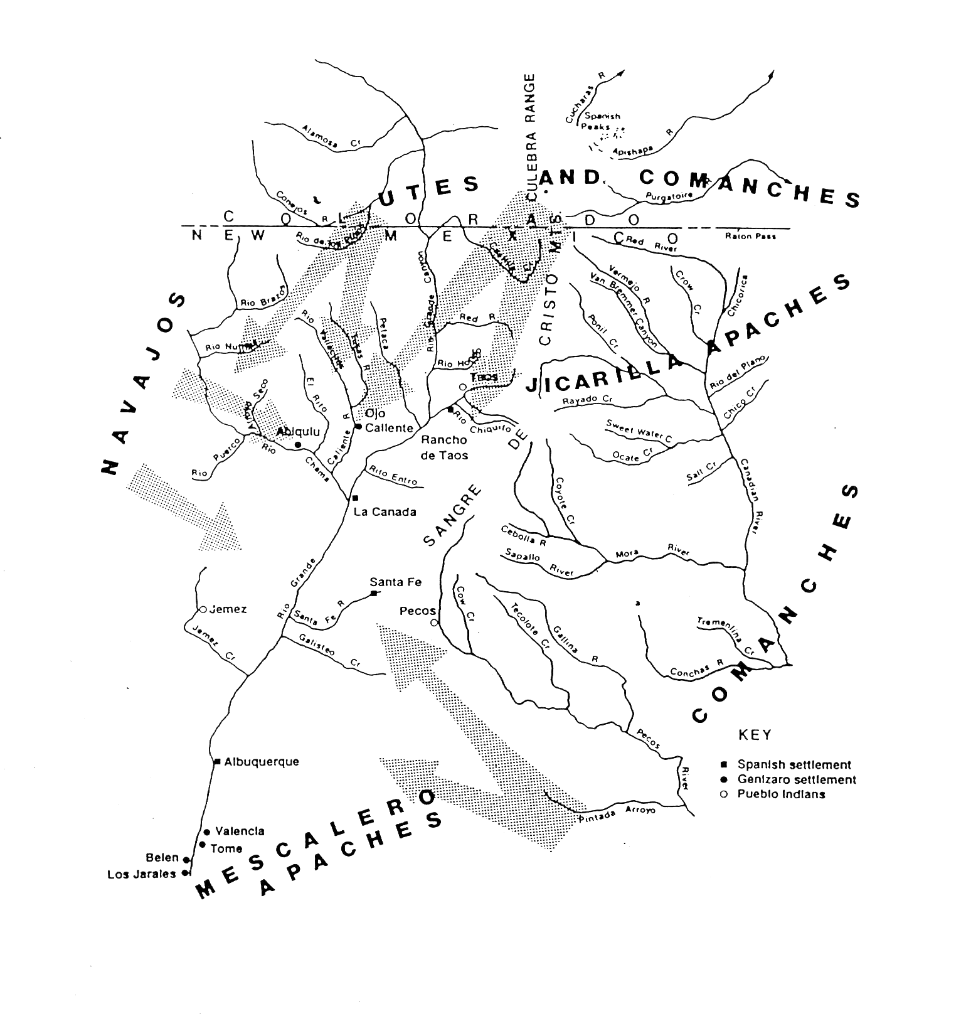

Fig. 1. Genizaro Settlements prior to Comanche peace of 1786.
(Data from Chavez 1979: 199–200; Dozier 1970: 85)

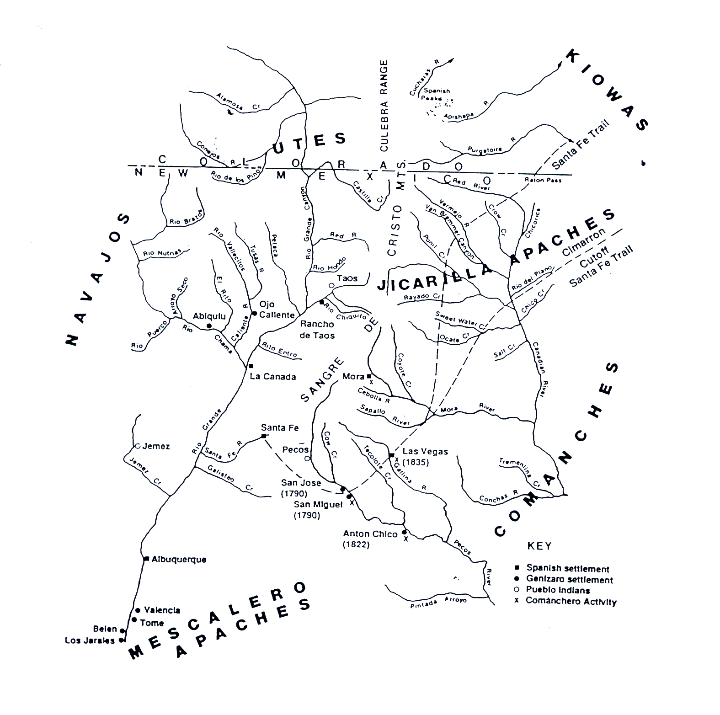

Fig. 2. Genizaro Settlements subsequent to Comanche peace of 1786

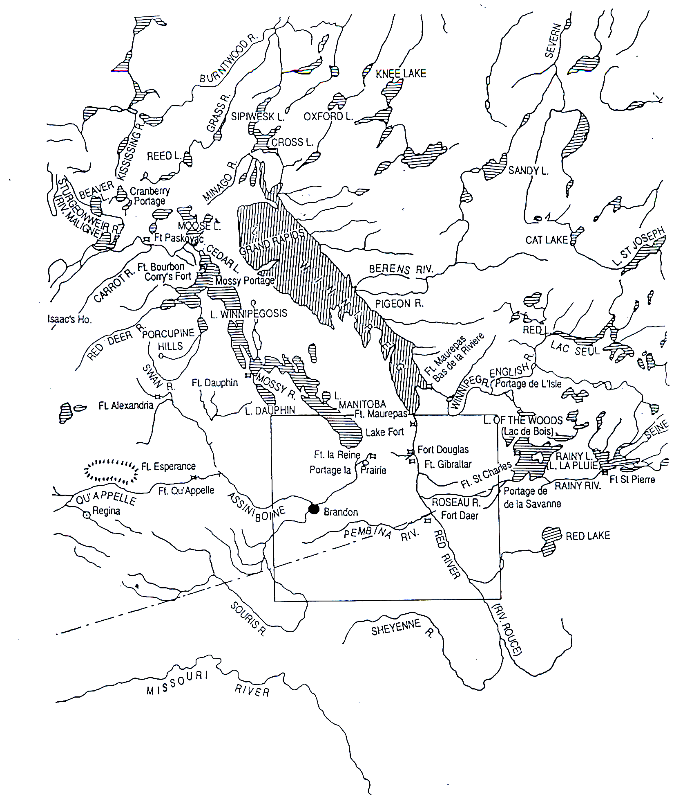

Fig. 3. Area of Red River Metis, HBC and Northwest Company
Activity. Fort Douglas was built by HBC in 1814, adjacent to Fort
Gibraltal, a Northwest Company stronghold. (Data from Giraud 1986)

