Middlemen and Marcher States in Central Asia and East/West Empire Synchrony
Christopher Chase-Dunn, Thomas D. Hall, Richard Niemeyer, Alexis Alvarez, Hiroko Inoue, Kirk Lawrence, and Anders Carlson
Institute for Research on World-Systems
University of California-Riverside
Abstract
East, West, Central and South Asia originally formed somewhat separate cultural zones and networks of interaction among settlements and polities, but during the late Bronze and early Iron Ages these largely separate regional systems came into increasing interaction with one another. Central Asian nomadic steppe pastoralist polities and agricultural oasis settlements mediated the East/West and North/South interactions. Earlier research has discovered that the growth/decline phases of empires in East and West Asia became synchronous around 140 BCE and that this synchrony lasted until about 1800 CE. This paper develops the comparative world-systems perspective on Central Asia and examines the growth and decline of settlements, empires and steppe confederations in Central Asia to test the hypothesis that the East/West empire synchrony may have been caused by linkages that occurred with and across Central Asia¹.
Earlier research has demonstrated a curious East/West synchrony from 140 BCE to 1800 CE. When large empires were increasing in population size in the West Asia/Mediterranean region they were also growing in East Asia. And periods of slow growth or decline in the sizes of largest empires were also largely synchronous in time (Chase-Dunn, Manning, and Hall 2000)². Thus these regions, separated by 4000 miles of intervening territory, were dancing in time with one another for nearly 2000 years³. Empires in South Asia were beating time to a different drummer. Indeed empires did rise and fall in South Asia, as they do everywhere, but the rises and falls were not synchronous with those of East and West Asia (Chase-Dunn, Manning, and Hall 2000).
Scholars who study the rise of civilizations have long pointed to the importance of Central Asia as a corridor of communications and trade, and as a generator of steppe pastoralist confederations that raided and traded with sedentary agricultural states in the great river valleys of the East and West. Frederick Teggart (1939) pointed to important historical synchronies between the Han and Roman empires and contended that these had been caused by migrations and incursions of steppe peoples. Teggart's magnificent map of Eurasia depicts the locations where steppe incursions and border conflicts were affecting the great agrarian civilizations in the first century CE.
The focus of world historians has long been on the diffusion of religions and technologies across the Silk Roads since the Axial Age, and the admixture of cultures and ways of life that developed in Central Asia during the long period in which the Eastern and Western regions of large cities became more and more strongly linked (e.g., Bentley 1993; McNeill and McNeill 2003). Others have contended that Central Asian societies, especially steppe pastoralists, have played a crucial role in world history (Lattimore 1940; Christian 1994, 2000). Frank (1992) and Frank and Gills (1994) contend that interaction between East and West across Central Asia, and the action of Central Asian peoples themselves, linked East
and West into a single world-system as early as 2000 BCE.
Chase-Dunn and Hall (1997) developed a comparative world-systems theoretical framework that geographically bounds world-systems by means of human interaction networks that have different spatial extents – bulk goods networks, political/military networks, prestige goods networks and information networks (see also Chase-Dunn and Jorgenson 2003). Bulk goods networks (BGNs) tend to be fairly local affairs that are nested within larger interpolity systems in which polities make war and alliances with one another (political/military networks or PMNs). And these are typically nested within even larger networks in which prestige goods (PGNs) and information (INs) are exchanged.
Chase-Dunn and Hall also note the importance of core/
periphery relations in the processes of socio-cultural evolution, pointing out that semiperipheral societies often play a crucial role in the transformation of technologies and institutions. Core/periphery relations are interactions among societies with different levels of population density and power. Chase-Dunn and Hall apply the comparative world-systems approach to the waves of expansion of interaction networks that eventually led to the incorporation and merger of Afroeurasia and then the whole globe into a single integrated interaction system (Chase-Dunn and Hall 1997: ch. 8). In their view Central Asia was originally a set of small and largely independent world-systems that increasingly became integrated into larger and larger networks of human interaction.
We define Central Asia broadly as: the territory that lies between the eastern edge of the Caspian Sea (longitude E53) and the old Jade Gate near the city of Dun Huang near longitude E95, and that is north of latitude N37, (which is the northern edge of the Iranian Plateau, the northern part of Afghanistan and the mountains along the southern edge of the Tarim Basin). The northern boundary is the northern edge of the steppes as they transition into forest and tundra⁴.
So the Central Asia region we are studying includes deserts, mountains and grasslands (steppes). It is a harsh environment for human habitation and, as David Christian (1994) has observed, this characteristic has repeatedly stimulated Central Asians to invent extreme adaptations that have had important consequences for
the peoples of distant lands. Christian (1994, 2000) tells the Central Asia story since the Paleolithic using both archaeological and documentary evidence and with an emphasis on the continuing importance of the dramatic ecological and geographical dimensions. He notes that Paleolithic hunter-gatherers had to develop specialized methods of hunting large herd animals over very large nomadic circuits in order to live in the harsh environment of the Central Asian and Eastern European steppes. These were the ‘Paleoindian’ peoples who first migrated to the Americas. Their specialized subsistence focus on hunting large herds across huge territories led them to spread rather quickly across both North and South America and may have been an important factor in the extinction of many megafauna species in the New World. This zoological impoverishment may have acted to slow down the emergence of complex civilizations in the Americas because of a relative lack of animals that could be easily domesticated.
Christian also points out that large tribal confederations of steppe nomads may have emerged first from the eastern steppe, where rainfall is less and pastures are less reliable (Christian 2000: 198). If this is so it is analogous to the widely known process of conquering polities emerging from semiperipheral regions that are relatively ecologically marginal (see Kirch 1984 on a similar phenomenon in
the interchiefdom systems of the Pacific).
What is unusual about Central Asia is that instead of semiperipheral marcher states we find a recurrent pattern of peripheral marcher states. The semiperipheral marcher state phenomenon occurs when recently settled nomads settle down in newly founded cities, undergo class and state formation and then conquer older adjacent core societies to form core-wide empires (see Chase-Dunn and Hall 1997: ch. 5). This is the most frequent way in which large empires have emerged, though it is not always nomads that do it.
In Central Asia we find nomadic peripheral societies that undergo a special kind of state formation while remaining nomadic and then occasionally conquer agrarian civilizations. In world historical comparison this is unusual. Peripheral peoples are often nomadic raiders, but they usually settle down on the edge of an old core region and then undergo class formation and state formation (becoming semiperipheral) well before they conquer adjacent core states. The unusual thing about Central Asian nomadic states is that they did not usually develop an institutionalized elite and a class of commoners from whom food and other products of labor were appropriated. These nomadic states were rather pure cases of the tributary mode of accumulation in which the peasant and artisan classes of adjacent agrarian civilizations substituted for a domestic working class (Kradin 2002).
Thomas Barfield's (1989, 1991) model somewhat complicates the above discussion. In the history of the interaction between steppe nomad confederations and agrarian states in China the nomads oscillated between what Barfield calls the ‘outer frontier’ and the ‘inner frontier’ strategies. The outer frontier strategy was to raid border settlements and demand tribute payments against threats of future raiding and destruction. These raids were conducted with strict avoidance of occupying Chinese land, and with the expectation that cities and towns would be rebuilt. The leader of a steppe confederation used the booty from these raids to reward current followers and attract new recruits (Barfield 1989: 49ff.). The inner frontier strategy is a variant of what we have described above as the typical semiperipheral marcher sequence. The weaker party in a conflict among steppe khans would seek an alliance with
a local agrarian warlord in China, who was eager to use ‘barbarians against barbarians’ (Ibid.: 63ff.). The steppe leader used goods from the warlord to gain followers. Both grew strong together, but the steppe leader then usually either himself became a non-nomadic agrarian lord or went back to the outer frontier strategy.
Barfield argues that large steppe confederacies usually cycle synchronously with the rise and fall of large sedentary agrarian states. This is because the ability of a steppe khan to hold his coalition together is based on success in raiding and extracting tribute (because he uses the booty to reward confederates), and this strategy works best when there is a large and healthy agrarian state to extort. If a large steppe empire emerges during a ‘time of troubles’ in the agrarian core it is unable to extract large quantities of surplus and is likely to itself fall apart. Barfield contends that it was in the face of this situation that Chinggis Khan opted for moving both west and east, and ended up conquering China rather than only extracting tribute from it. In short, he overplayed the outer frontier strategy.
Fig. 1 shows the evidence for East/West empire synchrony that we find from the quantitative study of city and empire sizes based on the research of Rein Taagepera (1978a, 1978b, 1979, 1997). Fig. 2 does not include Central Asian empires such as the Hsiung-nu, the Huns and the Mongols. These are taken out in order to see if East/West synchrony still holds without including the Central Asian empires.
Many other scholars have posited the existence of synchronous waves of expansion, development, golden and dark ages, population growth and decline and etc. (Teggart 1939; Frank and Gills 1994). David Christian (1994: 182) summarizes this hypothesis as follows: ‘…the political history of Inner Eurasia shaped the rhythms not just of Inner Eurasia but of the entire Eurasian world-system’.
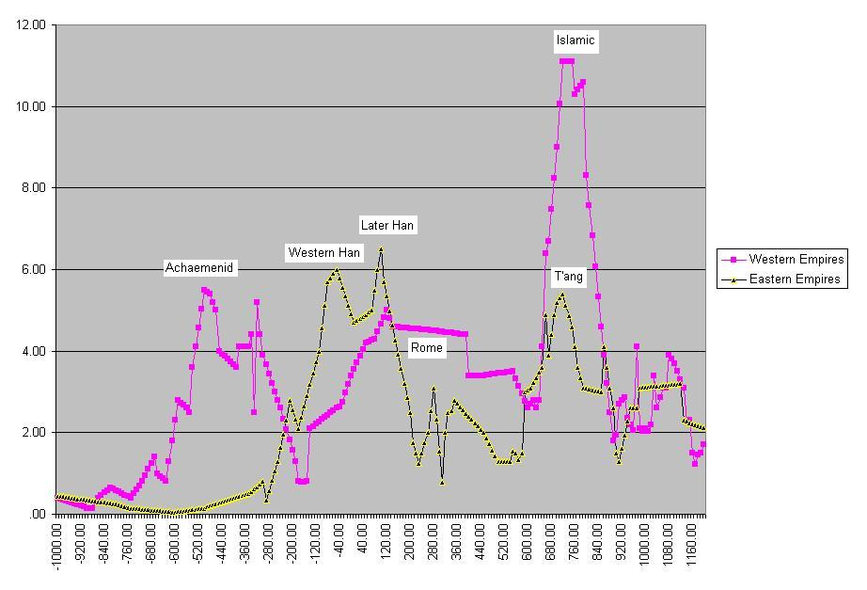
Fig. 1. Sizes of largest empires in East and West excluding Central Asian Empires, 1000 BCE – 1200 CE. Pearson's r = .46
As is evident in Fig. 1, the West has a whole large wave of empire rise and fall before this process starts in the East, but by 140 BCE the two regions fall into synchrony when the West recovers and joins the East in an upward sweep. The second synchronous wave starts up in the seventh century CE⁵. Earlier research has indicated that there is also an East-West synchrony in the growth/decline phases of largest cities, but this finding is now in doubt because it does not hold up with the revised city size estimates produced by Modelski (2003). An examination of cycles of total regional population also reveals East-West synchrony (see Chase-Dunn, Alvarez, and Pasciuti 2005: 324–325).
This paper mainly focuses upon a particular problem, the assessment of the several ways in which Central Asian peoples may have played a role in causing the synchrony of East/West empire growth/decline phases mentioned above.

Possible Explanations
Climate change might affect regions synchronously by causing growth and decline of agricultural productivity that in turn affects empires and populations. Perhaps because South Asia is nearer
the equator, its climate change history is different from that of East and West Asia and this might explain why its growth/decline pattern is different. The simplest thing would be to find ‘little ice ages’ or other large climate changes that correspond with the big changes in city and empire sizes. So far we have not found any indication that climate changes instigated or reinforced the synchronization of East/West growth/decline phases (Chase-Dunn
et al. 2006)⁶.
But climate change could also be involved in more complicated ways. Central Asian steppe nomads were very susceptible to climate change because their pastoral economy was greatly affected by changes in temperature and rainfall. It is possible that climate change in Central Asia affected the nomads, who then carried out incursions and military campaigns that affected the cities and agrarian empires of the East and West. Furthermore, even slight climate changes can have major effects on pastoral societies, especially in lambing season. A late frost can force a group to seek other sources of food, either through raiding or amalgamation (Cribb 1991).
The above hypotheses all conceive of climate change as an exogenous variable. But it is also likely that empire growth changes the local climate. Population growth, the building of large cities and the development of complex civilizations changes the environment because of deforestation, soil erosion and the construction of large irrigation systems and cities. These changes are likely to affect local rainfall and temperatures. Thus climate change may also be an endogenous variable.
Central Asian steppe nomads periodically formed large cavalries and attacked the agrarian empires of the East and the West (Barfield 1989). Famous examples are the Scythians, Sarmatians, Hsiung-nu, Huns and the Mongols. Perhaps there was a cycle of Central Asian migrations and incursions that impacted upon the agrarian civilizations of the East and the West and this accounts for the synchrony (Thompson 2005).
Epidemic diseases spread across Eurasia killing large numbers of people in cities, for example the Black Death (Bubonic Plague) of the 13th century (McNeill 1976; Abu-Lughod 1989). Perhaps earlier pandemics (e.g., the plague of Justinian, etc.) caused
the empire synchrony.
The Roman and Han empires were linked by long distance trade routes across the Silk Roads and by sea. Perhaps interruptions to trade, or periods of greater and easier trade flows, affected
the Eastern and Western civilizations simultaneously.
It is also possible that two systems that are cycling independently can become synchronized if they are both reset by simultaneous, but largely accidental, shocks. This is the so-called ‘Moran Effect’ known in population ecology. The Moran reset effect can cause long-term synchrony in processes that have a sine-wave form in which the duration of the waves is fairly constant. Most social cycles, including the growth/decline phases of cities and empires, have rather variable durations and so the Moran effect is unlikely to be the explanation of long-term synchronies like the one of interest here⁷. Fig. 2 depicts a propositional inventory that includes most of the possible causes of East/West empire synchrony.
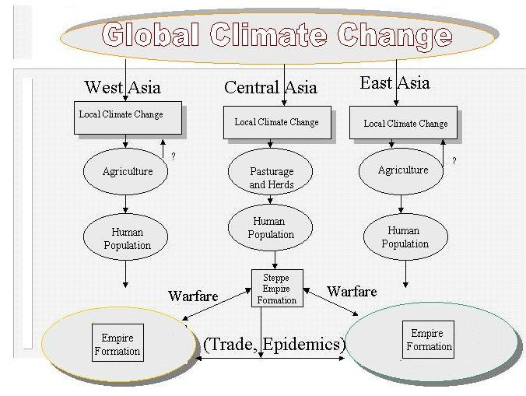
Fig. 2. An inventory of possible causes of East/West Empire
synchrony
David Christian describes, and then criticizes, the causal path that goes from Central Asian state formation, to trade intensification and then to the rise of large agrarian cities and empires of
the East and West. He says (2000: 6):
When agrarian civilizations or pastoralist empires dominated large sections of the Silk Roads, merchants traveled more freely, protection costs were lower, and traffic was brisk. One can quibble about the exact dating of these fluctuations, but roughly speaking favorable conditions held from about 100 BCE to about 1 BCE; in the second and third centuries, when the Kushan Empire flourished; in the era of the Tang and early Islam, in the seventh and eighth centuries; and in the era of the Mongol empire.
Christian's (2000) critique of this conventional historical description is that ecological exchanges were as important, or more important, than civilizational exchanges. Beckwith (1991) has documented the crucial role of steppe pastoralists in supplying horses to various Chinese dynasties. The rise of a large steppe confederation allowed the horse trade to flourish, brought more silk into the hands of pastoralists, and fueled the Silk Road trade.
The original basis of the Silk Roads was the local interaction between steppe pastoralist nomads and oasis farmers and settlement dwellers in Central Asia itself. Christian describes the early emergence of ‘transverse routes’ across which steppe nomads and oasis agriculturalists were exchanging bulk goods as well as some prestige goods. He says: ‘Thus the evidence shows that the transverse routes were not just tacked on to the arterial routes. They were older than the arterial routes, and were always integral to the functioning of the Silk Roads’ (Christian 2000: 9). Local bulk goods exchange networks among oasis farmers and steppe nomads within Central Asia came into existence before the emergence of long-distance prestige goods camel caravans. The long shift from semi-
sedentary horticulture and stock-raising to fully nomadic pastoralism was never complete. Di Cosmo (1994) shows that nomadic steppe pastoralists themselves sometimes planted temporary crops, and that farmers continued to live among them in certain areas of the steppe lands. The regional bulk goods transactions between pastoralists and farmers, especially the oasis farmers along the Silk Road routes, were expanded to become sources of supply for the caravansaries (inns and hostelries for caravans) once the long distance caravans got going.
In this paper we propose to further examine the possibilities that the East/West synchrony may have been caused by interaction mediated by Central Asia by studying the timing of the establishment and growth of settlements as indicated by reports of trade linkages and the formation of large empires in Central Asia.
The idea is that periods of growth and decline of settlements in Central Asia reflect intensifications of trade and communications that might have affected the agrarian citified empires of the East and the West. And the formation of Central Asia empires may also affect trade, or may directly affect East and West Asian empires by competing with them for territory or for control of trade routes and access to valuable raw materials.
There are other causes of the establishment, growth and decline of settlements besides increasing trade. Climate change, especially desertification, is thought to have greatly affected settlements in Central Asia, but in complicated ways. The shifting of river courses, drying up of oases, and changes in the amount of rainfall can have large effects on the sizes and the very existence of settlements in desert climes. And there is archaeological evidence that earthquakes greatly affected some settlements (Korjenkov et al. 2003). State formation also affects the sizes and growth rates of settlements. So settlement growth/decline phases in the Central Asian region may have been caused by factors other than changes in the intensity of trade. Nevertheless, if we find that growth/decline phases in the region as a whole, as opposed to the growth and decline of one or two individual settlements, does indeed temporally correspond with the growth/decline phases of Eastern and Western cities and empires, this will provide support for the idea that trade fluctuations were an important cause of East/West synchrony.
One way to improve the likelihood that changes in the number of settlements can be used as a proxy measure of changes in the intensity of trade is to limit our investigation to settlements that were located on or close to the various known trade routes that are known as the Silk Roads (see Fig. 3). But, as already mentioned, there were also maritime routes of East/West trade and historians have contended that the sea and land routes alternated with one another with respect to the volume of trade. If this is true a decline in the sizes of Silk Road settlements might not indicate a decline in overall East/West trade.
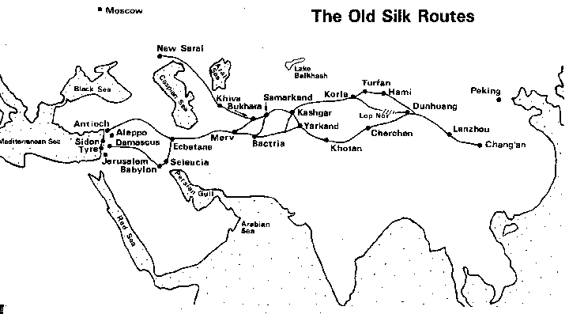
Fig. 3. Silk Road routes and settlements
Two of the three Silk Road routes skirted the north and south sides of the Taklamakan Desert in the Tarim Basin. The lack of extensive pasturage in the basin made it more difficult for pastoral nomads to raid oasis settlements, thus partially protecting the settlements from raids from the north (see Fig. 4).
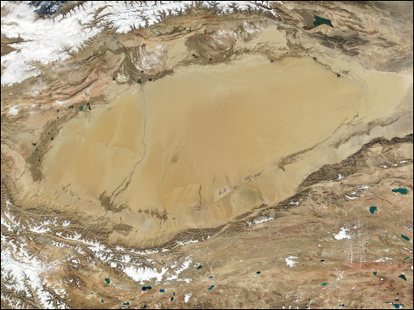
Fig. 4. The Tarim Basin and the Taklamakan Desert from
a satellite image
But these oases settlements in the Tarim Basin were vulnerable to changes in the availability of water and to storms. The city of Kashgar, at the west end of the Basin, is beset by dust storms from the prevailing easterly winds that blow sand and dust from the Taklamakan Desert on the average of 200 days per year. And Staffan Rosen (1999) reports that the route along the southern edge of
the Tarim Basin fell into disuse sometime before CE 642 when the region was visited by the famous Chinese Buddhist monk Xuan Zhuang on his search for the origins of Buddhism in India. Rosen writes:
The abandoning of this part of the Silk Road was most likely due to climatic and environmental changes. Unstable river-beds and the entailing draughts or floods would have destroyed the sensitive irrigation systems of the oasis cities, finally making the agricultural and stock-farming sectors of the economy of the area impossible to sustain (1999: 61–62).
Our earlier work on the growth of cities and empires focuses on mainly the largest settlements and polities and so we have little information about Central Asia in the standard data sets that we have used before (e.g., Chandler 1987 and Modelski 2003 for cities and Taagepera 1978–1997 for empires). The story of Central Asia is largely missed in these sources.
David Christian (1994) describes the Paleolithic emergence of big game hunting on the steppes, the emergence of first sedentary or short distance pastoralism using domesticated animals and then the emergence of long distance pastoralism on the steppes using large herds of horses. This is the story of radical adaptation to the environmentally challenging topography and climate of Central Asia. Christian contends that the ecological exchange between farmers and pastoralists has a deeper history in Central Asia than is known from the writings of observers from the agrarian civilizations. The domestication and riding of horses occurred first somewhere on the Eastern European or Central Asia steppes as early as the fourth or early third millennium BCE. Once people could ride horses, the labor productivity of herding radically increased. Larger herds could be moved over much larger territories. The formation of big nomadic polities may have occurred well before the historically known ones. And steppe pastoralists were probably the main early carriers of technologies, languages, shamanic practices, and diseases back and forth across Eurasia.
But oasis cities also emerged very early in the Bronze Age in the western part of Central Asia (Christian 1994; Hiebert 1994). We know most about the so-called Namazga or Margiana-Bactria Civilization of sedentary planters that emerged in the Bronze Age on the northern foothill slopes of the mountains bordering the Kumkarum Desert (Kohl 1981; Hiebert 1994). Population pressure led these early foothill states to expand out onto the desert floodplains of snow-fed rivers, clearing the oasis land of bushes and trees, digging large irrigation canals, and building large walled settlements in Margiana and Bactria (Hiebert 1994). The large square walled compounds were spaced out along the main irrigation canals of the oases with a lineage head in charge of each land-holding compound.
Fredrik Hiebert (Ibid.) surmises that the original oasis compounds were under the authority of the khan of the earlier and older foothill settlements for a period before they asserted their independence and proclaimed their own khan. These early oasis states in Bronze Age Central Asia developed a distinctive iconography and also contained elements that indicate contact with pastoral shamanism. And burials containing the artifacts of this culture are found in distant Bronze Age sites well to the south on the Harrapan Indus River, in southern Afghanistan and at Susa on the Susiana plain of ancient Iran. The Margiana-Bactria state did not import finished goods but rather imported raw materials that were then turned in to products by craftsmen in the home territories.
The presence of Margiana grave goods in distant different Bronze Age regions probably indicates the presence of trader-priests who were organizing the exchange of the desired raw materials for products from the Margiana-Bactria homeland. These agricultural settlements were composed of large walled compounds spread along the major irrigation canals in the oasis zones. Though there is no indication that they were engaged in regular East/West trading along the Silk Road, some silk has been found at one of the Bronze age sites from the early second millennium (Kohl 1981: xxi; Christian 2000: 13–14). Early interaction with China was probably mediated by down-the-line trade among steppe nomads. But this oasis mode of agriculture was to spread across the Silk Road, creating a chain of settlements, each with a ruling class that was originally composed of land owning lineage heads. As trade emerged and became more important, craft production for export was added to oasis agriculture and the landed rulers become engaged in trade and in information exchanges and religious activities that had important consequences for the emerging East/West ecumene.
William R. Thompson examines E. N. Chernykh's (1992) periodization of ‘migration crises’ (Thompson 2005: 22) as a framework for understanding the sequential nature of disruptions, migrations and incursions that occurred across Eurasia. Thompson concludes that with respect to the first millennium BCE Chernykh's periodization needs some modification, though the basic idea that there were important connections that linked the cyclical processes of social change across the world island is supported. Thompson concludes that the periods of systemic crises occurred from BCE 1250–1100, 850–650, and from 300–100 (2005: 43).
The story of states and empires across Eurasia from 400 BCE until 1600 CE is illustrated by Fig. 5.
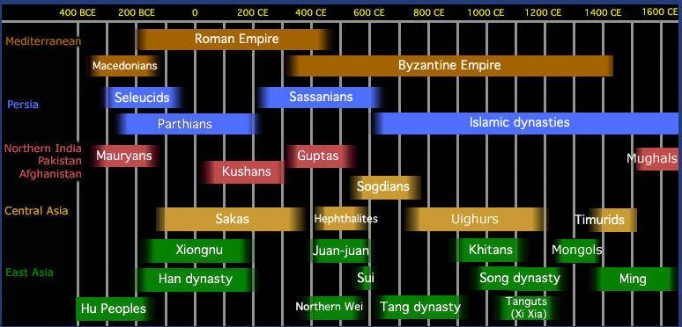
Fig. 5. Major states and empires in Eurasia from 400 BCE
to 1600 CE
Source: http://depts.washington.edu/silkroad/exhibit/timeline.html
Capitalist City-States in Central Asia
What are the implications of Central Asian historical change for understanding the evolution of modes of accumulation, especially capitalism? The ‘middle-men’ of the Silk Roads were in an interesting position. The city-states of Central Asia became specialized in trade and production of commodities for exchange and sometimes were under the control of a domestic class of merchant and production capitalists. They were comparable in this respect to another land-based semiperipheral capitalist city-state, Assur during the period of the Old Assyrian city-state and its colonies (Larsen 1976). The Old Assyrian merchants organized a wide carrying trade based on riverine and donkey caravan transportation that supplied tin and valuables to communities that were far away from the home city of Assur on the Tigris.
During the Bronze and Iron Age expansions of the tributary empires a new niche emerged for states that specialized in the carrying trade among the empires and adjacent regions. These semiperipheral capitalist city-states were usually ‘thalassocratic’ entities that used naval power to protect sea-going trade (e.g., the Phoenician city-states, Venice, Genoa, Malacca), but Assur on the Tigris, the ‘Old Assyrian city-state and its colonies’, was a land-based example of this phenomenon that relied mainly upon donkey caravans for transportation (Larsen 1976). The old Assyrian merchants established quarters (colonies) in the towns and cities whose trade they carried. The semiperipheral capitalist city-states did not typically conquer other states to construct large empires, but their trading and production activities promoted regional commerce and the emergence of markets within and between the tributary states.
The expansion of trading and communications networks facilitated the growth of empires and vice versa. The emergence of agriculture, mining and manufacturing production of surpluses for trade gave conquerors an incentive to expand state control into distant areas. And the apparatus of the empire was itself often a boon to trade. The specialized trading states promoted the production of trade surpluses, bringing peoples into commerce over wide regions, and thus they helped to create the conditions for the emergence of larger empires.
Sabloff and Rathje (1975) contend that the same settlement can oscillate back and forth between being a ‘port of trade’ (neutral territory that is used for administered trade between different competing states and empires – see Polanyi et al. 1957) and a ‘trading port’ (an autonomous and sovereign polity that actively pursues policies that facilitate profitable trade). This latter corresponds to what Chase-Dunn and Hall (1997) mean by a semiperipheral capitalist city-state. Sabloff and Rathje also contend that a trading port is more likely to emerge during a period in which other states within the same region are weak, whereas a port of trade is more likely during a period in which there are large strong states.
Ports of trade may be most likely to emerge in buffer zones or ‘no man's lands’ in between the territories of strong polities. The function of buffer zones is to reduce the likelihood of conflict, but these regions also present an opportunity for peaceful exchange, and so they may develop into ports of trade.
The interaction of capitalist city-states in Central Asia with pure tributary states of the steppes may have produced interesting and unique institutional forms. Some of the groups, such as the Soghdians, became trade diasporas, handling the carrying trade for the cities of emergent territorial states in Central Asia (Curtin 1984). The religious entrepreneurialism and cosmopolitan attitude toward different religions that was evident in Central Asia may have been partly a reflection of this intense combination of accumulation by means of commodity production and exchange and accumulation by means of pure tribute taking. Some groups such as the Türks and Oighurs transformed there economic roles radically to take advantage of opportunities presented by social change in Central Asia. The Türks were originally a mining and metal-working caste of mountain and forest people within the Juan-Juan steppe nomad empire who rebelled and established their own huge steppe states (Sinor and Klyashtorny 1996). Later the Oighurs shifted to become urban trading people in the oasis cities of
the Silk Roads.
Trade Growth and East/West Empire
Synchrony
It was our original goal to assemble a data set on settlement and empire sizes for Central Asia that would enable us to see if the city and empire growth decline phases there were synchronous with the growth/decline phases we found in the East and West shown in Fig. 1 above. We have succeeded in finding a few estimates, but completion of this task would take far longer than the time we have available. What we have been able to do instead is to use a data set that has been collected on Central Asian trade routes from 200 BCE
to 1200 CE (Ciolek 1999) to construct indicators of the number of new settlements known to have been connected to trade routes and the cumulative number of trade links over this period of time.
Figs 6–12 are GIS maps that show the locations of Central Asian settlements from 200 BCE to 1200 CE.
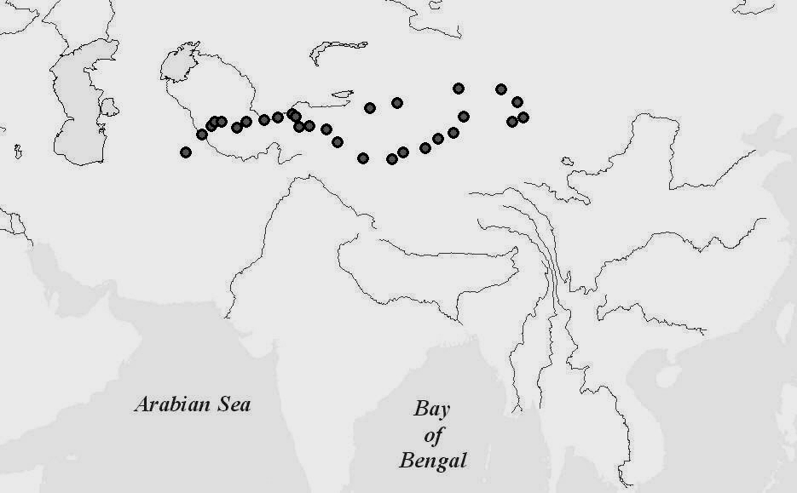
Fig. 6. Silk Road cities, 200 BCE
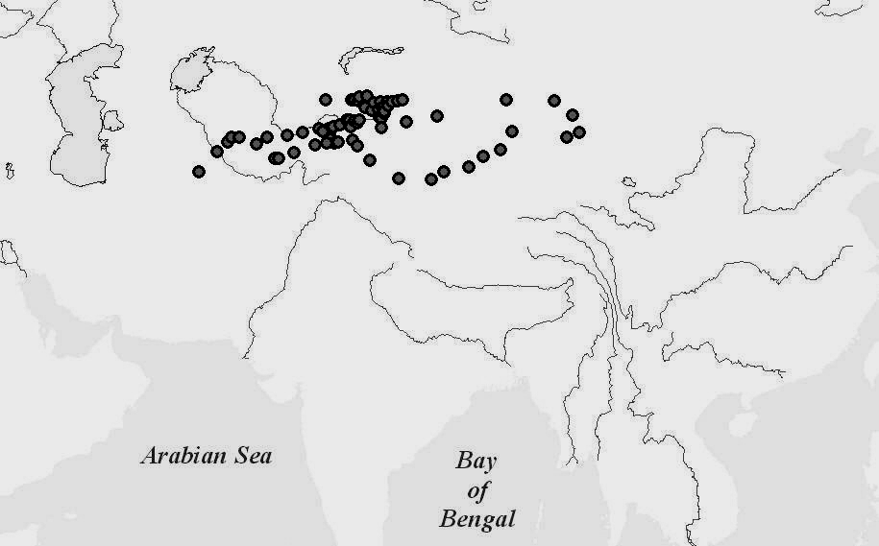
Fig. 7. Silk Road cities, 100 BCE (the new color represents
the cities added at this time)
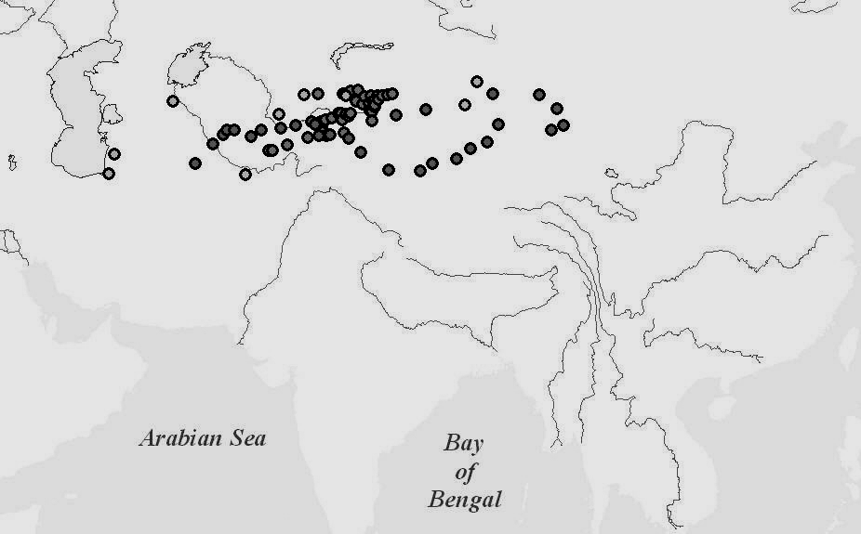

Fig. 8. Silk Road cities, 1 CE (the new color represents
the cities added at this time)

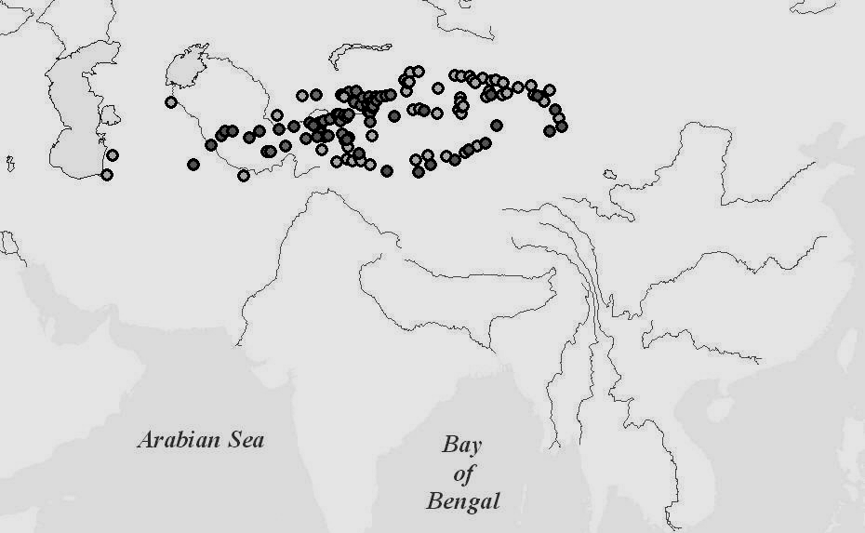
Fig. 9. Silk Road cities, 100 CE (the new color represents the cities added at this time)

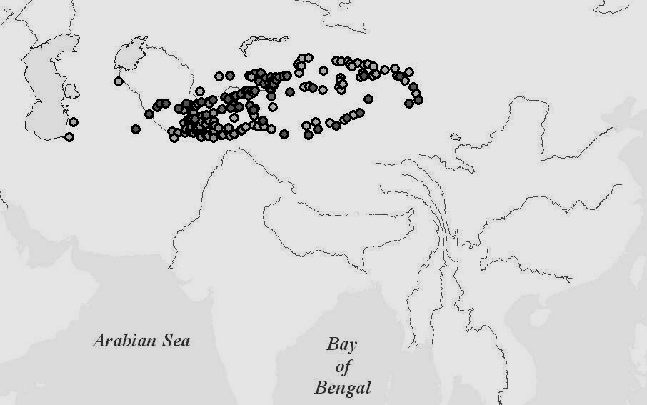
Fig. 10. Silk Road cities, 400 CE (the new color represents
the cities added at this time)

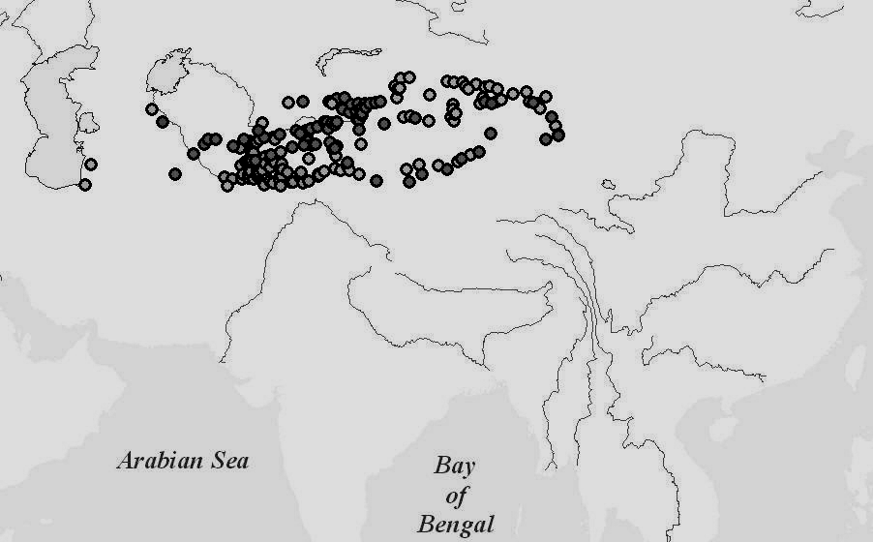
Fig. 11. Silk Road Cities, 700 CE (the new color represents
the cities added at this time)

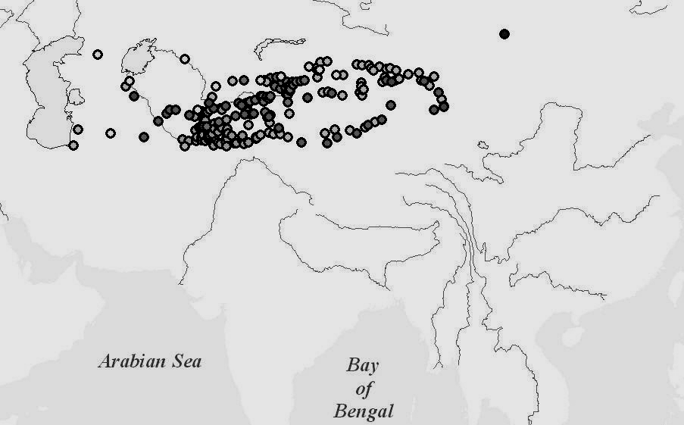
Fig. 12. Silk Road cities, 1200 CE (the new color represents
the cities added at this time)
Fig. 13 shows three counts that are proxy indicators for the amount and growth of trade across the Silk Roads.
Fig. 13. Cities added, cumulative number of cities and cumulative number of links (edges) in Central Asia trade routes, 200 BCE – 1200 CE
Fig. 13 shows that trade volume, as indicated by the number of known settlements in Central Asia that are connected to trade routes, increased from 200 BCE to 1200 CE, but at a changing rate. Fig. 13 shows that the cumulative number of cities that were connected doubles from 200 BCE to 100 BCE and then increased only slightly from 100 BCE to 1 CE. Then the number of known cities connected to trade routes again grew rapidly between 1 CE and 100 CE. Unfortunately the temporal resolution of the trade route data is very crude after 100 CE (two 300 year gaps and one 500 year gap).
There was another big increase from 100 CE to 400 CE, and after that the growth was slow. This could have been due to either
a leveling off of the growth of trade or to the saturation of Central Asia with settlements that were serving as trade stations. But the number of settlements did continue to grow during the later time intervals, though not at the same rate as during the earlier period. There may have been fluctuations that are hidden by the poor temporal resolution of the trade route data after 100 CE. Also settlements may have become smaller and less prosperous without completely disappearing, so these indicators are not ideal measures of the volume of trade. The number of cities added at each time point from Fig. 13 is also graphed in Fig. 14 in a way that makes it easier to see the fluctuations in the rate of growth over time.
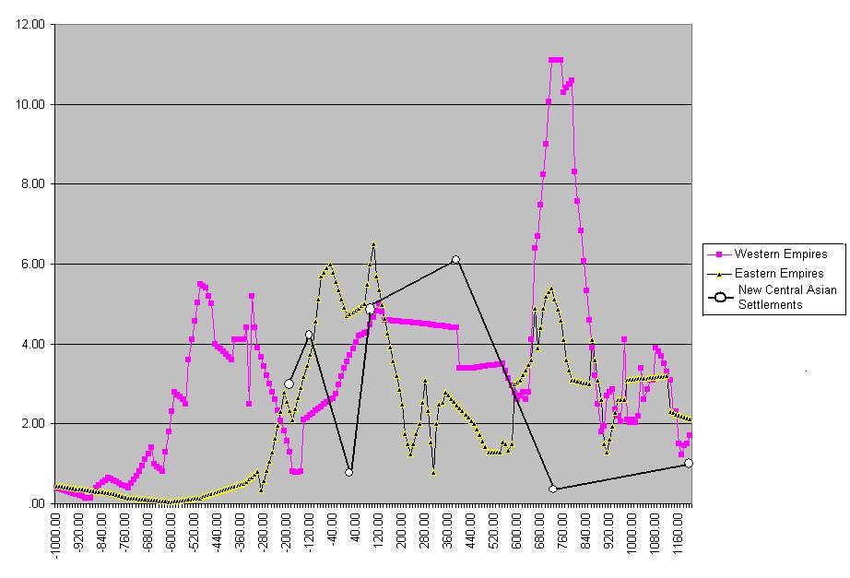
Fig. 14. Western and Eastern largest empires and Central Asia new settlements 1000 BCE-1200 CE. Central-Western Pearson's r = -.29; Central-Eastern Pearson's r = -.03
Fig. 14 shows the rise and fall of empires in the East and
the West (as in Fig. 1 above) and adds rescaled values of new Central Asian cities that were added to trade routes (e.g., 2.9=29; 4.2=42, etc.). Again, the rough temporal resolution of our data on Central Asian settlements makes it hard to see what is going on, but there does not appear to be a positive relationship between the establishment of new Central Asian cities and the rise of fall of Western and Eastern empires. The Pearson's r correlation coefficients, based on seven time points, are zero and somewhat negative.
A different way to approach the quantitative study of the effects of Central Asia on East/West synchrony is to examine the size of the largest empires that come out of Central Asia itself.
Fig. 15 shows these relationships from 230 BCE – the earliest date that we have an estimate of the territorial size of a Central Asian empire – to 1500 CE.
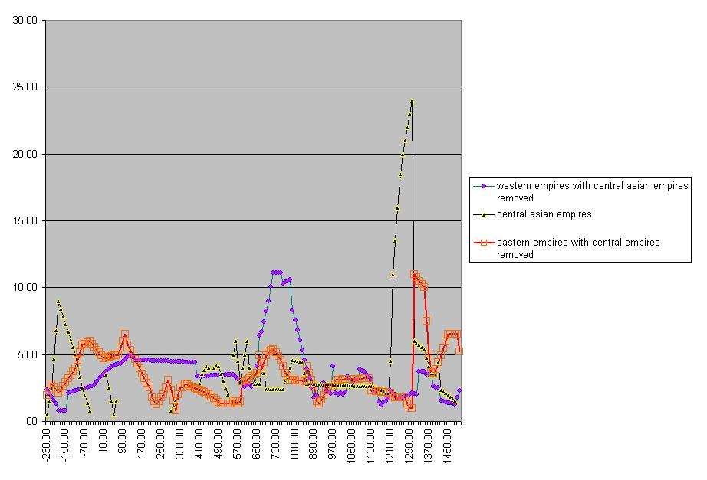
Fig. 15. East, West and Central Asia Empires, 230 BCE to 1500 CE
The Eastern and Western empires in Fig. 15 are the same ones that are include in Figs 1 and 14 above. The Central Asian empires include the Mongol Empire with 24 square megameters of territory in 1300 CE, one of the largest polities that has ever existed. A notable feature of Fig. 15 is that all the largest empires in terms of territory were the result of conquests by nomadic pastoralists (Huns, Mongols) or those who had recently been nomadic pastoralists (Islamic Arabs).
Visual examination of Fig. 15 does not reveal an obvious correspondence in the timing of the rise and fall of Central Asian empires with the empires of the East and the West. Indeed, the Pearsons r correlation coefficients are -.21 between West and Central and -.22 between East and Central.
But what is the relationship between Central Asian empires and the establishment of new settlements in Central Asia? New settlements may be established during periods in which broad areas are under the control of a single state, although it may depend on which kind of state. Steppe nomads have been known to have a rather negative attitude toward irrigation systems and cities. Fig. 16 shows the sizes of the largest Central Asian empires and the number of new settlements that are connected to trade routes.
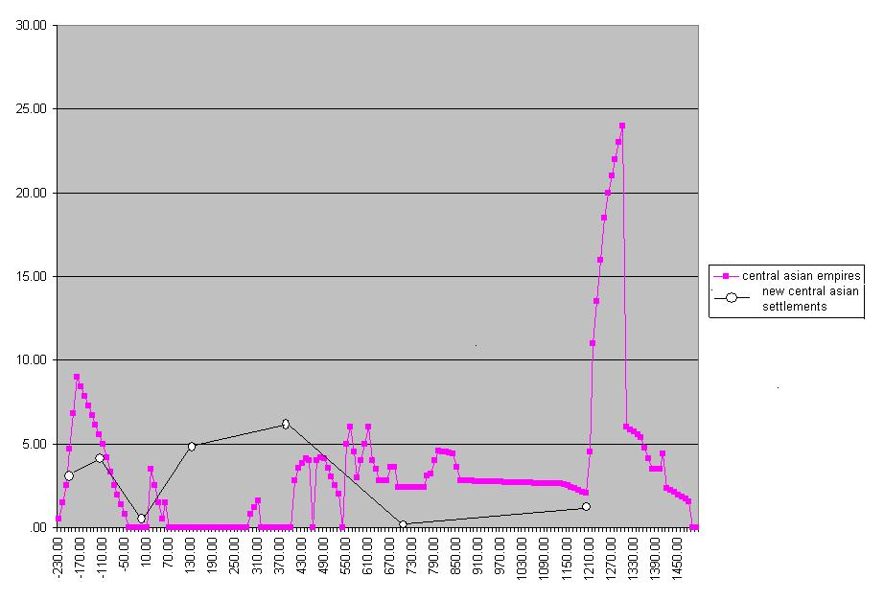
Fig. 16. Central Asian Empires and the number of new settlements in Central Asia that are connected with trade routes,
230 BCE to 1500 CE
Thus the two quantitative indicators that we have devised to indicate how Central Asia may have influenced East and West are themselves not highly correlated. The Pearson's r correlation coefficient based on seven time points is .38.
Conclusions
This reexamination of Central Asia suggests that it was much more than just a conduit of interaction between the great agrarian civilizations of East and West. Extreme climatic and geographical conditions repeatedly inspired Central Asian peoples to develop modes of subsistence and institutional structures that had huge consequences for world history.
We do not yet have a firm answer as to which of the possible explanations for East/West empire synchrony is most likely to have been the main culprit. Narratives of waves of migration and incursions such as provided by Thompson (2005) correspond fairly well with the growth/decline phases of East and West empires. But the only quantitative indicators we have been able to find for Central Asia so far – those based on trade routes and empire sizes – suffer from flaws that make it difficult to affirm or deny the role of trade fluctuations and state formation.
New sources of data continue to appear and so we are hopeful that we will be able to rule out some explanations and find support for others. In order to test the explanations for East/West empire synchrony we need quantitative data with good temporal resolution over the relevant time period and in the relevant regions for settlement and empire sizes, climate change, epidemic diseases, migrations, trade, and warfare. The trade route data are useful in providing lists of Central Asian settlements to be studied. Our future work will focus on the largest of these and will assemble more and better estimates of settlement sizes and the territorial sizes of the largest Central Asian states and empires. We will also revisit the question of East/West city size synchrony once new progress has been made in estimating the sizes of the largest cities in
the Bronze and Iron ages.

NOTES
An earlier version is available as IROWS Working Paper #30 at http://www.irows.ucr.edu/papers/irows30/irows30.htm. This paper is part of
a larger research project on ‘Measuring and modeling cycles of state formation, decline and upward sweeps since the Bronze Age’ NSF-SES 057720 http://www.irows.ucr.edu/ research/citemp/citemp.html
2 Chase-Dunn and Manning (2002) also reported an East/West synchrony in the growth/decline phases of large cities based on data from Chandler (1987). An analysis based on Modelski's (2003) more recently assembled estimates of the sizes of large cities does not confirm East/West city size synchrony.
³ The East/West empire synchrony holds up when Central Asian empires that linked both regions are taken out of the analysis. There is one glaring exception to East-West synchrony when the Ming Empire rises but the largest empire in the West is declining in territorial size. But the synchrony resumes after that period.
⁴ Of course the steppes extend further west to the area north of the Black Sea and beyond.
⁵ Fig. 1 ends at 1200 CE because this is the end of our data on Central Asian settlements discussed below.
⁶ The current explosion in research and writing about the effects of climate on civilization was presaged during the late 19th and early 20th century Central Asia age of rediscovery by the intrepid desert explorer Ellsworth Huntington (1922).
⁷ We have discussed this possibility in greater detail in Chase-Dunn, Alvarez and Pasciuti (2005).

References
Abu-Lughod, J. L.
1989. Before European Hegemony: The World System A.D. 1250–1350. New York: Oxford University Press.
Barfield, T. J.
1989. The Perilous Frontier: Nomadic Empires and China. Cambridge, MA.: Blackwell.
1991. Inner Asia and Cycles of Power in China's Imperial Dynastic History. In Seaman, G., and Markes, D. (eds.), Rulers from the Steppe: State Formation on the Eurasian Periphery. Los Angeles, CA: Ethnographic Press. Center for Visual Anthropology, University of Southern California.
Beckwith, Ch. I.
1991. The Impact of the Horse and Silk Trade on the Economies of T'ang China and the Uighur Empire. Journal of the Economic and Social History of the Orient 34(2): 183–198.
Bentley, J. H.
1993. Old World Encounters: Cross-Cultural Contacts and Exchanges in Pre-Modern Times. Oxford: Oxford University Press.
Chandler, T.
1987. Four Thousand Years of Urban Growth. Lewiston, NY: Edwin Mellen Press.
Chase-Dunn, C., Alvarez, A., and Pasciuti, D.
2005. World-Systems in the Biogeosphere: Three Thousand Years of Urbanization, Empire Formation and Climate Change. In Ciccantell, P. S., Smith, D. A., and Seidman, G. (eds.), Nature, Raw Materials and Political Economy (pp. 311–332). Research in Rural Sociology and Development. Vol. 10. London: Elsevier.
Chase-Dunn, C., Alvarez, A., Inoue, H., Niemeyer, R. Carlson, A., Fierro, B., and Lawrence, K.
2006. Upward Sweeps of City and Empire Growth since the Bronze Age. A Paper Presented at the Annual Meetings of the American Sociological Association, Montreal, Friday, August 11. IROWS Working Paper #22. Available at: http://www.irows.ucr.edu/papers/irows22/irows22.htm
Chase-Dunn, C., and Hall, T. D.
1997. Rise and Demise: Comparing World-Systems. Boulder, CO: Westview.
Chase-Dunn, C., and Jorgenson, A. K.
2003. Interaction Networks and Structural Globalization: A Comparative World-Systems Perspective. Society in Transition 34(2): 206–220. Available at: http://www.irows.ucr.edu/papers/irows13/irows13.htm
Chase-Dunn, C., and Manning, S. E.
2002. City Systems and World-Systems: Four Millennia of City Growth and Decline. Cross-Cultural Research 36(4): 379–398. Available at: http://www.irows.ucr.edu/research/citemp/ccr02/ccr02.htm
Chase-Dunn, C., Manning, S. E., and Hall, T. D.
2000. Rise and Fall: East-West Synchrony and Indic Exceptionalism Reexamined. Social Science History 24(4): 727–754. Available at: http://www.wsarch.ucr.edu/archive/papers/c-d&hall/isa98/isa98.htm
Chase-Dunn, C., Pasciuti, D., Alvarez, A., and Hall, T. D.
2006. Waves of Globalization and Semiperipheral Development in the Ancient Mesopotamian and Egyptian World-Systems. In Gills, B., and Thompson, W. R. (eds.), Globalization and Global History (pp. 114–138). London: Routledge.
Chase-Dunn, C., Niemeyer, R., Alvarez, A., Inoue, H., Lawrence, K., and Carlson, A.
2006. When North-South Relations Were East-West: Urban and Empire Synchrony (500 BCE–1500 CE). Presented at the 2006 Conference of the International Studies Association, San Diego, March, 23, 3: 45–55. 30 Panel: The Historical Long-Term. IROWS Working Paper #16. Available at: http://www.irows.ucr.edu/papers/irows16/irows16.htm
Chernykh, E. N.
1992. Ancient Metallurgy in the USSR: The Early Metal Age. Cambridge: Cambridge University Press.
Christian, D.
1994. Inner Eurasia as a Unit of World History. Journal of World History 5(2): 173–211.
2000. Silk Roads or Steppe Roads? The Silk Roads in World History. Journal of World History 11(1): 1–26.
Ciolek, T. M. (ed.)
1999 – Present. Georeferenced Historical Transport/Travel/Commu-nication – Asia & the Middle East. OWTRAD Dromographic Digital Data Archives (ODDDA). Old World Trade Routes (OWTRAD) Project. Canberra. Available at: http://www.ciolek.com/OWTRAD/DATA/oddda.html
Cribb, R.
1991. Nomads in Archaeology. Cambridge: Cambridge University Press.
Curtin, Ph.
1984. Cross-Cultural Trade in World History. Cambridge: Cambridge University Press.
Di Cosmo, N.
1994. Ancient Inner Asian Nomads: Their Economic Basis and its Significance in Chinese History. The Journal of Asian Studies 53(4): 1092–1126.
Frank, A. G.
1992. The Centrality of Central Asia. Comparative Asian Studies
No 8. Amsterdam: VU University Press for Center for Asian Studies Amsterdam (CASA).
Frank, A. G., and Gills, B.
1994. The World System: 500 or 5000 Years? London: Routledge.
Hiebert, F. T.
1994. Origins of the Bronze Age Civilization in Central Asia. Cambridge, MA: Peabody Museum of Archaeology and Ethnology, Harvard University.
Huntington, E.
1922. Civilization and Climate. New Haven: Yale University Press.
Kirch, P. V.
1984. The Evolution of Polynesian Chiefdoms. Cambridge: Cambridge University Press.
Kohl, Ph. L. (ed.)
1981. The Bronze Age Civilizations of Central Asia: Recent Soviet Discoveries. Armonk, N.Y.: M.E. Sharpe.
Korjenkov, A., Baipakov, K., Change, C., Peshkov, Yu., and Savelieva, T.
2003. Traces of Ancient Earthquakes in Medieval Cities along
the Silk Road, Northern Tien Shan and Dzhungaria. Turkish Journal of Earth Sciences 12: 241–261.
Kradin, N. N.
2002. Nomadism, Evolution and World-Systems: Pastoral Societies in Theories of Historical Development. Journal of World-Systems Research 8(3): 368–388.
Larsen, M. T.
1976. The Old Assyrian City State and Its Colonies. Copenhagen: Akademisk Forlag.
Lattimore, O.
1940. Inner Asian Frontiers of China. New York: American Geographical Society.
McNeill, W. H.
1976. Plagues and People. Garden City, NJ: Anchor Books.
McNeill, J. R., and McNeill, W. H.
2003. The Human Web. New York: Norton.
Modelski, G.
2003. World Cities: –3000 to 2000. Washington, DC: Faros 2000.
Modelski's ‘Evolutionary World Politics’. Available at: http://www. faculty.washington.edu/modelski/worldcities.html
Polanyi, K., Arensberg, C. M., and Pearson, H. W. (eds.)
1957. Trade and Market in the Early Empires. Chicago: Regnery.
Rosen, S.
1999. The Sino-Swedish Expedition to Yar-Tonguz in 1994. In Juntunen, M., and Schlyter, B. N. (eds.), Return to the Silk Routes: Current Scandinavian Research in Central Asia (pp. 59–72). London: Kegan Paul.
Sabloff, J., and Rathje, W. J.
1975. A Study of Changing Pre-Columbian Commercial Systems. Cambridge: Peabody Museum of Archaeology and Ethnology. Harvard University.
Sinor, D., and Klyashtorny, S. G.
1996. The Turk Empire. In Litvinsky, B. A., Guang-da, Zh., and Samghabadi, R. S. (eds.), History of Civilizations of Central Asia. Vol. 3. The Crossroads of Civilizations: A.D. 250 to 750 (pp. 327–348). Paris: Unesco.
Taagepera, R.
1978a. Size and Duration of Empires: Systematics of Size. Social Science Research 7: 108–127.
1978b. Size and Duration of Empires: Growth-Decline Curves, 3000 to 600 B.C. Social Science Research 7: 180–196.
1979. Size and Duration of Empires: Growth-Decline Curves, 600 B.C. to 600 A.D. Social Science History 3(3–4): 115–138.
1997. Expansion and Contraction Patterns of Large Polities: Context for Russia. International Studies Quarterly 41(3): 475–504.
Teggart, F. J.
1939. Rome and China: A Study of Correlations in Historical Events. Berkeley: University of California Press.
Thompson, W. R.
2005. Eurasian C-Wave Crises in the First Millennium B.C. In Chase-Dunn, C., and Anderson, E. N. (eds.), The Historical Evolution of World-Systems (pp. 20–51). New York: Palgrave.

