A Preliminary Look at Big History Today
Daniel J. Stasko
Barry H. Rodrigue
University of Southern Maine
Abstract
The inclusion of macro-studies in the world's educational systems is of great importance for resolving some of the most serious problems that human beings face today. One such pedagogical model is the rapidly growing discipline of Big History. This paper describes the status of the Big History courses, their instructors and their students around the world today. It also serves as a call for academics to engage in a process of ‘Global Enlightenment’.
Introduction
Educational systems have largely focused on Homo sapiens as their central topic of research and instruction since the beginnings of the universe a millennium ago. In addition to homo-centric studies such as philosophy and history, even non-species specific disciplines like chemistry or geology are taught with an orientation towards human existence. Such a focus is not unusual; chimpanzees and iguanas also focus on their own kind. What is perhaps more remarkable is that members of Homo sapiens have exhibited any interest in something outside of their own species!
As a result of human-centered education, we have a knowledge-base that has used biology to develop genetically engineered corn for a myriad of food products and physics to develop transportation systems with which to better move about the planet. In the last century, such human-centered applications have increasingly moved education into the midst of the market economy. Indeed, universities are often viewed today as a training ground and extension of the market, whether in the guise of state capitalism or corporate capitalism.
However, we have reached a point where Earth cannot support the standard of living expected by middle and upper class humans without drastic side-effects, which range from climate change to famine and from fresh water shortages to genetic damage. Unless something of significance is done in the next decade, even more catastrophic impact on our planet's biomes and life-forms will take place. While this set of problems has come to be almost universally accepted over the last decade, the disagreement about the degrees of impact and remedies continues.
As was vividly illustrated at the recent climate change conference in Copenhagen in December 2009, this divergence of opinion about global damage is exacerbated by political and economic competition between nation-states, corporations, ethnicities, social classes and other human groups. Unfortunately, the human-centered core of university education tends to exacerbate this situation. The narrow focus of classroom discussion on ourselves, our role, our history and our impact translates into an ideology that we are OK, but that other groups of humans are not – as opposed to a globally shared human responsibility.
This pedagogical conundrum came about as a result of geo-political history. By the start of the 20th century, education had developed a nationalist focus, reflecting the growth of the modern nation-state and its colonial offshoots. In the United States, this nationalism manifested itself in courses on American History and Western Civilization. After World War II, courses in Global Studies came to be increasingly offered in universities. Although such global courses sought to understand and avoid the situations that had resulted in two devastating world wars, they also served to justify and consolidate national positions on respective sides of the Cold War (1945–1991). Therefore, courses in Global Studies tended to develop a hierarchical structure that focused on power-relationships in geographic regions and economic markets. It was an ‘us’ versus ‘them’ approach, a form of political Darwinism.¹
Although much of this Cold War polarization has continued under the guise of the ‘War on Terror’, there has also been a movement towards a more humanistic and ecological globalism, which many distinguish as ‘mondalization’. Moving past nationalist style and geographic identity, professors are offering new courses that use the entire globe as their basic reference point, rather than a particular nation-state. As a part of this movement, a new academic subject emerged in the 1970s and 1980s – Big History.
Big History
Begun as a merger of natural sciences and social sciences with existential questions from the humanities, Big History was initially taught as a single course.² In its most basic form, it serves as a survey of all existence, from our origins in the Big Bang (or the Multiverse) to the present, with students getting exposure to ideas of quantum mechanics, plate tectonics, evolutionary biology and social development in a single semester or academic year. The condensation of all this material into one unified course is intentional, as it forces students to develop a holistic view of their existence and the existence of the universe at the same time – all based on the latest science and scholarship. One way of thinking about Big History is that it attempts to look at the big picture, the biggest picture, and orients the student in a way that shows how much they, as citizens of the universe, share in and are responsible for it: Big History is not theirs to own, but they can play a part in shaping the future.
Our belief is that the large-scale, global view of Big History can provide a frame of reference for leaders, educators and students with respect to the continually shrinking world in which we live. For instance, the intersection of geology, climate change, corporate globalization and political ideology has led to the need for low-cost, efficient arsenic removal methods to combat water quality threats in India and Bangladesh (Harvey et al. 2002). The naturally high levels of arsenic in the ground water make wells unsafe, leading to one of the most extensive, persistent mass poisonings in history. No one concept or field alone can fully address the issue, but together, a multidisciplinary approach can lead to insight and solutions (Smith, Lingas and Rahman 2000), and Big History is one way to introduce and/or foster this type of discussion.
Over the last 20 years, the teaching of Big History has developed and expanded. Three major texts have been issued since 1995 and the journal, Social Evolution & History, devoted an entire edition to the subject in 2005 (Spier 1996, 2005, 2010; Christian 2004). After the meeting of the Russian Academy of Sciences' Fifth International Conference on Hierarchy and Power in the History of Civilization in the summer of 2009, where several Big Historians presented papers, it became apparent that we needed get
a better handle on what was happening with Big History around the world today.³ So the authors assembled a directory of Big History instructors and their courses, which was recently published (Rodrigue and Stasko 2009). The results were somewhat unexpected and surprising: in short, Big History is a lot more active than had been assumed.
Today, there are roughly 30 professors teaching Big History at 35 different institutions around the world (Figs 1a and 1b). While many of these courses are based in English-speaking nations (notably Australia and the United States), they are also being taught in the Netherlands, Russia, South Korea, India and Egypt. The content and audience of Big History has likewise grown in new directions. In some universities, Big History remains part of the astronomy or history curriculum, while in others it has been oriented towards teacher education. At some locations, it is presented as
a public lecture series that includes optional academic credit. There are even efforts to establish it in elementary school education (Rodrigue 2009, 2010; Rodrigue and Stasko 2009).
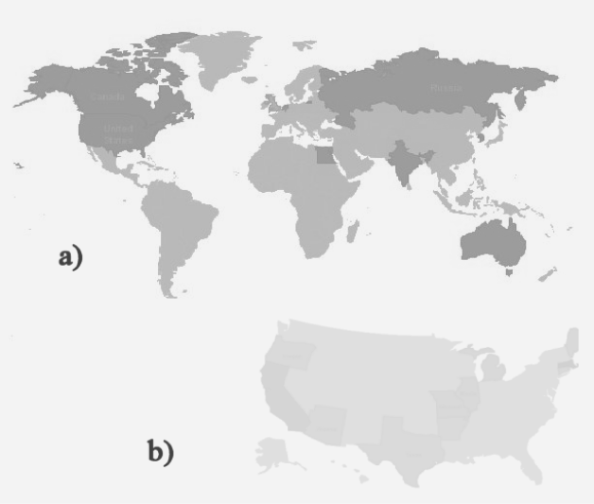
Fig. 1. a) Location of Big History instructors worldwide; b) Distribution in the US

As a result of this academic evolution over the last twenty years, the original focus on the natural and social sciences has expanded to include new content. For example, in our course on Big History at the University of Southern Maine (USA), students study socio-ecological issues for 30 % of the course. In addition, other professors are inserting Big History components, such as cosmology or quantum mechanics, into their courses on World History (Rodrigue 2009, 2010 in print; Rodrigue and Stasko 2009). In short, Big History is very much a ‘proto-discipline’ in the early stages of significant growth.
It became obvious from the collection of information about who was teaching Big History that what was being taught was highly variable. Upon initial examination of our growing directory, it seemed important to document what was known about the instructors, course makeup and student interests, with an ultimate goal of being able to glean topical information about how Big History is taught in its various forms around the world. Rather than analyze individual syllabi, it appeared more prudent to let the instructors themselves describe the general scope and sequence of their Big History courses.
Survey of Big History
In the autumn of 2009 a set of surveys were produced that were aimed at gathering information from the instructors of Big History. The sheer complexity of attempting to assess the content of 30+ different Big History courses precluded the use of any instrument other than a basic survey that looked at educator statistics and addressed topical coverage of a handful of globalization concepts, science topics and contemporary global issues. This was an evolving process.
First, a set of surveys were released, followed by a feedback period, and then the release of a final survey that took into account as many of the changes suggested in the first round as possible. For example, due to our limited perspective on the nature of Big History courses being taught, we neglected to take into account that Big History courses might be taught by the same instructor, at multiple levels, across multiple courses, all within the same curriculum – such as one course for introductory level students and another for senior level/graduate students. These more complex situations were actually more common than anticipated and, as the work progresses, a clearer picture of what is being taught in a Big History course should emerge.
The major purpose of the instructor survey was to obtain
a snapshot of information related to course size, number of times taught and the overall level of the course, as well as some statistics on the instructors themselves. A secondary purpose was to start assessing the content of Big History courses. It was our working assumption that cosmology, evolution and other such topics would be central to a course on Big History, so our questions focused on
a more narrowly defined set of concepts: types of globalization, specific science concepts and contemporary global issues. For the content questions instructors were asked to select a limited number of issues or ideas from a list that they covered in the most detail (1st generation survey) or to rank the relative importance of
a given topic in their lecture materials (2nd generation survey). The comparison of the first and second surveys shows fair agreement between these two different selection methods, though finer detail was possible in the second case.
The Results
Overall, 28 individuals responded for 32 different courses representing a significant cross-section of Big Historians. Where location information was provided, respondents supplied information regarding courses in six different countries, which illustrates their commitment to sharing Big History concepts around the globe. Additionally, many respondents took part in answering both sets of surveys, helping to clarify and provide deeper insight into the growing discipline of Big History.
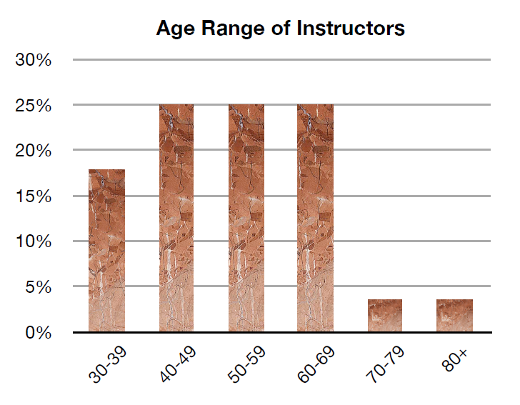
Fig. 2. Age range of the Big History instructors
The majority (92 %) of the instructors self-identified as male, with 57 % of the total respondents describing themselves as being aged 50 and above. The age distribution was fairly flat, with a near equal representation of instructors in their 40's, 50's and 60's (Fig. 2). One interesting facet of this portion of the study was that almost half of the respondents (46 %) describe themselves as having a multidisciplinary educational background that manifests itself as having more than a single degree in a single discipline. For instance, one respondent had obtained a Masters in Chemistry while obtaining a PhD in Social History. One question this raises is whether the Big History community attracts respondents with a disparate background or whether the multidisciplinary nature of Big History grows out of this diverse knowledge base.
Course Statistics
As mentioned above, gathering course statistics was slightly problematic. While 78 % of the instructors only taught one type of Big History course during a given timeframe, the remaining instructors taught multiple Big History courses (15 % taught two types, and 7 % taught three types). Another surprise was the frequency with which Big History courses are taught. While once-a-year was the dominant frequency of a Big History course, with 65 % of the courses being offered in this timeframe, the courses are also offered on a once-per-semester/quarter basis 22 % of the time. These two sets of frequencies for course offerings represent a significant amount of coverage and show that there is a high degree of demand for this type of course across a large number of university programs.
Fig. 3. Distribution of Big History class size
Along with the regular placement of these courses in curricular rotations, the numbers of students that share in the Big History experience is also significant. While the average course size of 63 students shows that the courses can be quite large, more telling is that 72 % of the courses have greater than 30 students and 31 % of the courses having greater than 60 students (Fig. 3). At the high end, course sizes of 250–300 were reported. Additionally, these courses were regularly taught – with the high enrollment courses routinely being taught once-a-year or once-per-semester. This large class size may be due to the location of Big History within the curriculum: many high enrollment classes are geared towards entry-level students.
In fact, just under half of the respondents (45 %) said that their courses are for first-year students. Looking just at the entry level courses, 63 % of them were reported to have enrollments greater than 60 students. This shows that Big History is often favorably situated within the curriculum and can offer the chance to touch
a large number of students at the beginning of their educational careers. The panoramic nature of many Big History courses makes it well suited for the introductory level, but – as can be seen from the Fig. 4 – there is a range of course levels.
Fig. 4. Course level breakdown by year of curriculum
Topical Coverage
The encompassing nature of many Big History courses makes it difficult to talk about the world system with some discussion of current global issues within the context of Big History. The development of Big History classes as a means to approach what are increasingly important, often border-spanning topics, was surveyed. Professors were asked to select from a list the five most heavily covered global issues that they would typically include in their Big History course (Fig. 5). Three global issues were deemed most relevant to Big History instructors: energy related issues and energy shortages, war and other human conflicts, and climate change. These three topics were rated the highest, with ~70 % of the instructors responding in these three cases, that, despite the disparities in the instructors and their courses, appear to serve as a current-events thread that links many of the discussions in the classrooms.
Fig. 5. Examination of global issues and their representation in Big History courses
One feature of Big History that separates it from other macro-history coursework is that most Big History courses incorporate
a large number of science principles in the development of the material. Instructors were asked to rank their coverage of a variety of topics that encompassed physics, chemistry, cosmology, geology and archeology (Fig. 6). Several topics stand out for the level of detail that instructors impart. It is not surprising to see that topics like natural selection and geological transformation are covered by 70–80 % of the instructors. There also is a strong showing of physics concepts, such as Newtonian mechanics and the works of Galileo and Copernicus. Instructors commented that certain broad topics, such as evolution, were further delineated into subtopics like evolutionary or developmental biology. Besides the more specific study of topics, there was also deeper exploration of the implications of these science issues on life, on the planet and on the human society. Prehistoric climate change and human migration are good examples of this type of interaction.

Fig. 6. Coverage of science topics in Big History
Further work needs to be undertaken to more fully explore the threads that interconnect Big History instruction. The comments by the instructors also included a few recurring items that were not on the list above. Three of the topics that were missing, but frequently mentioned, included human/primate evolution and behavioral similarities between the two (a glaring omission on the part of the authors), as well as the factors leading to the emergence of life.
One of the last things that we asked the Big Historians was about the obstacles to the development and expansion of Big History. While a quarter of the instructors felt there was no real issue, another quarter felt that there was an administrative or financial barrier, such as fitting new courses into their course rotation or compensating additional faculty for an increased teaching load. Large teaching loads make it difficult for instructors to fit Big History into their course rotation, while the over-specialization of faculty members was said to make the transition to a multifaceted, multidisciplinary course like Big History a slow process. Team teaching would be an ideal situation, although in lean economic times, such a luxury is not always available.
To summarize, our surveys show that the typical instructor tends to be multidisciplinary, teaching Big History courses to entry-level students every semester or every other semester, often with large class sizes. While this does not apply to all instructors or courses, it does provide a snapshot of what is going on around the community. The instructors use Big History to share science and globalization ideas, as well as a starting point and basis for addressing a large number of social issues affecting our ever-shrinking world.
What the Future Holds
So, what are the implications of all this? It is our contention that Big History will become the basic introductory course in worldwide education over the next twenty years. We feel that this is not only an inevitable process, but one that is desirable to promote. We, as scholars and educators, must find ways to address global problems using global linkages between ourselves, our students and our communities. Big History offers one model for educators to use to change the world. As one of our students wrote in her final paper:
I have broken through the surface – of my complacency in not-knowing – to the information that is being gathered by scholars in the study known as Big History. It is important to look at the world at both small and large scales to see patterns and possible solutions to global issues among the human race and the environment. It is important to know about time-space, quantum physics, gravity and the elements to further understand cause and effect between humans in the agrarian, industrial and modern eras. This knowledge will give us clues as to how we can replenish our living planet… It is up to each one of us to contribute to the health of this planet and grassroots efforts can produce results… Like the creative, forward-thinking people who have shared their knowledge and thoughts about issues relevant to Big History, I want to steward the human race in the same manner (Denise Scammon, University of Southern Maine, USA, 2009).
Big History considers how humans fit into the vast expanse of the universe, instead of orienting the universe around humans. This is an extremely important paradigm shift, a pedagogical equivalent to the Copernican revolution. It is in the spirit of such global endeavor that we educators need to ignite world change by empowering our world citizens with new ideas – in a process that English physicist David Hookes calls ‘Global Enlightenment’.⁴
NOTES
¹ Barry Rodrigue, ‘Big History, Civilization & Human Survival’, a paper presented at the Russian Academy of Sciences' Fifth International Conference on Hierarchy and Power in the History of Civilizations in Moscow (Russian Federation) on 23 June 2009. This paper will be published in the National Education Association journal Thought & Action 26 in 2010.
² The earlier courses that anticipated Big History included Universal History in the Soviet Union and Cosmic Evolution in the United States.
³ The Russian Academy of Sciences' Fifth International Conference on Hierarchy and Power in the History of Civilizations was held in Moscow (Russian Federation) on 23–26 June 2009. Fred Spier and Esther Quaedackers (Netherlands), Akop Nazaretyan, Andrey Korotayev, Leonid Grinin, Alexander Markov, and Alexander Panov (Russia), and Barry Rodrigue (USA) were among the Big Historians presenting there.
⁴ David Hookes, Liverpool, Merseyside (England), personal communication (e-mail) to Barry Rodrigue, Lewiston, Maine (USA), 19 June 2009.
REFERENCES
Christian, D.
2004. Maps of Time: An Introduction to Big History. Berkeley, CA: University of California Press.
Harvey, C. et al.
2002. Arsenic Mobility and Groundwater Extraction in Bangladesh. Science 22(5598): 1602–1606.
Rodrigue, B.
2009. Big History, Civilization and Human Survival. Fifth International Conference on Hierarchy & Power in the History of Civilizations. Moscow, 23 June 2009.
2010. Big History, Civilization and Human Survival. Thought and Action 26 (Autumn). In print.
Rodrigue, B., and Stasko, D.
2009. A Big History Directory, 2009: An Introduction. In World History Connected 6(3) Autumn. Available at: http://worldhistoryconnec-
ted.press.illinois.edu/6.3/rodrigue.html
Smith, A. H., Lingas, E., and Rahman, M.
2000. Contamination of Drinking-Water by Arsenic in Bangladesh:
A Public Health Emergency. Bull World Health Organ 78(9): 1093–1103.
Snooks, G. D.
2005. Big History or Big Theory? Uncovering the Laws of Life. Social Evolution & History 4(1): 160–188.
Spier, F.
1996. The Structure of Big History: From the Big Bang until Today. Amsterdam: Amsterdam University Press.
2005. How Big History Works: Energy Flows and the Rise and Demise of Complexity. Social Evolution & History 4(1): 87–135.
2010. Big History and the Future of Humanity. Oxford: Wiley-Blackwell.

