Cooperate or Compete?
Is Collective Action a Viable Way to
Develop Sustainable Political Regimes?¹
Ludomir R. Lozny
Hunter College, CUNY, New York
Abstract
I apply collective action theory here to examine empirical data on social dynamics in prestate societies of Central European Plains between 500 and 1000 CE. The proposition is that under certain socioeconomic conditions, levels of political formations reflect rational agreement and consent between the rulers and the ruled. This addresses the dilemma whereby self-interest behavior of social actors would seemingly limit the potential for collective action and group cohesion. The theory employed here, which derives from game theory assumptions, integrates political science and anthropological perspectives. The examined empirical evidence shows that a very basic community-level management of common pool resources seems a successful strategy to manage a short term risk, secure economic benefits and ultimately leads to sustainable higher level political organization.
Introduction
The concepts I explore here relate to culture as the key factor in human decision-making and adaptability (Rappaport 1971; Boyd and Richerson 1995). Other ideas briefly touched on include suggestions that regulated access to and distribution (consumption) of common pool resources (CPRs) define societal interactions on various scales from communal to global, and that participatory polycentric governance is more efficient in the (local?) management of CPRs, especially in achieving short-term societal goals, as polycentric political agencies (oppose to centralized ruling) contribute to improved management of CPRs. Currently, examples of cooperative CPRs management are present in many societies and range from small-scale community-run projects, like nature preserves, to global, like worldwide cultural heritage preservation programs (Lozny 2010). Collective action theory is used here to explain community-level economic and political sustainability through cooperative management of local CPRs. The assumption is that under certain conditions collective management of natural resources mitigates problems such as overuse or degradation and contributes to political and economic sustainability. Adjustments to the rules of cooperation impact intergroup socioeconomic dynamics (see Dominguez et al. 2010), and contribute to a new power structure. In a broader context, the point is that decisions with short-term goals may have long-term consequences.
Blanton and Fargher (2008: 285) concluded that ‘common property systems at the base of society did not provide models for state formation, nor did they facilitate the development of collective institutions for the political community as a whole’. I attempt to examine the 6th – 10th century CE societies of Central European Plains (CEP) to see whether they were initially organized as collective polities and if such organization may have contributed to the emergence of centralized and hierarchal political system during the 10th century CE. My discussion concerns two hypotheses:
- the 6th to 9th century CE societies of CEP were quasi-egalitarian swidden cultivators/livestock keepers who managed the critical CPRs (land, water, livestock, game, forest products, etc.) in cooperative manner, and
- as economic and political conditions changed during the 9th – 10th century CE (farming and trade intensified), cooperative management of CPRs contributed to the creation of socioeconomic conditions suitable for the emergence of higher level hierarchal structure resembling state-level complexity, and this transition is visible in the archaeological record (for instance, change of settlement pattern, house size, land use, evidence of collective works, etc. [for discussion on the relationship between archaeological data and social complexity see Johnson 1973, 1980; also Wright 1984]).
I examine a proposition that past CEP societies have devised, adopted and maintained, cooperative arrangements to manage CPRs, under which local users became interdependent, willing and capable of following networks of communication and institutional development in order to create conditions for sustainable economic and political regimes. A collective action creates specific forms of societal interaction common to both egalitarian and nonegalitarian communities, where the rulers and the ruled interact according to
a consensus based on the distribution (and redistribution) of incentives (see Blanton and Fargher 2008, 2009 for a review of cases from around the world). The change from reciprocal distribution of goods and services to redistribution and market exchange does not necessarily eradicate the principle of collective actions, but it changes its dynamics. Redistribution of incentives can also be seen as an appealing strategy to promote collective actions in an agency-client type of interaction.
I wish to discuss whether collective actions may have been applied to the management of CPRs during the process of social changes that took place in CEP from the 6th to 9th century CE, and whether such organization contributed to the emergence of sustainable and more complex economic and political regimes during the 10th century CE. Evidence of aboriginal social cooperative behavioral patterns past and present derive directly from archeological investigation² and first-hand ethnographic data, and indirectly from analogies and theoretical assumptions.
Theoretical Assumption: Collective Action as a Strategy for Communal Success
I am interested in the aspect of the theory which considers factors contributing to communal integration (social behavior that underlines conditions for the emergence of social institutions). The point is that under certain economic and political conditions a network of communal organizations of different scale (clubs in Buchanan's terminology [see Buchanan 1965 and discussion by Atkinson 1987]) becomes a successful alternative to centralized decision-making. In a polycentric structure, a federation of independent governing bodies organized as a set of nested institutions focused on a common goal contributes to effective, beneficial to all parties involved, decision-making. The economic benefit of collective action lies in the provision of CPRs (fish, forest products, hunting game, livestock, land, water, etc.) through cooperative activities beyond what would be expected from individual consumer rationality, which may not warrant efficient provisions of goods for others. An intellectual outlook focused on common goals (public goods) rather than individually designed objectives and strategies is necessary for cooperative activities to become successful.
Collaboration is more common, some argue spontaneously emerging, in small size societies³ (see Dunbar 1992; according to Dunbar 150 individuals was an optimal number for group cohesion, for instance acting together in defending a territory; on the Dunbar number see Gladwell 2000; American researchers [McCarthy et al. 2000] suggested higher numbers, around 231 to 290; on the correlation between group size and collective action see also Agrawal and Goyal 2001). Critics (Olson 1965) point out, however, a free rider strategy when individuals might benefit from collaborative attitudes toward the common resource (public good), but do not contribute to its provision.
There are specific incentives that make cooperation appealing (borrowed from game theory). The point is to show behavioral choices in strategic situations when individual's success depends on decisions by others:
- Reciprocal behavior (including the choice described by ‘prisoner's dilemma’)
- Frequency of contacts and transparency
- Flexibility (opportunity to change rules)
- Reputation (status)
The following two hypothetical examples suggesting the conditions for cooperation (prisoner's dilemma; for discussion see Hardin 1971, 1982) and competition (zero sum game) illustrate the point.
Table 1
Prisoner's dilemma payoff matrix (modeled for two
players); non-zero sum game (most cases Pareto optimal)
Decision | Cooperate | Defect
Cooperate | 0,0 win-win | –10,0 lose much-win much
Defect | 0,–10 win much-lose much | 5,5 lose-lose (minimized gains and losses)

This example shows that the best strategy concerning communal goals is not to pursue self-interests (symmetric game), but to cooperate in order to either win or minimize losses (and gains). The key point is that a gain by one player does not necessarily correspond with a loss by the other.
Table 2
Zero-sum game payoff matrix (modeled for two players;
all cases Pareto optimal)
Decisions for x and y | a (x) | b (x) | c (x)
1 (y) | x30, y-30 | x-10, y10 | x20, y-20
2 (y) | x10,y-10 | x20, y-20 | x-20, y20
If the players know the matrix (conditions) they engage with maximizing their payoffs (often asymmetric game). The point is that a loss by one player compensates the net gain by the other.
Probability impacts zero-sum decision making. If players compute the probabilities (rationalize decisions) they can minimize the maximum expected losses independently of the opponent's strategy (such minimax method for designing optimal strategies almost never works – cf. Nash's equilibrium for alternative solution; if players choose a strategy to minimize gains, the matrix in Table 2 shows at least one quality of Nash's equilibrium: decision 2 for y and c for x).
The larger point is that decisions modeled by the zero-sum matrix promote competition (individual success), while the non-zero sum matrix suggests better payoffs (beneficial to all involved but not necessarily maximized) if cooperation is pursued.
The key question that should be debated than is: What is the best strategy in the context of non-cooperative behavior (explained by all kinds of equilibrium games like Nash equilibrium)? Two alternative solutions seem advisable:
- Cooperative games (partnership, consensus, etc.; players form binding commitments to support stable structures for as long as they accept the rules; generally, the objective is to tie the game not to win),
- Hybrid games (coalitions, alliances, confederacies, etc.;
a mixture of cooperative and non-cooperative behaviors to support short-term stability of otherwise dissipative structures).
Empirical Argument: Common Pool
REsources, Ethnographic and
Archaeological Data
Ostrom (1990: 30) defined a CPR as ‘a natural or man-made resource system that is sufficiently large as to make it costly (but not impossible) to exclude potential beneficiaries from obtaining benefits from its use’. This definition suggests that in order to use CPRs a consensus is necessary binding the participating parties to a certain conduct (rules). The eight ‘design principles’ (Ostrom 1990) stipulate the conditions for sustainable CPRs management:
- Clearly defined boundaries (effective exclusion of external unentitled parties);
- Rules regarding the appropriation and provision of common resources are adapted to local conditions;
- Collective-choice arrangements allow most resource appropriators to participate in the decision-making process;
- Effective monitoring by monitors who are part of or accountable to the appropriators;
- There is a scale of graduated sanctions for resource appropriators who violate community rules;
- Mechanisms of conflict resolution are cheap and of easy access;
- The self-determination of the community is recognized by higher-level authorities;
- In the case of larger common-pool resources: organization in the form of multiple layers of nested enterprises, with small local CPRs at the base level.
Following these principles the subsequent key assumptions are proposed for a successful management of CPRs by the CEP societies 500–1000 CE:
- CPRs are finite in size but may be renewable and resources appropriated or used are no longer available to others; that is, appropriation must detract from the overall value of the resource pool.
- Since the exclusion is difficult, resources within CPR systems are often owned, used, and managed by multiple groups of different size (a more sizable [powerful] group may attempt to regulate the access).
- CPRs can be held at various social scales, ranging from partnerships between individuals or families to resources held in common by more complex societies. Protected core resource (stock variable like water or fishing grounds), and extractable fringe units are used for consumption.
- Within intertribal CPR systems groups may harvest resources without gaining prior permission or making any type of repayment, though they must follow mutually agreed upon rules (by all joint users) of the system.
- Appropriators should have similar leadership and social organization structures. Groups with unequal structures may have difficulty entering into binding agreements over harvesting rules and may have alternative goals for extracting resources (i.e., to support different types of institutions). More organized groups may be able to influence decision making and may be motivated to take more than their fair share, causing destruction of the natural resource system.
- Physical environment also plays a role. CPR strategies develop in uncertain, variable, and complex environments.
In the following section I examine the ethnographic and archaeological data that corroborate the above assumptions. The archaeological data come from the northern part of CEP (Fig. 1), which has been extensively researched archaeologically for over one hundred years (see Losinski 1982; Dulinicz 2006), while the ethnographic examples come from the case studies published in the journal Human Ecology.
Central European Plains
Archaeological records suggest major cultural shift (also identified as cultural decline) in Central European Plains around 500 CE. The change was set off by the fall of the Roman Empire, which triggered a range of cultural modifications including significant adjustments to regional economic and political patterns. After approximately 500 years since the collapse suitable socioeconomic conditions emerged to support a state-level polity. The central problem addressed relates to identification of the socioeconomic conditions that underlined the transition from less complex (tribal) to more complex (state) level society in CEP between 500 and 1000 CE. I argue that the societies occupying CEP around 500 CE were quasi-egalitarian with some evidence of social ranking, swidden agriculturalists and livestock keepers, who managed their resources in a primarily cooperative manner for about 300 years until a more centralized and hierarchically arranged socioeconomic system was gradually established during the 800–900s CE.
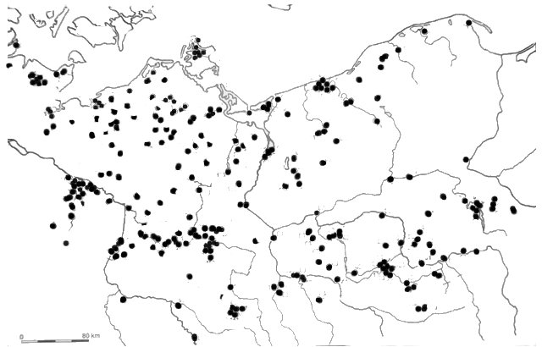
Fig. 1. Central European Plains. Selected archaeological sites 500–1000 CE (after Dulinicz 2006)
The following key arguments supported by archaeological data suggest the possibility that a variety of cooperative activities may have been applied to manage local CPRs.
Tribal political (quasi-egalitarian) system was based on the principle of reciprocity as a major form of distribution of goods and services; evidence for redistribution exists but there is no clear evidence for institutionalized (codified) social stratification before 800s CE. Similar in size and shape pit-houses date primarily to the 500–700 CE (Fig. 2). Oval structures are thought to represent pit-houses or places to keep animals (pigs), at the average area 6 m². Rectangular houses may suggest population growth or change in social organization as they can be more densely packed than oval structures. No burial and settlement diversification; cremation was the key burial custom.
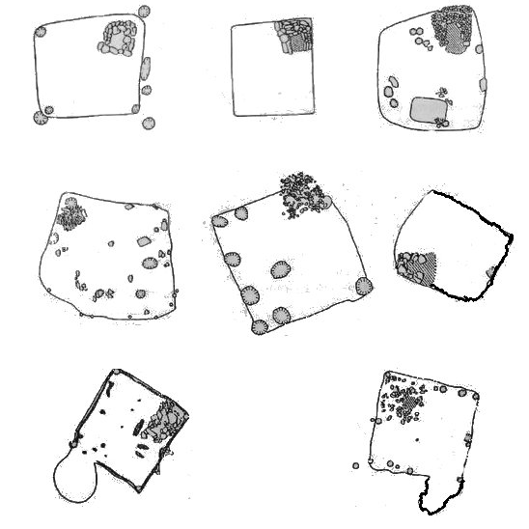
Fig. 2. Typical houses from Central European Plains, 500–800 CE
Small size communities fit the condition characterized by the Dunbar number as promoting spontaneous cooperative actions.
Subsistence patterns were based on shifting farming and limited animal husbandry; the economy was based on a family/kinship as the basic unit of production and consumption with animal husbandry supported by swidden farming (slash-and-burn technique was common; no use of plough or animals for traction until after 1000 CE), gathering of forest product and hunting; the assumption of grazing and fishing rules, access to forest and farming activities probably organized through the principles of collective (management) action.
Land tenure involved communal decision-making. The land tenure system of communal ownership (access and management) of land has not changed at times of political centralization (after 1000 CE) and earlier authority and control of the manorial-like system was fused into the emerging feudal system. Territorial community represented by a cluster of settlements covering an area of 1 km in radius was recorded in Mecklenburg by the Kumerower See and the Peene River (Fig. 3). Dulinicz (2006) estimates the communal area to 2 km². The diverse ecosystem was suitable for farming, cattle herding, and fishing. The cluster is dated after 650 CE to 750 CE (dendrochronology and radiocarbon assays). It existed until after 900 CE and became a part of higher level sociopolitical complexity. Historic sources confirm the existence of communal territorial units identified by Polish historians (Buczek 2006) as opole, to be part of the socio-administrative-political structure of the early state but with roots in prestate social organization. A similar concept (pogost) was used in medieval Ruthenia to identify a territorial unit, a community, of ca. 1000 people inhabiting ca. 300 km² area. Scholars suggest that the unit size varied from 12 to 20 settlements (villages, see Kobyliński 1988: 158) covering areas from 10 km² to 70–100 km². The 12 – 13th century CE written sources confirm the communal use of forests and forest products, grazing areas, and probably fishing grounds (Modzelewski 2000).
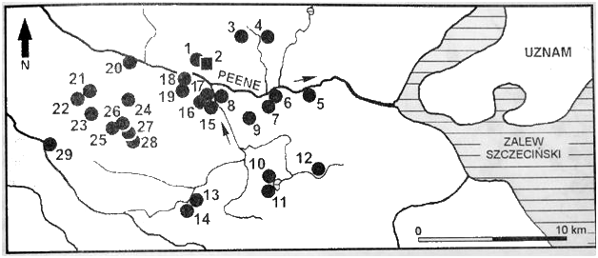
Fig. 3. Mecklenburg, a cluster of settlements the 7th/8th – 10th centuries CE (tribal period; after Dulinicz 2006)
Political ability to organize labor in a non-coercive context (corvée); organized labor used to construct early forts from the 700–800s CE (possibly recognized primarily as common goods of symbolic meanings rather that the ruler's seat), suggest a higher level of social cohesion; the emergence of multi-component forts after 1000 CE suggests the existence of well-defined social ranks (Lozny 2004).
Increase in social complexity. House size changed over time (Fig. 4) suggesting a possibility for emergent social ranking after 700 CE (larger houses are less numerous in 500–700 CE). In the early tribal period (500–600 CE) average house area was around 10 m² and rarely exceeded 20 m², while houses of the tribal period (700–800 CE) and early state period (after 950 CE) show greater diversity in size.

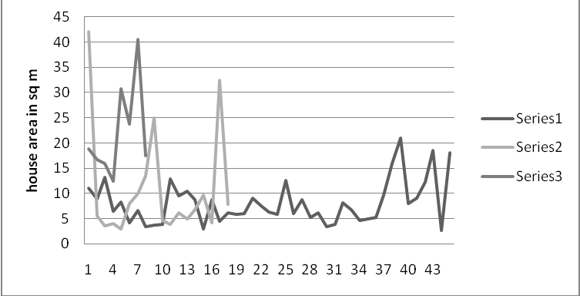
Fig. 4. House size 500–1000 CE: 1. early tribal period (500–600 CE); 2. tribal period (700–800 CE); 3. early state period (900–1000 CE)
Fort sizes changed after 900 CE suggesting greater political integration within the existing political system (Figs 5–8). Forts from the prestate phase show greater variety of sizes (Fig. 5) than forts from the early state phase (Fig. 6), where most were smaller, standardized in size of approximately 4 ha, with two clusters of forts up to 8 ha and only two larger than 12 ha in area. A comparative scatter-plot (Fig. 7) illustrates the change. Three groups of forts according to their sizes are clearly visible in Fig. 8, which also includes sizes of forts from the prestate phase for comparison.
Change in distance between forts (Figs 9, 10) also confirms political integrity and suggests an increase in social complexity toward 900 CE and later. Forts from the earlier period (600–700 CE) were dispersed, while forts from later periods (after 800 CE) were located in more regular intervals, which in the 900–1000s were 9 to 10 km average. A tiered network of forts emerged at the end of 900s CE (Figs 11, 12) and correlated with the major trade routes (Fig. 13).
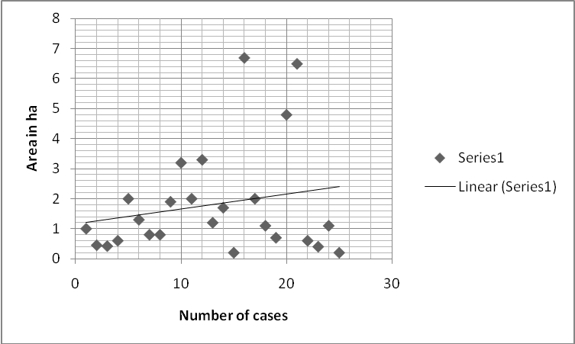
Fig. 5. Fort size: 800 to 900 CE (prestate)

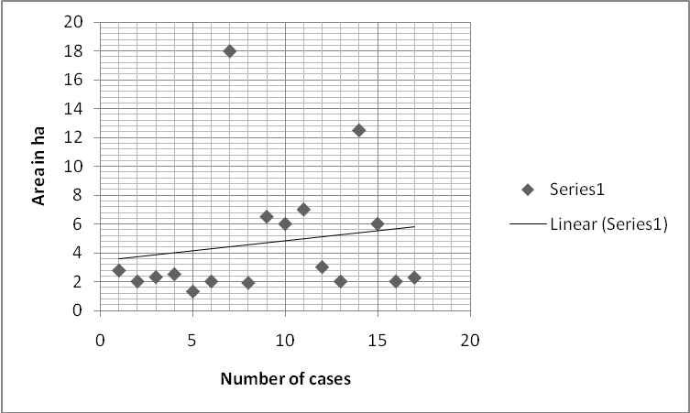
Fig. 6. Fort size: 900–1000 CE (early state)
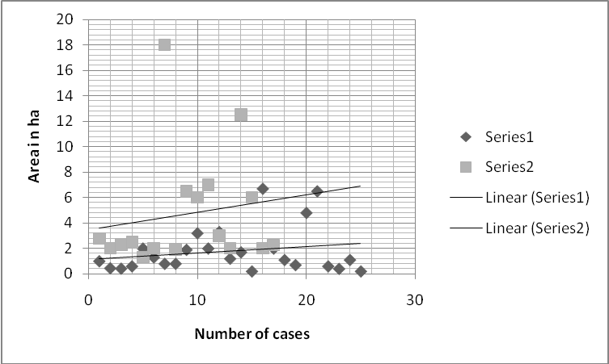
Fig. 7. Comparative scatter-plot of fort sizes: 1. pre-state forts (800–900 CE); 2. early state forts (900–1000 CE)

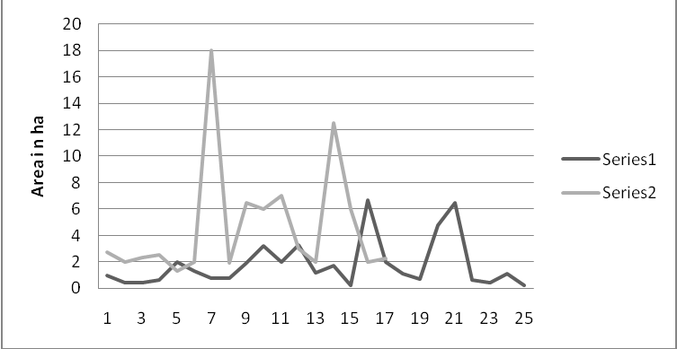
Fig. 8. Comparative fort size: 1. pre-state (800–900 CE); 2. early state (900–1000 CE)

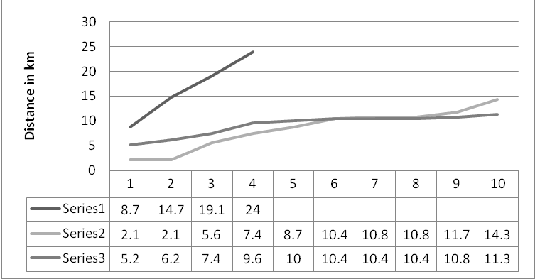
Fig. 9. Estimated distance between forts
Series 1, 600–700 CE
Series 2, 800–900 CE
Series 3, 900–1000 CE

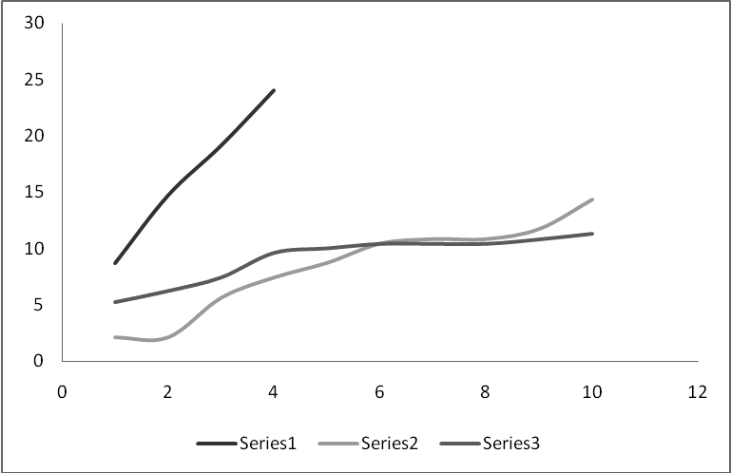
Fig. 10. Forecasted trendline for distance between forts: 1. 600–700 CE, 2. 800 CE, 3. 900 CE
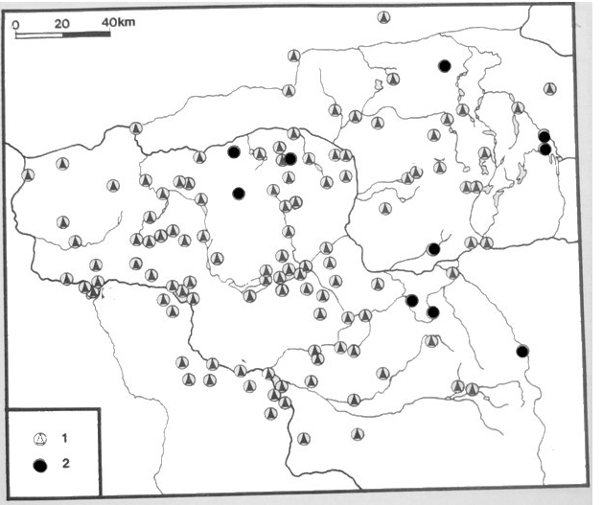
Fig. 11. Density of forts from 700/800 to 950 CE (after Kurnatowski 1983)
- Forts dated from 700/800 to 950 CE
- Forts possibly dated from 700/800 to 950 CE
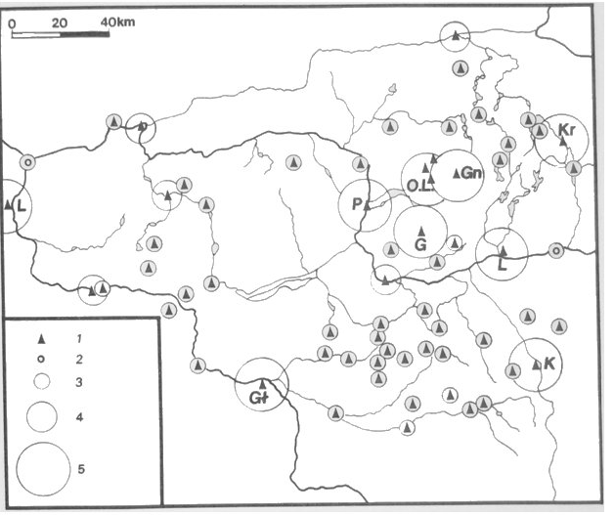
Fig. 12. Tiered network of forts dated to 950–1050 CE (after Kurnatowski 1983)
- Forts dated to 950–1050 CE
- Possible forts dated to 950–1050 CE
- Local centers
- Provincial centers
- Capital centers
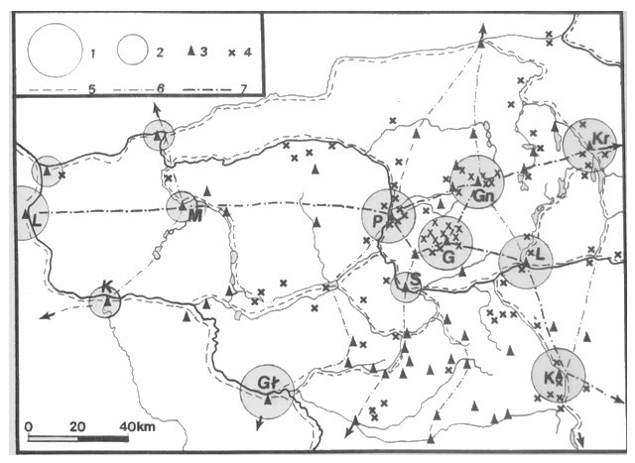
Fig. 13. Trade and communication routes 900–1000 CE (after Kurnatowski 1983)
- Capital centers
- Provincial centers
- Local centers
- Hoards of silver dated from the end of 800/900 to 1038 (invasion by Brzetyslav I of the Czech Kingdom and decline of the state)
Communities that may have organized their activities in a collective manner eventually turned to socially more complex. Small and medium size territorial units were most common during the 600–800 CE but around 800 CE the emergence of larger community size exceeding 10 ha is noticeable and after 900 CE community units close to 20 ha appeared (Figs 14 and 15). It is interesting to note that large territorial communities of 10 to 20 ha were not recorded archaeologically for 600–700 CE (Fig. 14).
A well-documented archaeologically region of Pomerania in northern Poland (Losinski 1982) serves as an example. During the 600–700s CE small communal territories prevailed (3.6 to 7.4 km²), while during the 800–900s CE the settlement pattern changed to a more diverse and hierarchically organized one (Figs 14–17). A typical territorial community model during the 800s CE consisted of one 1 ha area settlement accompanied by several middle size settlements of areas from 0.3 to 1 ha, and also several small settlements of less than 0.3 ha area, and suggests a hierarchal settlement structure, nonexistent in earlier times. Territorial unit size increased around 800 ha in some region of Pomerania, while in others it decreased (Fig. 17). This phenomenon might be attributed to a growing political competition (the Wolin region became politically and economically more significant due to the emerging urban center), which supports my idea that during the 800s CE more complex social hierarchies emerged and collective use of CPRs changed (refocused). Early forts appeared within the existing territorial communities during the 700s CE (objectives of collective action and CPRs management were redirected from natural goods to public goods, organized labor, etc.) and average settlement area changed from 5.82 to 7.13 km². The percentage of small communities covering areas of 3–5 km² declined, larger communities of 5–10 km² increased, and new territorial communities of 10–15 and 15–20 km²
in size appeared (Losinski 1982). This enlargement of territorial communities suggests an integration of political and economic structures and a transition from collective to a more centralized decision-making. A larger community was composed of 2–5 smaller communities and approximately 4–16 settlements of different size. Some territorial communities were composed of undefended settlements while other included forts. Throughout the discussed period 500–1000 CE communal territories were clearly divided into the inhabited section and communal lands (Fig. 16). The enlarged territorial communities covered in average 42 km² (43 % of the area was inhabited). The territorial community model for the end of 800 – beginning of 900 CE included three-level structure: small communities of 10–20 km², medium communities of 30–50 km², and large communities of 50–100 km². This suggests that around 800 CE processes of socioeconomic and political consolidation were well in progress.
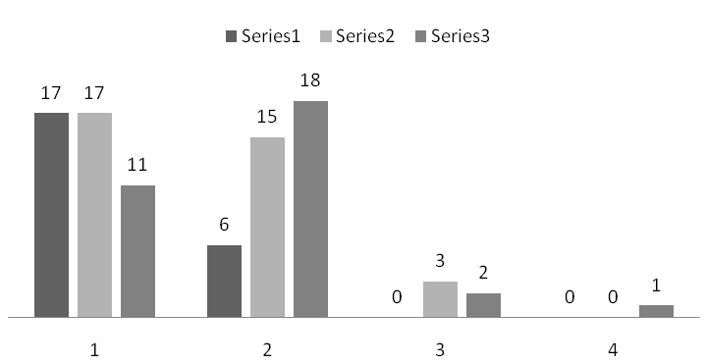
Fig. 14. Number of territorial units around 600–900 CE from the Wolin region, Pomerania (data after Losinski 1982)
- 3–5 km²
- 5–10 km²
- 10–15 km²
- 15–20 km²
Series 1, 600–700 CE
Series 2, 800 CE
Series 3, 900 CE
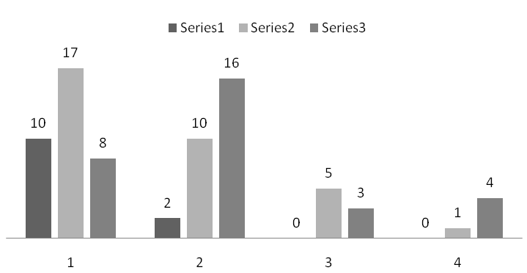
Fig. 15. Number of territorial units around 600–900 CE from the Pyrzyce region, Pomerania (data after Losinski 1982)
- 3–5 km²
- 5–10 km²
- 10–15 km²
- 15–20 km²
Series 1, 600–700 CE
Series 2, 800 CE
Series 3, 900 CE
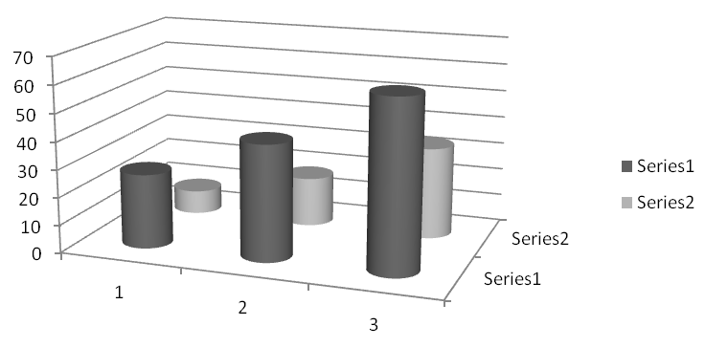
Fig. 16. Average size of territorial units with the estimated percentage of inhabited area
- 600–700 CE
- 800 CE
- 900 CE
Series 1, territorial unit size (in km²)
Series 2, the percentage of inhabited area within each territorial unit (in km²)

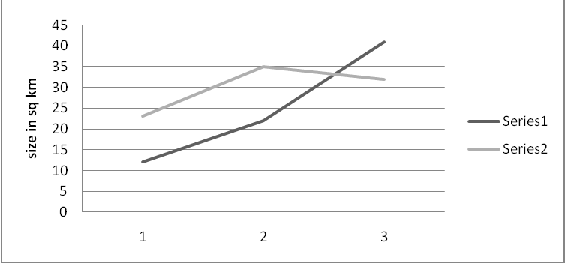
Fig. 17. Change in the average size of territorial units around 600–900 CE
- 600–700 CE
- 800 CE
- 900 CE
Series 1, Wolin region
Series 2, Pyrzyce region
Villages were often placed in close proximity to small forts and such network resembles the manorial-like system described for other European regions (see Blanton and Fargher 2008 for discussion). Another network of forts was established at the end of the 900s CE and represented a more centralized controlling system characterized by a new sociopolitical dynamics between the rulers and the ruled.
Archaeological and ethnographic data
on collective action
In the following section I review one archaeologically recognized case (Fort Irvin, USA) and four ethnographically confirmed cases (Zambia, Bolivia, Australia, and Canada) of cooperative approaches toward CPRs to see whether they might contribute insights to the assumed collective action behavior among past societies of Central European Plains.
Inter-tribal comanagement of resources, Fort Irvin, the Great Basin, USA
Jelmer W. Eerkens (1999) examined inter-tribal CPR systems consisting of land and other resources jointly used (managed) by distinct ethnic and/or linguistic groups in the Mojave Desert, the Great Basin, USA. This type of land tenure is distinct from reciprocal access arrangements. Ethnographic, archeological, ethnohistoric, and ecological data support this position. Ethnographic work shows that joint land ownership was practiced. Permission-seeking was commonly observed among the Great Basin groups when gathering outside their home territory. Sporadic use of the region by small and ethnically diverse groups as they dispersed from their winter villages in spring best accounts for the ethnographic, ethnohistoric, and archaeological information.
Eerkens' study contributes to answering the following question: How and why do CPR systems develop among small-scale societies? There are three main scenarios:
- Defendability or cost-benefit suggests that CPR systems developed because areas are not worth claiming and defending as private. Managed and jointly owned CPRs system provides greater benefits to all than an attempt by any single group to secure private and exclusive ownership.
- Environmental risk buffering emphasizes that if territories and resources are pooled and jointly owned, groups have unconstrained access to a larger and more diverse range. Coordinating harvesting activities from a pooled territory is effective in regulating access and preventing overlap between groups. A larger group of monitors control the region, protecting it against intrusion and/or illegal harvest and overexploitation (preventing a ‘tragedy of the commons’) of the resource base.
- Social conflict buffering suggests that joint-use lands serve as social buffers among groups. Although adjoining groups have exclusive access to their respective core areas, space among the groups may serve as a buffer against social friction. Such ‘no-man's-lands’ have been described by several ethnographers to exist among band and tribal societies.
Centralized vs localized management of fishing (Zambia)
Haller and Merten (2008) argued that the presence of centralized government thwarted a successful local collective action toward
a common resource. Locally developed institutions for fisheries existed in Africa before colonial and state rules were imposed. Traditional fishery institutions of the Batwa and Ila/Balundwe reduced transaction costs and regulated fishing in a common property regime. The result seemed to have been sustainable. Local chiefs retained power even with the influx of ‘foreigners’, the Lozi fishermen, who were encouraged to settle there by the central government. They actually enlarged the chiefs' spheres of influence, as they set up participatory, subsidiary mechanisms of control by forming fishery committees to implement some of the regulations. The link to identity was crucial, for it legitimized the bargaining power of the actors involved in order to transform or maintain institutional regimes.
The authors concluded that:
- open access is most profitable for commercial users and for traders who are very mobile; the use of citizenship is their strongest ideological asset.
- some local interest groups would be more interested in
a combination of locally and state enforced rules, limiting access to the fisheries to obtain better distribution in favor of small-scale fishing.
- traditional institutions face more free riding as they hinder livelihood critical gains in the new state-controlled context.
- new statutory initiatives addresses the chiefs as main representatives of the local groups, but recognizes the sometimes contested position of chiefs and tried to incorporate as many different fractions as possible, including male and female fish traders.
- the major positive aspect is that a process of participatory consent seems possible.
Nested institutions (polycentric decision-making)
in the Andean water management (Bolivia)
Amber Wutich (2009) presented a study on water regulations at times of scarcity in the Cochabamba region of Bolivia. As a result of social protests water management was not privatized and remains in public control. Water is extremely scarce in the southern region of Cochabamba occupied by urban migrants – a condition that made urban common pool water institutions unsustainable. The author examined three questions: (1) How does a common pool water resource function in urban Cochabamba? (2) Are its rules sustainable during periods of severe water scarcity? and
(3) Are the underlying institutions (including those for collective choice rules and operational rules) also sustainable during periods of severe water scarcity?
The author concluded that:
- the system is managed according to the principles of uniformity, contiguity, and proportionality, which ensures that all eligible community members receive fair and equal access to water. These rules are enforced via monitoring and sanctioning, yet it appears that a small amount of free-riding is tolerated in order to help some households meet short-term subsistence needs.
- the system is governed following the principle of regularity to prevent overexploitation and to ensure that water cutbacks are apportioned to all community members equally.
- while the function of the CPR institution was stable, the social structures that underlie it were noticeably more sensitive to external events. Activity in the nested institutions that organized collective choice (the Neighborhood Council) and oversaw operational rules (social networks) fluctuated in patterned ways and there is some evidence that seasonal water scarcity played a role in those fluctuations.
The results suggest that while institutions with strong historical precedents for contingencies under resource stress can endure periods of scarcity intact, the nested institutions that organize collective choice and operational rules may not be as resilient to external stressors. This indicates that a well-organized CPR institution may have the ability to remain ecologically and socially sustainable during periods of stress and uncertainty. Andean CPR management principles are embedded in cultural knowledge passed down through generations; the findings indicate that such knowledge is passed from rural to urban communities. Yet there are likely thresholds at which disruptions in polycentric and nested institutions begin to directly affect CPR institutions.
Social behavior toward nested CPR (Australia)
Ashutosh Sarker and his collaborators (2008) investigated interdependence of a set of nested CPRs in the Lockyer, the Brisbane River, and Moreton Bay catchments in Southeast Queensland, Australia and showed that the catchment (watershed) has several interdependent CPRs, linked through ecological processes and mediated by human actions that create positive or negative externalities for many resource users.
The authors examined three interrelated propositions: (1) that sets of CPRs can be interconnected within a landscape (i.e., they are ecologically interdependent), so that natural assets formerly considered as single CPR can be recognized as influencing each other; (2) that users of one CPR thus have interests in the management of other CPRs, which if depleted, affect their collective wellbeing (i.e., the CPRs are socially and socioecologically interdependent); and (3) that the management of such CPRs becomes more complex as ecological and social processes intersect because it potentially brings together several groups of users (and regulators) of both single and multiple use of CPRs. They termed interconnected CPRs ‘interdependent CPRs’.
The authors concluded that:
- Different CPRs, connected by ecological processes and often by externalities arising from human interventions, can be interdependent within a catchment and that their users are also interdependent.
- Collective action is therefore necessary, not only for the multiple uses of an individual CPR, but also to cater for socioecological interdependencies associated with the management of CPRs.
- The study of a set of nested catchments – the Lockyer,
the Brisbane River, and Moreton Bay – demonstrates that socioecological interdependencies do exist, but there is paucity of theoretical debate and practical approaches to understand and address the nature and consequences of such interdependencies.
Polycentric rules for aboriginal berry harvesting (Canada)
Brenda Parlee and her co-authors (2006) discussed common property arrangements that govern the subsistence harvest of berries in the Gwich'in region of the Northwest Territories, Canada, including rules for resource access, sharing information and harvest sharing. The rules change in response to year-to-year variations in the abundance and distribution of the species, spatially and temporally across the region. One of the problems discussed is how are common property rules modified by knowledge about variability in the abundance and distribution of commons? The authors researched
a number of dimensions of ‘sharing’ and rules in use for accessing cranberry, blueberry, and cloudberry picking areas. Extended family ownership regimes appear to have developed around many cranberry patches particularly those near cabin sites along the Peel River and in the Mackenzie River Delta.
They concluded that:
- Institutions or rules-in-use governing commons resources develop in many indigenous and other communities to prevent what has been called the tragedy of the commons (Hardin 1968).
- Formal institutions created under this agreement, such as the Gwich'in Renewable Resources Board and other comanagement boards, largely serve to limit non-Gwich'in access to local resources.
- There are also a variety of informal institutions within Gwich'in communities (nested institutions) that shape local resource use as in the case of berries and fish.
From the examples discussed above I conclude that:
- participatory consent is favored and traditional social arrangements toward CPRs often prevail over centrally imposed rules (Zambian fisheries, Bolivian water management).
- intergroup comanagement of CPRs was favored by small-scale societies for political and economic reasons (the Great Basin, USA).
- nested institutions (a mixture of formal and informal) secure successful management of scarce resources (Bolivian water management; indigenous berry harvesting in Canada).
- the concept of landscape allows an identification of nested CPRs and a collective action is therefore necessary not only for
the multiple uses of an individual CPR, but also to cater for socioecological interdependencies associated with the management of CPRs (Australia).
- polycentric pattern of decision-making is effective in the management of CPRs and is followed by groups of various socioeconomic status (African fishermen, Andean farmers and urbanites, aboriginal Canadian foragers).
Discussion
Several theories on state formation suggest that factors like population growth, warfare, and circumscription were crucial in promoting changes in social organization. The key arguments are:
- Environmental/social circumscription: the process of controlling and protecting (from other groups) specific, usually localized, physical resources or social groups.
- Population growth may put pressure on the system.
- Warfare may result from the actions of circumscription and from population pressure, which in turn yields intensified organization necessary for warfare and (potentially) increased ability for further development of the state.
None of the above models is a satisfactory explanation for the development of all states, since each sequence has its specific trajectories.
The theoretical assumptions discussed earlier clearly point out to the advantage of cooperative behavior if the welfare of the group is in question. It also contributes to answering a more general question: Why many aboriginal groups stayed relatively stable for so long with no increase in complexity and what factors swayed others into greater complexity?
The reviewed ethnographic and archaeological cases suggest that an attitude toward CPRs management is not limited to a specific type of society (simple or complex), but is present in a variety of social organizations – past and present. It is very common in situations where economic hardship or certain constrains favor cooperative behavior (ecological constrains in the Great Basin, in Zimbabwe, in the Andes, etc.). It has been argued that in small-scale societies with homogenous interests, local people should be able to act collectively (Olson 1965; Ostrom 1990; Ensminger 1992; Agrawal and Gibson 1999). Jointly owned grazing lands are often found among pastoralist societies, particularly those living in more marginal regions (e.g., Fratkin 1994; Gilles and Jamtgaard 1982; McCabe 1990; Mearns 1993; Ostrom 1990). Another example of customized (institutionalized) cooperation among herders is provided by Fekadu Beyene (2010), who discussed interclan cooperation in eastern Ethiopia. Since the private ownership is expensive, impedes access to a diversity of pasture types, communal ownership and CPR systems are preferred. Dominguez et al. (2010) have recently reported that although the Berber of the Mesiuoa tribe of the High Atlas still follow the traditional cooperative custom (agdal) regarding CPRs, individual attitudes changed due to the introduction of new economic ideas from elsewhere (France). A literature review by Agrawal (2003) points out that common property regimes are as successful as private or state-controlled regimes in managing CPRs.
Several arguments suggest the possibility for collective activities among CEP societies of 500–800 CE:
- Quasi-egalitarian social organization around 500–700 CE (no clear evidence of social diversity in housing); evidence of increase in social ranking after 800 and into 900 CE.
- Small size groups.
- Economic pattern based on slush-and-burn farming and limited animal husbandry with accompanying fishing and gathering.
- Land tenure most likely involved communal holdings (resembling the opole system), and their leaders were able to organize communal labor (corvée rather than coercion).
- Redistribution of incentives was used (local community built a place for the leader but also a refuge place for themselves), for the construction of forts and defendability became a public good to benefit local authorities and commoners and both groups were interested in achieving that goal.
- The case from Mecklenburg represents a small community,
probably around 50 to 75 people, who managed an area of about
2 km², and represents a typical 500–800 CE Central European Plains community until a more elaborated system of forts was put in place after 800 and during the 900s CE, introducing consolidation of power and a centrally governed, state level social complexity. Conditions that may have contributed to the emergence of social complexity during the 800s CE and later include specialization of labor, external political influence, and intensification in local trade which was linked to long-distance, intergroup economic network.
Preferences toward collective actions did not disappear with the increase of political integrity and social complexity in Central European Plains but were channeled into other forms of communal activities (reciprocal behavior replaced by redistribution of incentives, cf. Lozny n.d.).
Conclusions
The question was: Does collective action contribute to sustainable political regimes? Following Hardin's (1968) model literally that is if individuals act rationally but in self-interest they will deplete common resources, we might conclude that sustainability in general is not attainable.⁴ However, if we assume the following:
- CPRs management is efficient and flexible.
- Experience-based, small-scale community management is responsive to change.
- CPR stakeholders control each other as they share investment costs and benefits (especially if they share group identity), we might conclude that by making decisions resembling the conditions explained by a non-zero sum game (Table 1), there are cases not governed by Pareto optimality (efficient) that any (additional) change to make any person better off is impossible without making someone else's condition worse. And these cases justify the logic of collective actions, which in effect may contribute to the emergence of sustainable economic and political patterns at all levels of social complexity.
The lack of convincing evidence for centralized (coercive) power in Central European Plains between 500–800 CE suggests that there must have been another form of social organization, probably more communal (segmentary) than hierarchal and that further suggest a possibility that cooperative behaviors practiced through a pattern of nested polycentric governing institutions were present in the management of local CPRs. A hierarchal sociopolitical system emerged during the 800s CE and contributed to the rise of a primary (short-lived) state after 950–1000 CE.
Following other studies on the subject in which several cross-cutting similarities important to the development of collectively managed systems have been presented (cf. Ostrom 1990), I accept that attitudes toward collective management of CPRs emerge where:
- population is stable or has been stable for a relatively long period of time.
- norms defining proper behavior are clearly outlined and known by all, including clear definition of the region, and the reputation for honest dealings is highly valued.
- appropriators of CPRs have similar extraction technologies. Cases where technologies are significantly different, that is, where one group is able to harvest resources more efficiently or faster than another, can lead to differential value placed on resources. Appropriators should also have similar leadership and social organization structures.
Finally, I suggest the need for more research on the dynamics of collective action examined through collective management (polycentric, nested institutions to manage ‘public goods’) of common pool resources and its applicability to understand social complexity. Ostrom's eight ‘design principles’ established that nested institutions for resource management, collective choice, and oversight of operational rules are crucial for sustainable commons governance. While a number of scholars have examined how polycentric and nested institutions contribute to CPRs management
(cf. McGinnis 1999; Ostrom 1999), few have examined how the success of sustainable CPR institutions is affected by disturbances in nested governance institutions. Undoubtedly, certain regulations are necessary, but central government ruling may limit individual access to common resources. Participatory polycentric governance seems a feasible alternative. ‘Polycentricity’ is a normative approach to governance which stresses the degree to which higher levels of government should not crowd out self-organization at lower levels. It points out that local people know the local environment better than outsiders. The conventional wisdom that common property is poorly managed and should be either regulated by central authorities or privatized is challenged. Based on numerous studies of user-managed fish stocks, pastures, woods, lakes, and (ground) water, etc., it might be concluded that the outcomes are (more often than not) better than predicted by standard theories.
NOTES
¹ An earlier version of this paper was presented at the 31st Theoretical Archaeology Group conference, Durham University 2009. I would like to thank Daniel Bates for his helpful comments on earlier draft.
² I chose Central European Plains for its well-documented archaeological records supported by absolute dating (C14 and dendrochronology); for discussion see Losinski 1982; Dulinicz 2006.
³ See ethnographic studies on band and tribal-level societies, for example Pospisil 1963; Barth 1964; Leach 1964; Evans-Prichard 1971; Marshall 1976; Chagnon 1984; Barnard 1992; Lee 1993.
⁴ Hardin's tragedy of the commons might be, in a sense, viewed as multiplayer example of prisoner's dilemma. In a highly hypothetical scenario if many (all) decide to defect, the ultimate outcome is the obliteration of the commons (maximum penalty as shown in the matrix). In order to avoid collapse members of a society must refine their maximizing choices (deviate from the pattern described by Pareto optimality).
References
Agrawal, A.
2003. Sustainable Governance of Common-Pool Resources: Context, Methods, and Politics. Annual Review of Anthropology 32: 243–262.
Agrawal, A., and Gibson, C.
1999. Community and Conservation: Beyond Enchantment and Disenchantment. World Development 27(4): 629–649.
Agrawal, A., and Goyal, S.
2001. Group Size and Collective Action: Third Party Monitoring in Common Pool Resources. Comparative Political Studies 34(1): 63–93.
Andersson, K. P., and Ostrom, E.

2008. Analyzing Decentralized Resource Regimes from a Polycentric Perspective. Policy Sciences 41(1): 71–93.

Atkinson, A. B.

1987. James M. Buchanan's Contributions to Economics. Scandinavian Journal of Economics 89(1): 5–15.

Barnard, A.

1992. Hunters and Herders of Southern Africa. A Comparative Ethnography of the Koisan Peoples. Cambridge Studies in Social and Cultural Anthropology, 85. Cambridge: Cambridge University Press.

Barth, F.

1964. Nomads of South Persia. Oslo: Universitetsforlaget.

Beyene, F.

2010. Interclan Cooperation in a Risky Pastoral Ecology: Some Lessons from Eastern Ethiopia. Human Ecology DOI:10.1007/s10745-010-9335-1.

Blanton, R., and Fargher, L.

2008. Collective Action in the Formation of Pre-Modern States. New York, NY: Springer.
2009. Collective Action in the Evolution of Pre-Modern States. Social Evolution and History 8(2): 133–166.

Boyd, R., and Richerson, P. J.

1995. Why does Culture Increase Human Adaptability. Ethology and Sociobiology 16: 125–143.

Buchanan, J. M.

1965. An Economic Theory of Clubs. Economica 32(125): 1–14.

Buczek, K.

2006. Studia z dziejow ustroju spoleczno-gospodarczego Polski Piastowskiej. Vol. 2. Warsaw: Vistulana Press.

Chagnon, N. A.

1984. Yanomamo: The Fierce People. 3rd ed. New York, NY: Holt McDougal.
Dominguez, P., Zorondo-Rodríguez, F., and Reyes-Garcia, V.
2010. Relationships between Religious Beliefs and Mountain Pasture Uses: A Case Study in the High Atlas Mountains of Marrakech, Morocco. Human Ecology 38(3): 351–362.

Dulinicz, M.

2006. Frühe Slawen im Gebiet zwischen unterer Weichsel und Elbe. Eine archäologische Studie (Studien zur Siedlungsgeschichte und Archäologie der Ostseegebiete 7). Neumünster: Wachholtz Verlag.

Dunbar, R. I. M.

1992. Neocortex Size as a Constraint on Group Size in Primates. Journal of Human Evolution 22: 469–493.

Dutta, P. K.

1999. Strategies and Games: Theory and Practice. Cambridge, MA: MIT Press.

Eerkens, J. W.

1999. Common Pool Resources, Buffer Zones, and Jointly Owned Territories: Hunter-Gatherer Land and Resource Tenure in Fort Irwin, Southeastern California. Human Ecology 27(2): 297–318.
Ensminger, J.
1992. Making a Market: The Institutional Transformation of an African Society. Cambridge: Cambridge University Press.

Evans-Prichard, E. E.

1971. The Azande: History and Political Institutions. Oxford: The Clarendon Press.
Fratkin, E.
1994. Pastoral Land Tenure in Kenya: Maasai, Samburu, Boran, and Rendill Experiences, 1950–1990. Nomadic Peoples 34/35: 55–68.
Gilles, J. L., and Jamtgaard, K.
1982. Overgrazing in Pastoral Areas: The Commons Reconsidered. Nomadic Peoples 11: 1–10.

Gladwell, M.

2000. The Tipping Point – How Little Things Make a Big Difference. New York, NY: Little, Brown and Company.
Haller, T., and Merten, S.
2008. We are Zambians – Don't Tell Us How to Fish! Institutional Change, Power Relations and Conflicts in the Kafue Flats Fisheries in Zambia. Human Ecology 36: 699–715.

Hardin, G.

1968. Tragedy of the Commons. Science 162: 1243–1248.

1998. Extensions of ‘The Tragedy of the Commons’. Science 280(5364): 682–683.
Hardin, R.
1971. Collective Action as an Agreeable n-Prisoners' Dilemma. Behavioral Science 16: 472–481.

1982. Collective Action. Baltimore, MD: Johns Hopkins University Press.

Johnson, G. A.

1973. Local Exchange and Early State Development in Southwestern Iran. Anthropological Papers, no. 51. Museum of Anthropology, University of Michigan (Ann Arbor).
1980. Spatial Organization of Early Uruk Settlement Systems. In Barralet, M. T. (ed.), L'Archéologie de l'Iraq du début de l'époque néolihtique a 333 avant notre ère. Perspectives et limites de l'interprétation anthropologique de documents (pp. 233–263). Paris: CRNS.
Kobyliński, Z.
1988. Struktury osadnicze na ziemiach polskich u schyłku starożytności i w początkach wczesnego średniowiecza. Warsaw: Polish Academy of Sciences Press.
Kurnatowski, Z. i St.
1983. Problematyka ksztaltowania sie osiedli wczesnomiejskich w Wielkopolsce. In Zak, J., and Ostoja-Zagorski, J., (eds)., Studia z dziejow i kultury zachodniej Slowianszczyzny. Materialy z sesji poswieconej pamieci profesora dra Wojciecha Kocki. Seria Archeologiczna, nr 20: 89–106. Uniwersytet im. Adama Mickiewicza w Poznaniu. Poznan: UAM Press.
Leach, E. R.
1964. Political Systems of Highland Burma. Foreward by Raymond Firth. Boston, MA: Beacon Press.
Lee, R. B.
1993. The Dobe Ju/'hoansi. New York, NY: Holt, Reinhart and Winston.
Losinski, W.
1982. Osadnictwo plemienne Pomorza (VI–X wiek). Wroclaw; Warszawa; Krakow; Gdansk; Lodz: Ossolinuem Press.

Lozny, L. R.

2004. The Transition to Statehood in Central Europe. In Grinin, L. E. et al. (eds.), The Early State, Its Alternatives and Analogues (pp. 278–287). Volgograd: Uchitel Publishing House.

2010. Archaeology in the Age of Globalization: Local Meanings, Global Culture. In Lozny, L. (ed.), World Archaeologies: A Comparative Perspective. New York, NY: Springer (In print).
n.d. The Rise of Social Complexity in Central European Plains, 500–1000 CE.
Marshall, L.
1976. The !Kung of Nyae Nyae. Cambridge, MA: Harvard University Press.
McCabe, J. T.
1990. Turkana Pastoralism: A Case against the Tragedy of the Commons. Human Ecology 18: 81–103.
McCarty, C., Killworth, P. D., Bernard, H. R., Johnsen, E., and Shelley, G.
2000. Comparing Two Methods for Estimating Network Size. Human Organization 60: 28–39.
McGinnis, M. D. (ed.)
1999. Polycentricity and Local Public Economies. Readings from the Workshop in Political Theory and Policy Analysis (Paperback). Ann Arbor, MI: Michigan University Press.
Mearns, R.
1993. Territoriality and Land Tenure among Mongolian Pastoralists: Variation, Continuity and Change. Nomadic Peoples 33: 73–103.
Modzelewski, K.
2000. Organizacja gospodarcza panstwa piastowskiego X–XIII wiek. Poznań: Poznańskie Towarzystwo Przyjaciół Nauk.
Olson, M.
1965. The Logic of Collective Action. Cambridge: Harvard University Press.
Ostrom, E.
1990. Governing the Commons: The Evolution of Institutions for Collective Action. New York, NY: Cambridge University Press.
1999. Coping with Tragedies of the Commons. Annual Review of Political Science 2: 493–535.
Parlee, B., Berkes, F., and Teetl'it Gwich'in Renewable Resources Council
2006. Indigenous Knowledge of Ecological Variability and Commons Management: A Case Study on Berry Harvesting from Northern Canada. Human Ecology 34(4): 515–528.
Pospisil, L.
1963. The Kapauku Papuans of West New Guinea. New York, NY: Holt, Reinhart and Winston.
Poundstone, W.
1992. Prisoner's Dilemma. Doubleday, NY: Anchor Books.
Rappaport, R. A.
1971. Nature, Culture, and Ecological Anthropology. In Shapiro, H. L. (ed.), Man, Culture and Society (pp. 237–267). 2nd ed. Oxford: Oxford University Press.
Sarker, A., Ross, H., and Shrestha, K. K.
2008. Interdependence of Common-Pool Resources: Lessons from
a Set of Nested Catchments in Australia. Human Ecology 36(6): 821–834.
Wright, H. T.
1984. Prestate Political Formation. In Earle, T. (ed.), On the Evolution of Complex Societies; Essays in Honor of Harry Hoijer (pp. 41–78). Malibu, FA: Udena.
Wutich, A.
2009. Water Scarcity and the Sustainability of a Common Pool Resource Institution in the Urban Andes. Human Ecology 37(2): 179–192.

